Name: Date:

Moment of Inertia PreLab

Instructions: Provide correct answers to the following questions. Complete this PreLab and turn it in to your lab instructor upon arrival in lab.

Review the Glossary in the Student Lab Handbook for important terms associated with this lab.

- State the theoretical moments of inertia for a dumbbell, a cylindrical ring, and a disk rotated around their centers of mass.

I_{dumbbell} = I_{ring} = I_{disk} =

- State the parallel axis theorem for moments of inertia.

- Consider a disk that is free to spin about a horizontal axis attached to a weighted string (see figure). The string is wrapped around the outer rim of the disk and connected to a weight of mass m suspended over the edge of the level surface with a pulley. The disk has a moment of inertia I, and a radius R. The force of tension, T, arising from the disk, opposes the acceleration of the suspended weight. On the basis of Newton’s second law one can conclude that $−T+\text{mg}=\text{ma}$ where a is the acceleration of the entire system. Given this relationship and assuming the definitions of torque, τ = TR, angular acceleration, α, the relationship between them, τ = Iα, and the relationship between linear acceleration and angular acceleration, a = Rα, show that the moment of inertia of the disk can be found using the following relationship:
$$I={\text{mR}}^{2}\left(\frac{g}{a}−1\right)$$
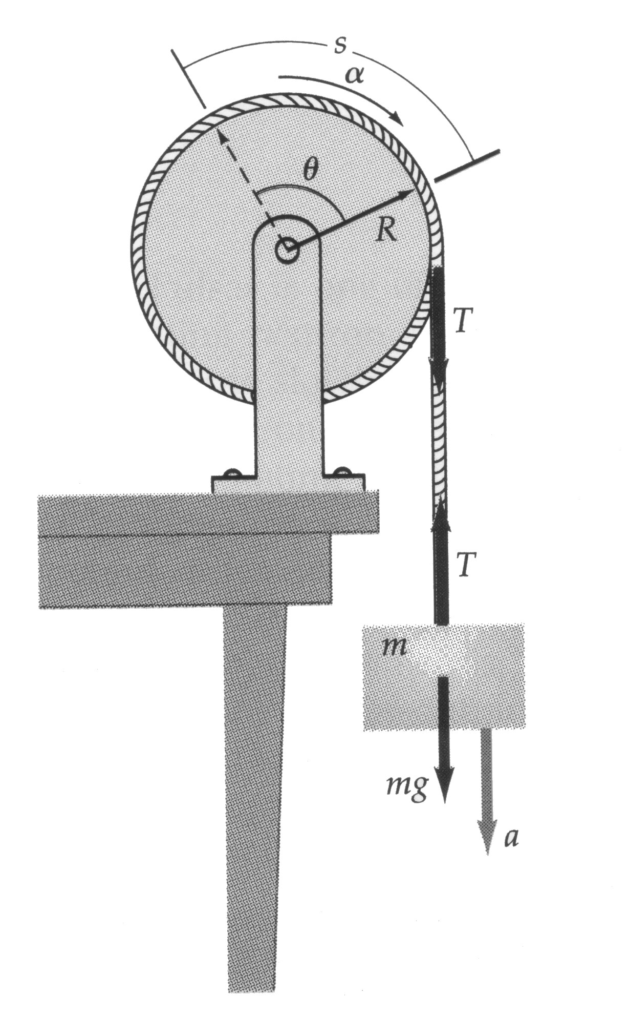

Name: Date:

Moment of Inertia Lab Guidelines

Objectives: As a result of this lab, the student will:
- Demonstrate a conceptual understanding of the phrase “moment of inertia.”
- Find the relationship between the moment of inertia and the amount of mass in a dumbbell system.
- Find the relationship between the moment of inertia and the distribution of mass in a dumbbell system.
- Verify the moment of inertia for a cylindrical ring with interior and exterior radii of R₁ and R₂ rotated about its central axis.

Task 1. Demonstrate a conceptual understanding of the phrase “moment of inertia.”

a. The moment of inertia is to rotational motion as mass is to linear motion. In a linear system, the mass can be thought of as a “measure of resistance to linear acceleration.” In a rotational system, the moment of inertia can be thought of as a “measure of resistance to rotational acceleration.” The parallels between the force and torque relationships are clearly evident: $F=\text{ma}$ and $t=Iα$. As force is responsible for linear acceleration, so torque is responsible for angular acceleration.

b. Conduct a qualitative controlled experiment to determine the affect of the amount of mass at a fixed distance on the perceived moment of inertia of a weighted meter stick. Hold the meter stick at the 50cm position, and quickly rotate the meter stick back and forth with changing amounts of mass located at the same position each time. Note any changes in the resistance to rotational acceleration.

Q1. How does the amount of mass affect the perceived moment of inertia in this system?

b. Conduct another qualitative controlled experiment to determine the affect of the location of mass on the perceived moment of inertia. Use the same amount of mass each time. Again, hold the meter stick at the 50cm position, and quickly rotate the meter stick back and forth with changing mass distribution. Note any changing resistance to rotational acceleration.

Q2. How does the location of mass affect the perceived moment of inertia in this system?

Q3. Given the above system of meter stick and masses, what other pertinent variable(s) beside mass and location of those masses exist that might affect the perceived moment of inertia?

Task 2. Predict the dependence of moment of inertia on the amount and location of mass.

a. From the first task, it should be clearly evident that the moment of inertia of two equal units of mass placed at an equal distance from the axis of gyration is a function of both the total mass, m, and the distance of the two masses, r, from the axis of gyration. That is, I = f(m, r). Perform a dimensional analysis to determine the expected form of this relationship. Keep in mind that because τ = Iα, the units of I should be those of τ/α.

Q4. How did you perform your dimensional analysis? Show all work.

Task 3. Determine the moment of inertia of the test apparatus.

a. In order to conduct this experiment, you’ll need to use PASCO’s rotary motion sensor and accessories along with DataStudio. Using the equation derived in the PreLab

$$I={\text{mR}}^{2}\left(\frac{g}{a}−1\right)$$

experimentally determine the moment of inertia for the test apparatus. The test apparatus should consist of the base assembly, the three-wheel axel mechanism directly attached to it, and the black metal rod. Be certain to average the results of three or four test runs.

Important Warnings: Be very careful in your use of the above equation; don’t confuse the mass of the suspended weight – m in the above equation – with the mass of the weights added to the rotational motion sensor. Don’t confuse the radius arm – R in the above equation – with the radius of gyration of the masses added to the rotational motion sensor. Also, be certain to calibrate your rotational motion sensor so that the pulley wheel selected (radii of 5mm for small, 14.5mm for medium, and 24mm for large) is the same as the pulley about which you will wrap your string. Lastly, determine the linear acceleration of the falling weight, a, by taking the slope of a velocity-time graph. Direct measurements of acceleration have proven to be rather inaccurate using the provided rotational motion sensor.

Q5. What is the moment of inertia of the specified test apparatus? Be certain to include units in your answer.

b. This moment of inertia will have to be subtracted from the measured moments of inertia of any configurations of mass placed upon the test apparatus. Note that it will be taken for granted in this lab that moments of inertia about the same axis of gyration are additive. That is, the total moment of inertia of a system will be assumed to be the sum total of all individual moments of inertia. This has not been shown experimentally, but to do so would result in an excessively long lab activity.

Task 4. For two equal masses placed equidistant from the axis of gyration, conduct a controlled experiment to determine how the location of mass affects the moment of inertia.

a. Controlling for mass, perform an experiment using the test apparatus with two equal movable masses to determine what affect the distance of these masses from axis of gyration has upon the measured moment of inertia. Be certain to adjust the moment of inertia of your experimental system by the amount equal to the moment of inertia of the test apparatus. Make certain that both masses are equidistant from the axis of gyration at all times.

Q6. Note that the masses on the rod are not point sources. From “where to where” does one correctly measure the distance used to derive this relationship?

b. Create a graph of radius versus moment of inertia. If the graph is not linear, linearize the data so that you can use a linear form of regression. Give the linear regression a physical interpretation (e.g., Must the regression line pass through the origin? Adjust your best-fit relationship so that you end up with a physical interpretation of the data.). Label this graph Graph 1. Print the graph and include it with your lab report.

Q7. Must the regression line pass through the origin? Why or why not?

Q8. What is the nature of the dependence of the moment of inertia, I, on radius of gyration, r, in this system? (e.g., $Iµr$, ${Iµr}^{3}$, $Iµ1/r$)

Task 5. Conduct a controlled experiment to determine how the amount of mass affects the moment of inertia.

a. Controlling for radius of gyration, perform an experiment using the test apparatus with identical masses set atop the test apparatus to determine what affect the mass of these objects has upon the measured moment of inertia. Make certain that all masses are centered over the axis of gyration at all times.

b. Use a variable stack of weights set atop the grey platter to perform this experiment. Be certain to re-determine the moment of inertia of the newly configured test apparatus, and adjust the moment of inertia of your experimental system by this amount.

c. Create a graph of mass versus moment of inertia. If the graph is not linear, linearize the data so that you can use a linear form of regression. Give the linear regression a physical interpretation (e.g., Must the regression line pass through the origin? Adjust your best-fit relationship so that you end up with a physical interpretation of the data.). Label this graph Graph 2. Print the graph and include it with your lab report.

Q9. Must the regression line pass through the origin? Why or why not?

Q10. What is the nature of the dependence of the moment of inertia, I, on the total mass, M, of this system? (e.g., $Iµm$, ${Iµm}^{3}$, $Iµ1/m$)

d. It should be clear from the analysis that a series of “point” sources distributed in a variety of ways (disks, rings, rods, etc.) and the fact that moments of inertia about the same axis of gyration are additive, that a more complete definition of moment of inertia can be based upon the following formula:

$$I=\sum_{i=1}^{n}{m_{i}}r_{i}^{2}$$

Task 6. Verify the moment of inertia for a ring.

a. Integral calculus can be used to show that the moment of inertia of a cylinder of mass M (with inner radius R₁ and outer radius R₂) rotated about its central axis is given by the following relationship:

$$I=\frac{1}{2}M(R_{1}^{2}+R_{2}^{2})$$

b. Predict and experimentally verify the moment of inertia for the cylindrical ring provided.

Q11. What values did you get for theoretical an experimental values of the moment of inertia? Clearly distinguish your answers, one from the other. Include units.

Q12. What is the percent difference between these two values? Show your calculation.

Q13. What experimental error might account for the difference between these two values?

