Atom Notes

- The smallest unit of matter with its own unique properties is the .

- The is at the center of the atom and contains both
and .

- In a neutral atom, move around the nucleus.

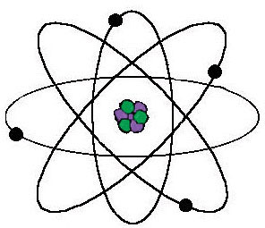
Neutron
Charge:
Mass:

Proton
Charge:
Mass:

Electron
Charge:
Mass:

