Name:
Fruit/Vegetable Battery
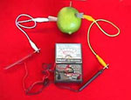
1. Set up your fruit battery.

Place a piece of copper (clean penny) and a piece of zinc (zinc-coated nail) onto opposite sides of any juicy fruit or vegetable.
http://www.scienceproject.com/projects/index/free.asp
Attach a voltmeter to each piece of metal.

Record the voltage and the pH of each fruit below.

Fruit/Vegetable | Voltage | pH

2. Which fruit/vegetable produced the best battery?

3. What are the characteristics of the types of fruits and vegetables that make a battery work?

