Name: ______________________________________ Date: ________________________

Student Exploration: Phases of Water

Vocabulary: boil, condense, density, freeze, gas, liquid, melt, molecule, phase, solid, volume

Prior Knowledge Questions (Do these BEFORE using the Gizmo.)

- A pot filled with snow is left on a hot stove for a while. What would happen? _____________

_________________________________________________________________________

- A phase is a state of matter, such as a solid, a liquid, or a gas. Which phases would you see? Explain. ______________________________________________________________
_________________________________________________________________________

- A phase change is a change from one phase to another. What phase changes would you see in this example? ________________________________________________________
_________________________________________________________________________

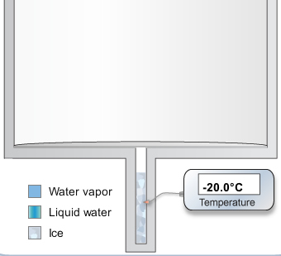
Gizmo Warm-up
In the Phases of Water Gizmo™, you can heat up or cool down a beaker of water.

- Press Heat to heat up the water. Wait until the temperature stops rising and observe. What happens?

________________________________________________

________________________________________________

- Why do you think the lid lifts up? _______________________________________________

_________________________________________________________________________

- Now press Chill to remove thermal energy from the water. What happens now? _________

_________________________________________________________________________

Activity A:  Phases of water | Get the Gizmo ready:  - If necessary, press Chill and wait until the temperature is -20°C. | 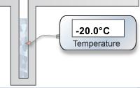

Question: How does temperature affect the phase of water?

- Observe: In the Gizmo, solid ice is gray, liquid water is blue, and water vapor gas is light blue. Heat or Chill the water as needed to reach the temperatures below.

    - What phase is the water in at -20°C? (Circle one): solid liquid gas

    - What phase is the water in at 30°C? (Circle one): solid liquid gas

    - What phase is the water in at 105°C? (Circle one): solid liquid gas

- Hypothesis: How does the temperature affect the phase of water? ____________________

_________________________________________________________________________

- Predict: Predict the phase of water at the six temperatures given below. List your predictions in the Predicted phase row of the table. Then fill in the Actual phase row using the Gizmo.

Temperature | -10°C | 10°C | 50°C | 90°C | 110°C | 120°C
Predicted phase (solid, liquid, or gas)
Actual phase (solid, liquid, or gas)

- Analyze: While testing your predictions, you may have noticed that there were specific temperatures at which the phase of the water always changed.

    - At what temperature does water melt (change from solid to liquid)? _____________
    - At what temperature does water boil (change from liquid to gas)? _______________
    - At what temperature does water condense (change from gas to liquid)? __________
    - At what temperature does water freeze (change from liquid to solid)? ____________

- Extend your thinking: Describe an example of a phase change you’ve seen in real life.

_________________________________________________________________________

_________________________________________________________________________

Activity B:  Comparing phases | Get the Gizmo ready:  - Click Chill until the water is completely frozen. | 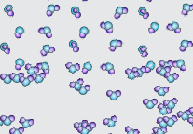

Question: How are the phases of water different from one another?

- Form hypothesis: One of the three phases holds its shape. The other two do not.
    - Based on your experience, which phase has a fixed shape? _____________
    - Which phases have a shape that can change? _____________ and _____________

- Observe: Water is made of small particles called molecules. Use the magnifying glass to see the molecules of ice. Then click Heat to observe the liquid and gas phases. Draw a sketch of the molecules in each phase below.

Solid | Liquid | Gas

- Analyze: Based on your sketches, why do solids have a fixed shape while liquids and gases do not? ___________________________________________________________________
_________________________________________________________________________

- Observe: Another way that phases are different is how they fill a container. Press Chill until the water is completely frozen. Observe the ice without the magnifying glass.

    - Does the ice reach the top of the container, where the lid is? ____________

    - Click Heat until the ice is gone. Does the liquid water reach the top? ____________

    - Click Heat until the water boils. Does the water vapor reach the top? ____________

- Draw conclusions: Which phase always fills its container? ________________
Which phases do not always fill their containers? _______________ and ______________

Extension:  Volume and density | Get the Gizmo ready:  - Press Chill until the water is completely frozen. | 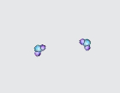

Introduction: The density of a substance refers to how much matter is packed into a particular space, or volume. The denser the object, the more “tightly packed” it is. Objects that are less dense tend to float in denser materials.

Question: How do phases of water compare in volume and density?

- Form hypothesis: Answer the following questions based on your personal experience and the observations you have made of the Gizmo:

  - Does an ice cube in water float or sink? ___________________________________

  - When water boils, bubbles of water vapor form in the water. Do these bubbles tend to rise or sink? _______________________________________________________
  - Which phase of water is densest? ______________ Least dense? ______________

- Observe: Be sure all the water is frozen. Drag an arrow from the left side of the Gizmo to mark the top of the ice. Then press Heat. Watch until all the ice has melted.

  - Does the liquid water take up as much space as the ice? ______________________

  - Wait until all the water has boiled away. Which takes up more space, the liquid water or the water vapor? ___________________________________________________
  - Which phase of water is densest? ______________ Least dense? ______________

(Note: In most substances, the solid phase is densest. Water is unusual.)

- Extend your thinking: Look at all three phases of water through the magnifying glass. How does the spacing of molecules fit with what you found about densities of ice, liquid water, and water vapor?

_________________________________________________________________________

_________________________________________________________________________

_________________________________________________________________________

_________________________________________________________________________

