Soap Lab
Pre-Lab
Soaps have two properties – they are hydrophilic on one end and hydrophobic on the other.

- What does it mean when a molecule is hydrophilic?

- What does it mean when a molecule is hydrophobic?

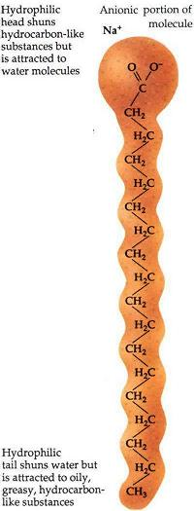

- Put a few drops of oil and a few drops of water into a test tube. Do the water and the oil mix? Draw a picture to explain this.

- Add a drop of soap and mix. Do the water and oil mix now? Draw a picture to explain this.

Lab
- Measure out 12 mL of vegetable oil (liquid lard) and add to a
beaker.
- Measure out 10 mL of ethyl alcohol and add to the beaker.

- Do the liquids in the beaker mix? Why or why not?

- When your hands get dirty, the dirt mixes with the oil from your skin, and water will not wash it off very easily. Considering this, what is the purpose of the oil in the soap?

- Measure out 12 mL of 5 M NaOH (lye) and add to the beaker.

6. What is the purpose of the NaOH?

- Vigorously stir the beaker on a hot plate for 15 minutes.

7. What changes do you observe?

- Add 50 mL of saturated NaCl (salt) and stir.

8. What changes do you observe?

- Let the beaker set until it is dry (leave for a few days
overnight).

9. After you have let the soap set and dry, try it out as you wash your hands. Explain how soap cleans your hands.

10. Detergents are often preferred over simple soaps, explain why.

