Spectroscopy Lab

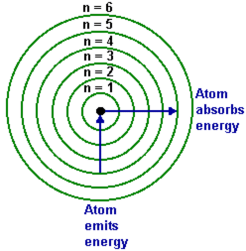
Each atom has its own “spectral fingerprint” produced by excited electrons that “jump” from high to low energy levels.

Large jumps correspond to high energy light (violet end of spectrum).

Small jumps corresponding to low energy light emission (red end of spectrum).

- Record the spectral fingerprint of the following elements. Electricity excites the electrons in these plasmas. Use diffraction glasses to split the overall color into its spectral lines.

Element: Overall color:

Element: Overall color:

Element: Overall color:

- Record the overall spectral color of the following elements. Combustion excites the electrons in these solids.

Element | Color

- Combust a small amount of the unknown element. Which element corresponds to the color produced?

