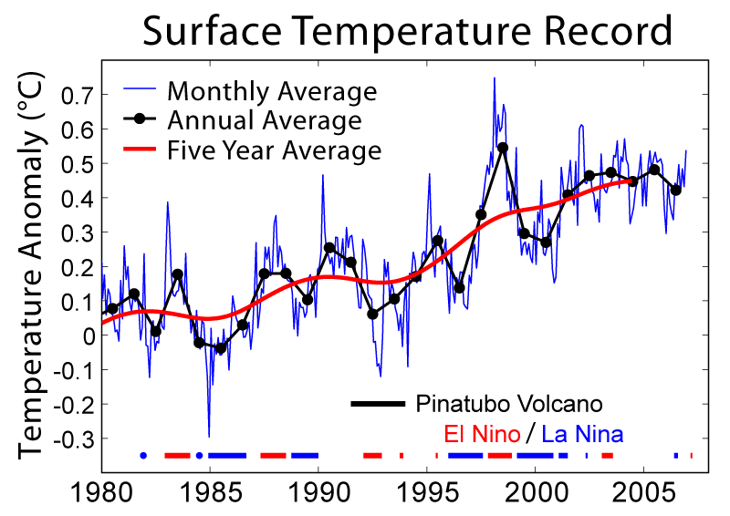Brohan, P., J.J. Kennedy, I. Haris, S.F.B. Tett and P.D. Jones (2006). "Uncertainty estimates in regional and global observed temperature changes: a new dataset from 1850". J. Geophysical Research 111: D12106. doi:10.1029/2005JD006548.
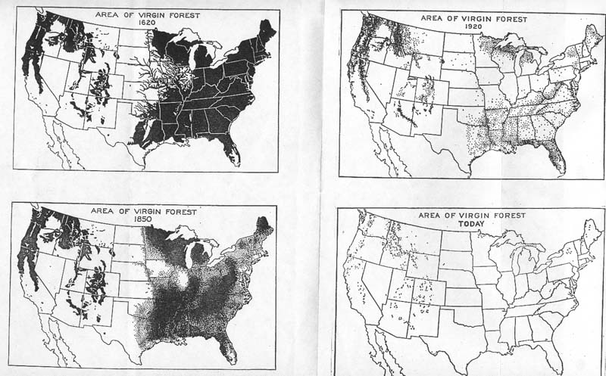

Source of 1620, 1850, and 1920 maps: William B. Greeley, The Relation of Geography to Timber Supply, Economic Geography, 1925, vol. 1, p. 1-11.Source of TODAY map: compiled by George Draffan from road less of an area map in The Big Outside: A Descriptive Inventory of the Big Wilderness Areas of the United States, by Dave Foreman and Howie Wolke (Harmony Books, 1992)
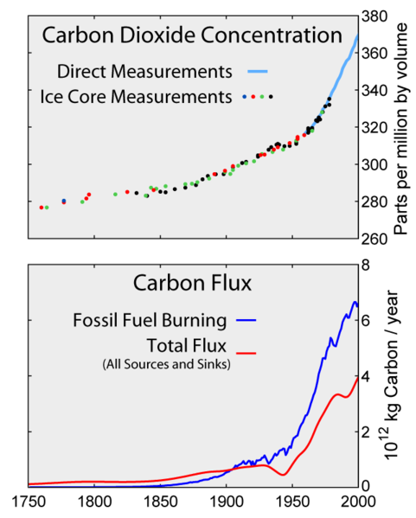

Global Warming Art, Mike Young 08:40, 7 May 2007 (UTC)
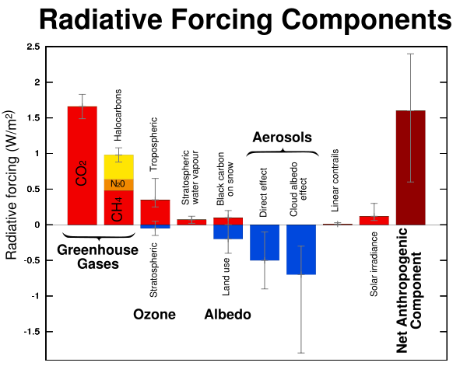
IPCC Working Group I Fourth Assessment Report Summary for Policymakers, page 16.

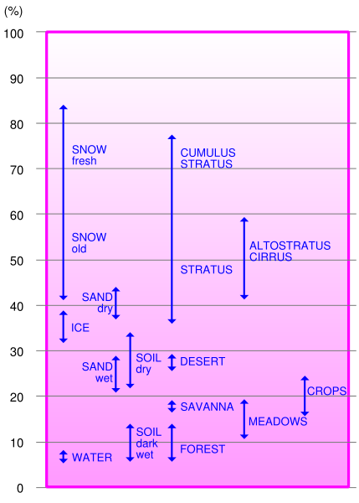
Hannes Grobe, who released it under the Creative Commons BY-SA licence

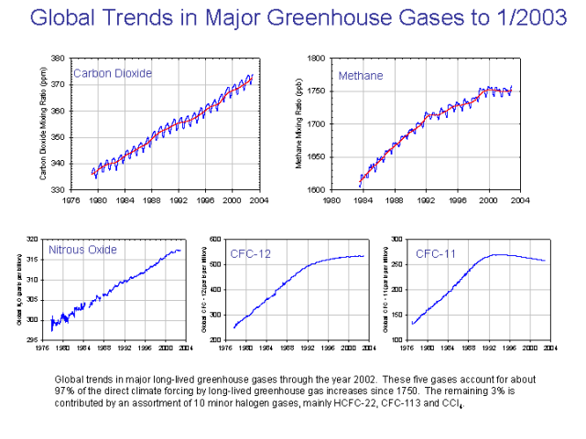
National Oceanic and Atmospheric Administration

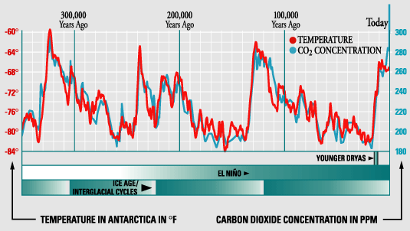
Intergovernmental Panel on Climate Change

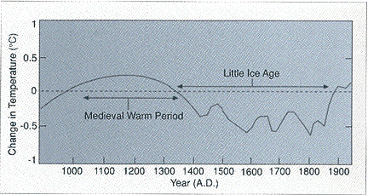
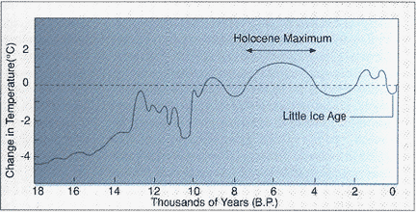
IPCC

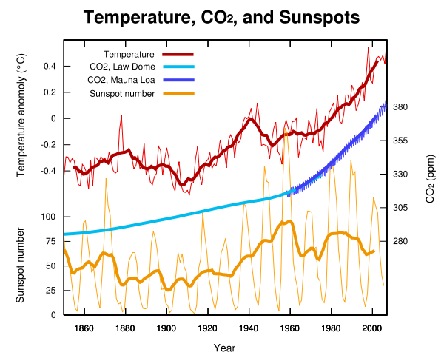
IPCC

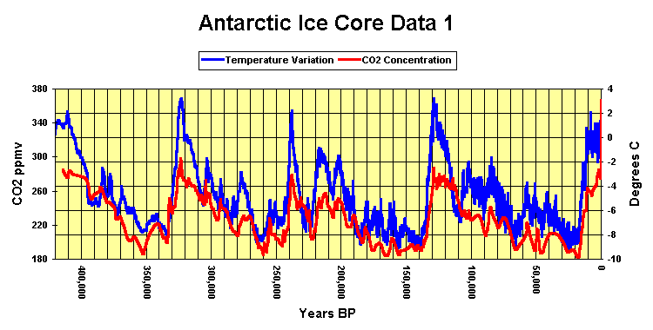
Note on graph presentation: The heavier temperature lines 160,000 BP to present reflect more data points for this time period, not necessarily greater temperature variability.

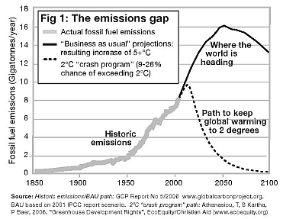

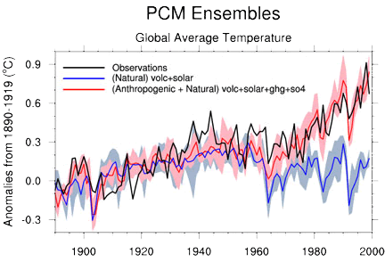
Model results confirm the importance of human-produced emissions in the temperature trends of recent decades. This graphic depicts global average temperature since 1890 as reproduced by the NCAR/DOE Parallel Climate Model. The blue line summarizes simulations performed using only natural influences on climate (volcanoes and solar variations). The red line, from a set of simulations that includes sulfates and greenhouse gases, is much closer to the observed record (black line). The blue and red shading shows the range of results (the model uncertainty) for each group of simulations. (Illustration courtesy Gerald Meehl, NCAR.)

