Name __________________
Acceleration Quiz
Part 1 – Multiple Choice

How fast is fast?
Practice A and B are data tables of a remote control cars speed over 4 seconds of time. Use this data to answer the following questions.

1. _____ In Practice B, how fast was the car going after 3 seconds?

A. 6 meters/ seconds
B. 4 meters/ seconds
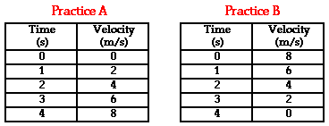
C. 2 meters/ seconds
D. 0 meters/ seconds

2. _____ In Practice A, how long did it take the car to reach 6 m/s?

A. 2 seconds
B. 3 seconds
C. 4 seconds
D. 6 seconds

3. _____ In Practice B, what was the car doing over those 4 seconds?

A. speeding up
B. slowing down
C. keeping a constant speed
D. free falling

4. _____ How would you calculate the acceleration of this car in Practice B?

A. (4s) / 0 m/s
B. (0 – 8 m/s) / 4 s
C. (4s) / 8 m/s
D. (8 m/s – 0) / 4 s

5. _____ What is the acceleration of the car in Practice A?
A. 32 m/s/s
B. 8 m/s/s
C. 4 m/s/s
D. 2 m/s/s

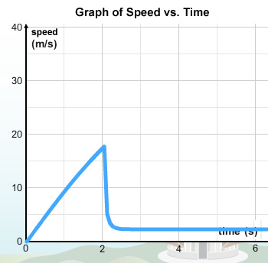
Figure 1.a

Figure 1.b

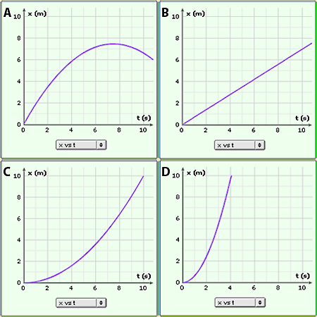
Figure 1.c
Distance vs. time

6. _____ According to Figure 1.b, what is happening to the soccer ball?

A. the ball is moving with a constant speed
B. the ball is slowing down
C. the ball is speeding up
D. the ball is speeding up then stopped

7. _____ Figure 1.a shows the graph of a falling object. What probably happened?

A. At 2 seconds the object fell off of a cliff
B. At 2 seconds a parachute opened on the object.
C. At 2 seconds the object hit the ground and stopped moving.
D. At 2 seconds the object stopped going up and started going down.

8. _____ Which of the graphs, in Figure 1.c, shows an object with a high acceleration?

A. Graph A
B. Graph B
C. Graph C
D. Graph D

9. _____ Using the speed-time graph (Figure 1.a), how fast was the ball moving after 1 second?

A. 1 m/s
B. 5 m/s
C. 10 m/s
D. 20 m/s

10. _____ Using Figure 1.c, which graph shows an object with no acceleration at all?

A. Graph A
B. Graph B
C. Graph C
D. Graph D

Part 2 – Free Response

11. Two people are in an airplane just about ready to do a sky dive.

- The first man jumps and his parachute does not open. He accelerates at
10 m/s/s for 4 seconds before the parachute opens. How fast is he going just before the parachute opens?

- A woman then jumps with an open parachute, and she has a constant velocity of
5 m/s. How long will it take her to fall a distance of 15 m?

- Draw a dot map for the motion of the man and the woman after they jump.
man woman

12. Two balls are dropped on the moon (there is very little air resistance). One ball weighs
1 lb and the other ball weighs 5 lbs. Will the balls land at the same time? Why or why not?

- Two sets of coffee filters are dropped on earth. One set of coffee filters is heavier than the other, but they both have the same size and shape. Will the filters land at the same time? Why or why not?



Part 3 – Reflection

Multiple Choice; Reflection
I missed question # ________ because I answered letter ______.

The reason that I picked that answer is because I thought

Now, I think the correct answer might be __________ because

I missed question # ________ because I answered letter ______.

The reason that I picked that answer is because I thought

Now, I think the correct answer might be __________ because

I missed question # ________ because I answered letter ______.

The reason that I picked that answer is because I thought

Now, I think the correct answer might be __________ because

I missed question # ________ because I answered letter ______.

The reason that I picked that answer is because I thought

Now, I think the correct answer might be __________ because

I missed question # ________ because I answered letter ______.

The reason that I picked that answer is because I thought

Now, I think the correct answer might be __________ because

