Free Fall Stations Lab

Station 1 Mass
- Have the same person hold the steel ball and the baseball in one hand. Drop them carefully onto the carpet. What do you notice about their fall times?

- Does your observation agree with what you have experienced in real life? Explain.

Station 2 Velocity and Time
- Hold a steel ball 20 centimeters above the clay and drop it. Do the same thing again, but at a height of 80 centimeters. Which height resulted in the deepest dent?

- What does the deepest dent suggest about the velocity of the ball before it hit the clay? Explain.

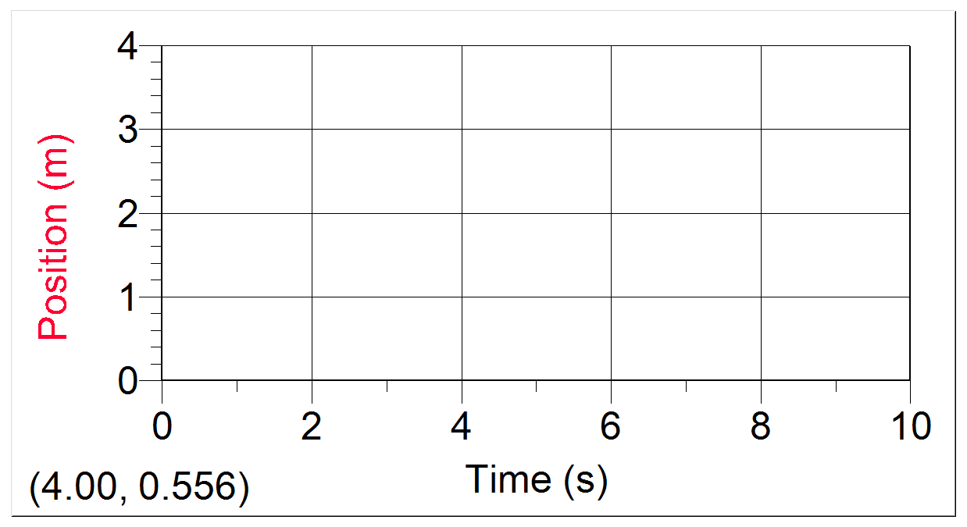

Station 3 Position Graph
- Put the cart right next to the motion detector. Hit the record button, and let the cart go. Sketch the graph to the right.

- Describe what happens to the position of the cart as time goes by. Be detailed!
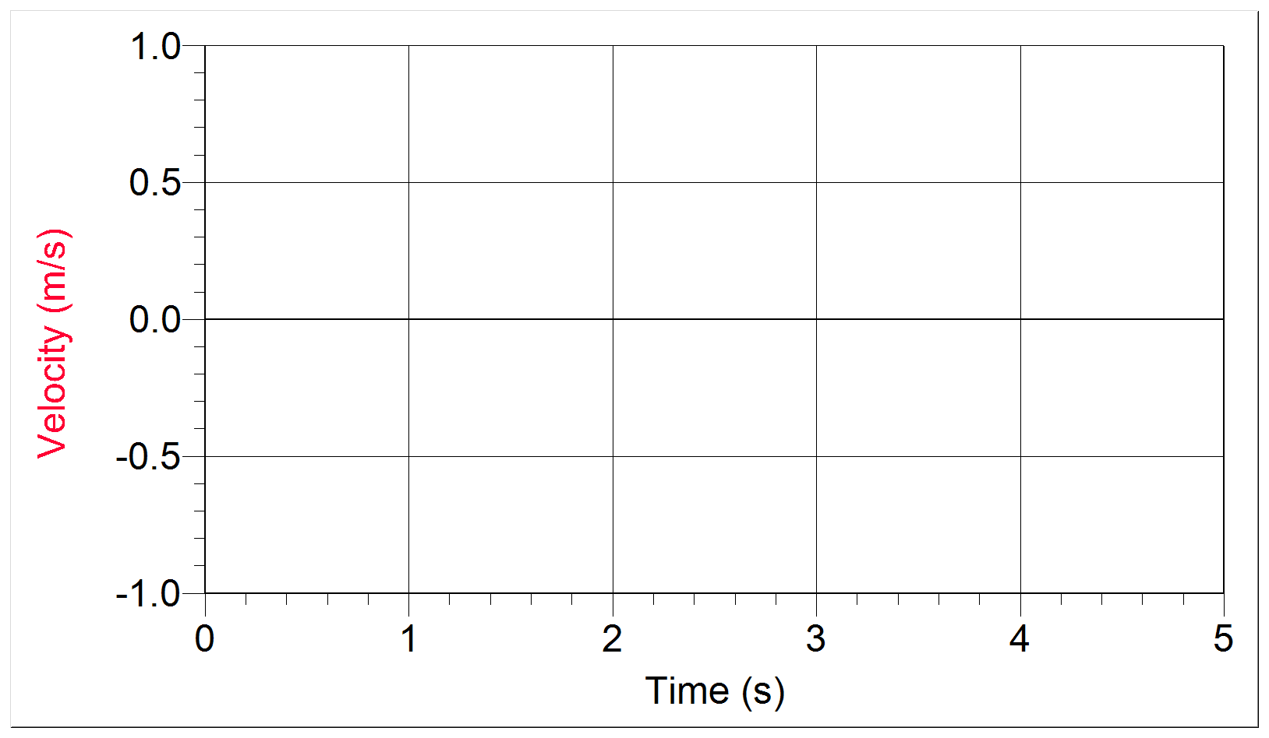
Station 4 Velocity Graph
- Put the cart right next to the motion detector. Hit the record button, and let the cart go. Sketch the graph to the right.

- Describe what happens to the velocity of the cart as time goes by. Be detailed!

Station 5 Friction Test: Shape
- Drop a single coffee filter from shoulder height. What do you notice about its speed on the way down?

- Take another coffee filter and change its shape. Explain how its falling speed compares to a regular coffee filter.

Station 6 Friction Test: Size
- Drop a set of regular coffee filters (having the same mass as the maxi coffee filter) and one maxi coffee filter. What do you notice about their falling speeds?

- Explain why their falling speeds are different.
Station 7 Friction Test: Mass
- Drop the following: 1 coffee filter, 3 coffee filters (stacked), and 9 coffee filters (stacked). What do you notice about their falling speeds?

- Explain how this situation is different from the two balls at station 1.

Station 8 Friction Test: Viscosity
- Watch the metal ball as it falls down the length of the test tubes filled with water or soap. Time the fall of each, and record here:

Water: Soap:

- Does this demonstration relate to objects falling in air? Explain why or why not.

Summary Questions
- When objects fall, their velocities increase / decrease.

- When there is not much friction between a falling object and the air surrounding it, does not slow it down that much.

- When there is lots of friction between a falling object and the air surrounding it, , , and can slow it down a lot.

