Graphs and Motion Worksheet

Learning Target: Relate descriptions of motions to graphs and graphs of motion to description for both constant velocity and uniformly accelerated motion.

Constant Velocity Motion – Complete the corresponding graph, and provide a written description.

Distance-time graph | Velocity-time graph | Written Description
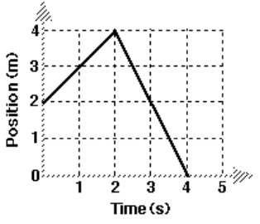 | 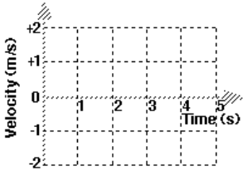
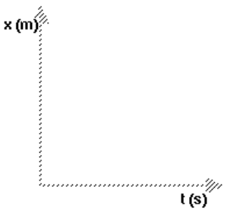 | 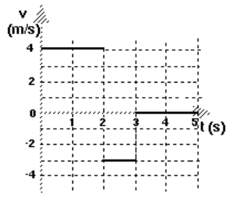

Uniformly Accelerated Motion (distance as a function of time for acceleration down an incline)
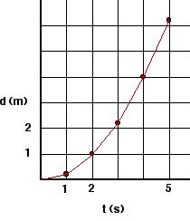
Explain how you can obtain velocity at t = 3 seconds from the graph to the left. Find the speed, and show your work.

