Name _____________________
Motion Test

- Which pendulum to the right has the longest period? A B C

- A
- B
- C

- Which of the following has a significant influence on the period of a simple pendulum?

- mass
- amplitude
- length
- Misleading – all three have a significant impact on the period of a simple pendulum.

Complete each row providing the two missing components; use pencil to make graph drawings.

Distance-time graph | Velocity-time graph | Written Description
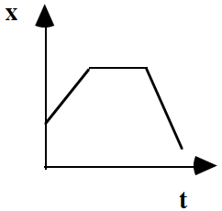 | 3. | 4.
5. | (Note 3 horizontal graph segments.)  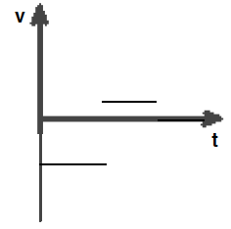 | 6.
7. | 8. | An object moves with constant positive velocity for 4 seconds. Then, it stops for 2 seconds and returns to the original position in 2 seconds.
Questions 9, 10, and 11 relate to the following graph showing uniformly accelerated motion.
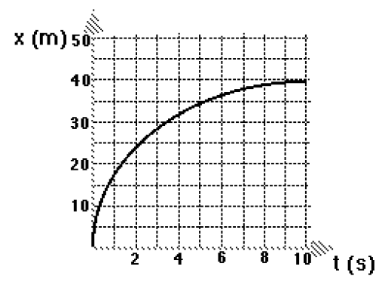
- Give a written description of the motion of this object.

- Explain how you could determine the instantaneous velocity of the object at t = 2 s.

- Assume the initial velocity was 50 m/s, determine the acceleration of the object.

- A car, initially at rest, accelerates at a constant rate of 4.0 m/s² for 6 s. How fast will the car be traveling at t = 6 s?

- A tailback initially running at a velocity of 5.0 m/s becomes very tired and slows down at a uniform rate of 0.25 m/s². How fast will he be running after slowing down for 4 seconds?

- Which of the following is NOT accelerating?

- a car moving at constant velocity
- a car moving around in a circle at constant speed
- both responses a and b
- Misleading – both a and b are accelerating

Part 3 – Reflection

Multiple Choice; Reflection
I missed question # ________ because I answered letter ______.

The reason that I picked that answer is because I thought

Now, I think the correct answer might be __________ because

I missed question # ________ because I answered letter ______.

The reason that I picked that answer is because I thought

Now, I think the correct answer might be __________ because

I missed question # ________ because I answered letter ______.

The reason that I picked that answer is because I thought

Now, I think the correct answer might be __________ because

I missed question # ________ because I answered letter ______.

The reason that I picked that answer is because I thought

Now, I think the correct answer might be __________ because

I missed question # ________ because I answered letter ______.

The reason that I picked that answer is because I thought

Now, I think the correct answer might be __________ because

