Speed and Acceleration Lab

Learning target: Find the relationship between speed (s), acceleration (a) and time (t) using an inclined plane to “dilute” the effect of gravity on a falling object.

- When an object such as a ball is dropped, does it fall at a constant speed (ignoring friction)? yes no

- What do we call this changing speed with time? ______________________

- Roll a small car down an inclined plane and study how speed changes with the release angle. If the angle is smaller, the acceleration will be ( higher / lower ). If the angle is larger, the acceleration will be ( higher / lower ).

Acceleration ramp only

- Using blocks of wood under a pair of two closely-spaced table legs, set a small angle for your ramp and keep it constant during the experiment. All groups should be the same.

- Calculate the acceleration of your car down the acceleration ramp due to gravity. It can be determined from knowledge of acceleration due to gravity which is 9.8 m/s² for a freely falling object, the rise (equal to the height of the blocks under the table legs minus any height added to overcome the force of friction), and the run (distance between blocked and non-blocked table legs).

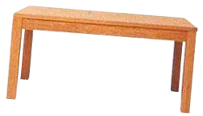
run
rise

In this case, acceleration = 9.8 m/s² x (rise/run) = _____________________

- Using a stopwatch, make 5 timed trials to determine how long it takes the car to roll down the length of the acceleration ramp. Record and average your results and place that information in the spaces below.

 | Trial #1 | Trial #2 | Trial #3 | Trial #4 | Trial #5 | Average
 | s | s | s | s | s | s

Constant speed ramp only

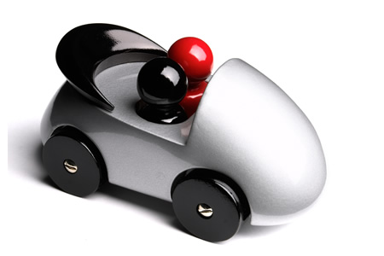
time

distance

- Using a stopwatch, make 5 timed trials to determine how long it takes the car to roll down the length of the constant speed ramp. Record and average your results and place that information in the spaces below.

 | Trial #1 | Trial #2 | Trial #3 | Trial #4 | Trial #5 | Average
 | s | s | s | s | s | s

- Determine the speed of the car as it moves along the constant motion ramp. Using distance and time for the constant motion ramp, find the speed. Recall that speed equals distance divided by time.

Speed = distance / time = _________ /__________ = ____________

Putting it all together

- Collect data from other groups so that you have a complete set of speeds, accelerations, and times. Complete the table below and find the average values of the second, third, and fourth columns.

Group | Speed on constant motion ramp (from step 8) | Acceleration down inclined plane (taken from step 5) | Time on inclined plane (taken from step 6)
a. | m/s | m/s² | s
b. | m/s | m/s² | s
c. | m/s | m/s² | s
Ave. | m/s | m/s² | s

- Carefully review the average data in the table of step 8. State the apparent relationship between speed, acceleration, and time, and then write this mathematical relationship in terms of s, a, and t only in the box below.

