Weight versus Mass Graphing Notes

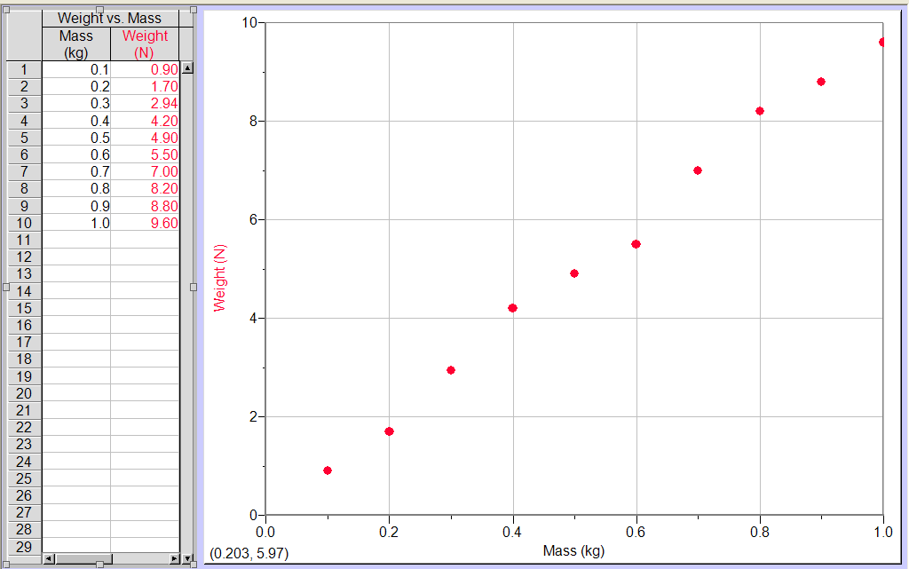
1. Draw a best-fit line through the data points.

2. Write a sentence describing the relationship between mass and weight.

________________________________________________________________________

3. What is the general equation of a line?

4. Replace the "x" and the "y" in your basic math equation in question #3 with the names of the variables you graphed.
______________________________________________

5. What is the value and units of your slope? Show work below.

6. What is the meaning of your slope?

7. Replace "m" in your basic equation in question #3 with the value and unit from question #4.

______________________________________________

8. What is the value and unit of your y-intercept? ________

9. What does the y-intercept on your graph represent?

10. Re-write the equation of the line using the real variables and making sure your numbers have units.
______________________________________________

