Buoyancy Technical Notes

From where does buoyancy originate? The answer rests in the fact that pressure in a fluid increases with depth. We’ve all had experiences to show this to be true. When an airplane approaches a runway, the pressure on our eardrum increases. When we descend deeper into water, the pressure on our eardrum similarly increases. The pressure in non-compressible fluid (like water) is directly proportional to the depth. $P=ρ\text{gh}$ where rho is the density of the fluid, g the acceleration due to gravity, and h the depth.

This pressure difference with depth can be demonstrated with a “spouting cylinder” such as the one shown below. Once filled with water, water will squirt out of each of the three holes on the side of the cylinder. Water from the bottom hole will squirt the farthest because it is under the most pressure.

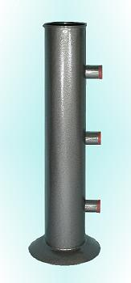

You can make your own spouting cylinder out of a 2-liter soda bottle by punching three holes in its side – one near the bottom, one about ¼ way up, and one about ½ way up.

If an object is immersed in a fluid, the pressure on the bottom surface is greater than it is on the top surface. The difference in these pressures results in a net upward force.

Like pressure at depth, the buoyant force depends upon three factors. $F_{B}=ρ\text{Vg}$ where rho is the density of the liquid in which an object is immersed, V the submerged volume of an object either floating or sinking in that fluid, and g the acceleration due to gravity.

