Name

Bicycle Race Worksheet
1. Bicyclists Anna (A) and Bob (B) plotted their motion on a position graph.

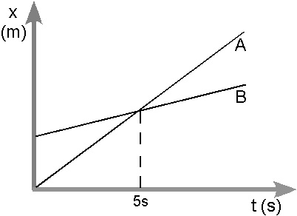

a. Do the cyclists start at the same point? How do you know? If not, which is ahead?

b. After 7 seconds, which cyclist is ahead? How do you know?

c. Which cyclist is travelling faster at the 3 second mark? How do you know?

d. Do they ever have the same speed? How do you know?

e. What is happening at the intersection of lines A and B?

2. Consider the new position graphs for Anna and Bob below.

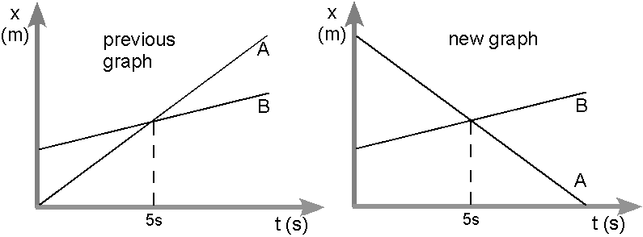

a. How does the motion of Anna in the new graph compare to her motion in the previous graph?

b. How does the motion of Bob in the new graph compare to his motion in the previous graph?

c. Which cyclist has the greater speed? How do you know?

d. Describe what is happening at the intersection of lines A and B.

e. Which cyclist traveled a greater distance during the first 5 seconds? How do you know?

