Tumble Buggy Lab #1 – Distance versus Time
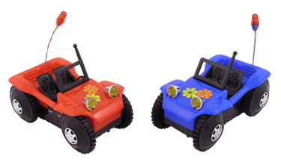
You and your partner each have one tumble buggy. Your goal is to find out the speed of each tumble buggy.

- What do you need to know about each tumble buggy to get its speed?

- Turn on and set down each tumble buggy. Which one do you think has a higher speed? Explain how you know.

- Collect at least 6 pieces of data for each tumble buggy.

RED BLUE
Distance (cm) | Time (s) |  | Distance (cm) | Time (s)
- Use a red and a blue marker to plot your data on the same graph.

- Using a ruler and a pencil, draw a best-fit line for each set of your data.

- How many centimeters did the red car travel in one second? Explain how you got this number.

- How many centimeters did the blue car travel in one second? Explain how you got this number.

- If the blue car were to travel for 10 seconds, how far away would it be from the starting line? Show your work.

- If the red car were to travel for 10 seconds, how far away would it be from the starting line? Show your work.

- How many second would it take the red car to travel a distance of 3 meters? Show your work.

