Graphing Quiz

On the incomplete graph below is plotted the data for the total cost in dollars and the number of toppings on a pizza.
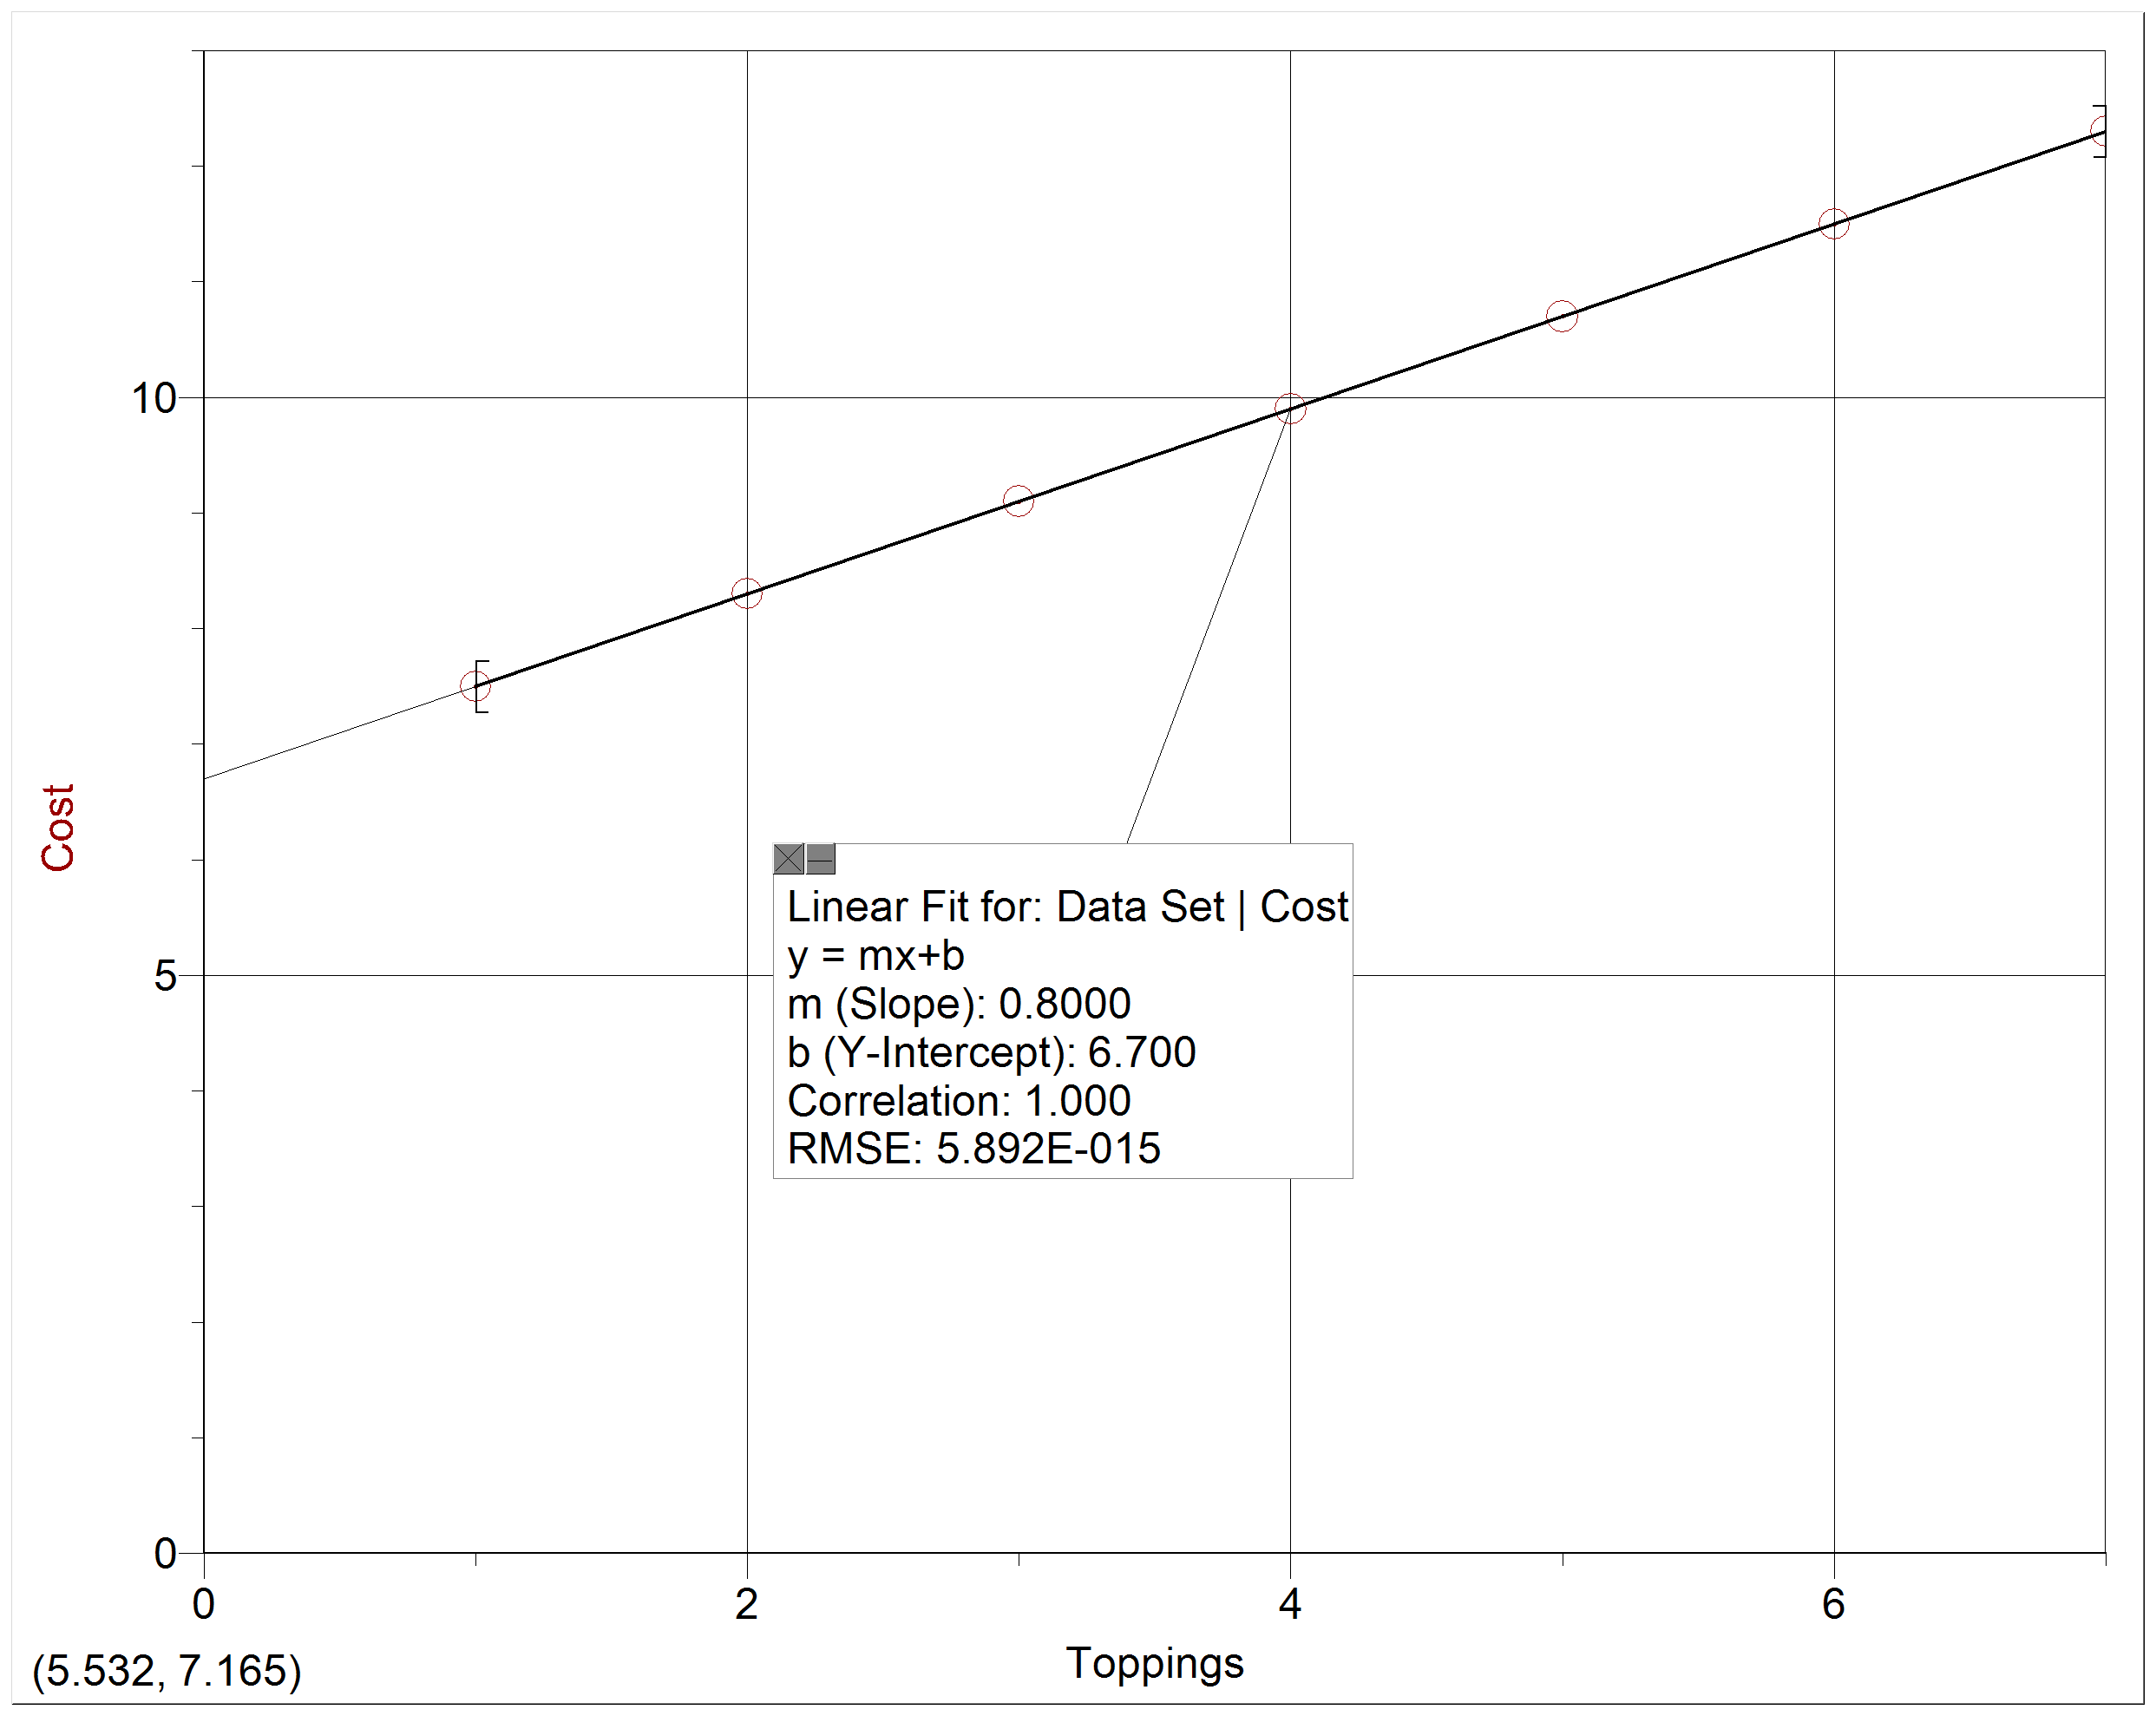
- Complete the graph by placing an appropriate unit in parentheses next to each label.

- Describe in words the relationship between the cost and number of toppings on a pizza.

- Which of the following would be an appropriate title for the graph?
- Toppings vs. Cost
- Cost vs. Toppings
- # vs. $
- $ vs. #

- What is the value of the slope and unit of this graph?

- What is the meaning of the slope of this graph? Be specific.

- What is the value and unit of the y-intercept of this graph?

- What is the meaning of the y-intercept of this graph? Be specific.

- What is the full mathematical model for this graph? Use y = m x + b and substitute the labels, slope, y-intercept, and appropriate units.

- How much would the Meat-Supreme, a 9-topping pizza cost? Show your work or explain how you got your answer.

- What is wrong with the graph below? List at least two problems, and explain how it needs to be corrected.

