Metals and Non-Metals Notes

- Describe how you think a metal is different from a non-metal.

- Look at the metals in your tray. What similar properties do they share? List them in the “metals” box. Then list properties of non-metals.

Metals | Non-Metals

- Use the multimeter, liquids, and other tools provided to you by your teacher. Perform some tests to see if you can find any other differences that what you listed above.
- Where are the metals located on the periodic table? Describe where they are on the table, then color metals red.

- Where are the non-metals located on the periodic table? Describe where they are found on the table, then color non-metals blue.

- Where are the semi-metals located on the periodic table? Describe where they are found on the table, then color semi-metals yellow.

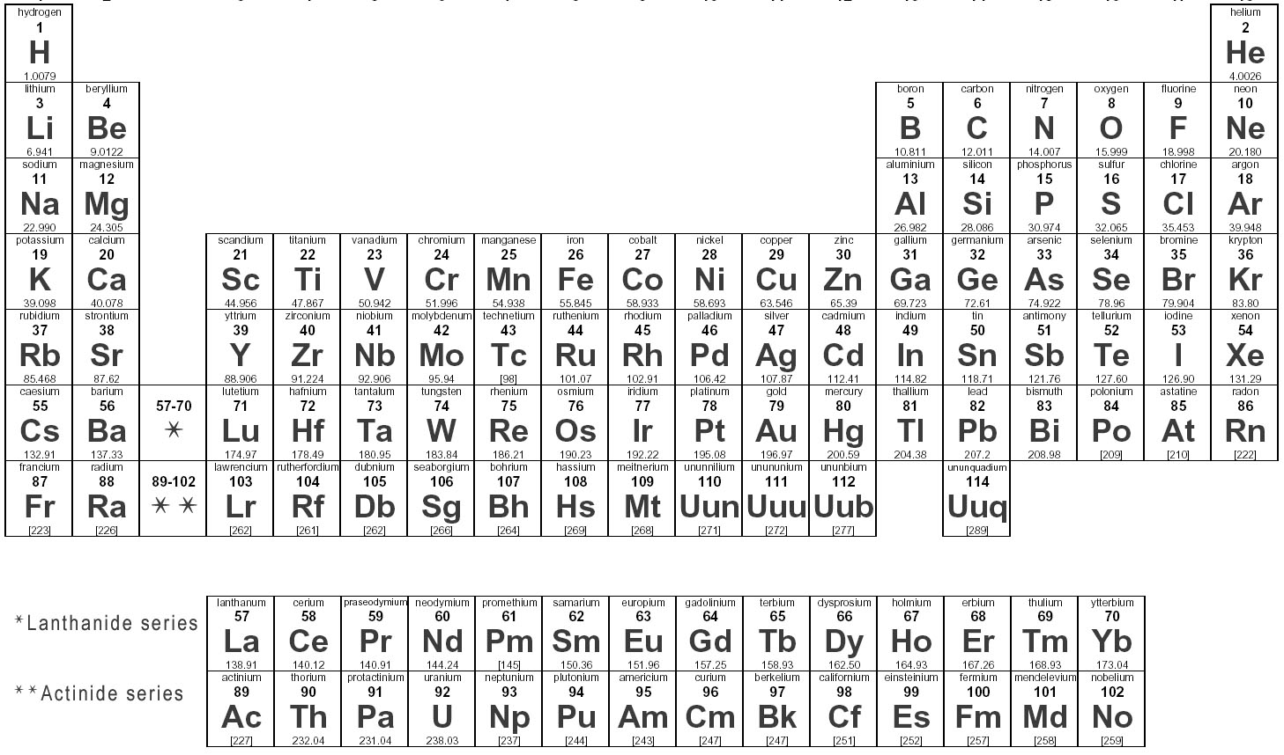

- Think back to what you know about atoms. What chemical property makes metals different from non-metals?

