Physical Science
Inclined Planes Activity

LT: Explain how inclined planes make work easier.

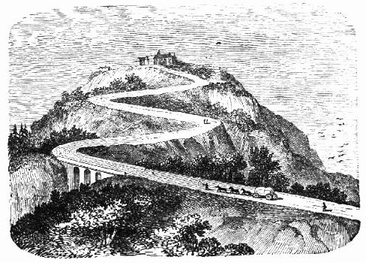
Inclined planes are useful in many areas of our lives, and actually make up wedges and screws, two other simple machines.

The most common place we see inclined planes is in roads:

"When roads are to be made over steep hills, they are sometimes constructed around the hill, like the thread of a screw , or in a winding manner as shown in the [figure at the right]. The road from Callao to Lima, in South America, is said to be one of the longest and best-made inclined planes in the world. It is six miles in length, and the total rise is 511 feet." -- from J. Dorman Steele, Fourteen Weeks in Natural Philosophy, New York, A. S. Barnes, 1869), pp 93-94
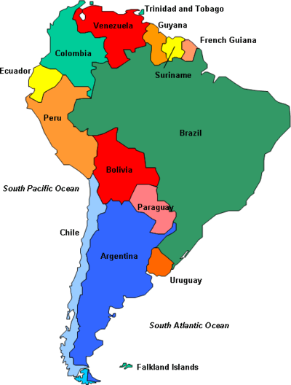
- Explain why the road from Callao to Lima is so long.

- Look back in your notes. How do you calculate the mechanical advantage of an inclined plane?

- Six miles is about 30,000 feet. The total rise in the road is about 500 feet. What is the mechanical advantage of this road? Show how you got your answer.

In this lab, you will practice calculating mechanical advantage and see how inclined planes make work easier.

- Measure the length of the inclined plane: cm

- Angle your track, as shown. Measure its height and the force that you need to hold the cart and keep it from sliding downward.

Example Diagram | Height (cm) | Force (N)
Horizontal
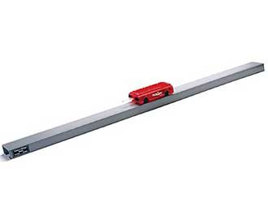
Shallow Angle
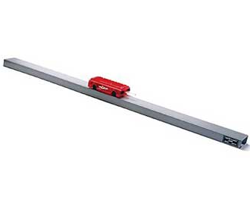
Medium Angle
Steep Angle
Vertical

- Calculate the mechanical advantage for each of your situations.

Example Diagram | Math | Mechanical Advantage
Horizontal
Shallow Angle
Medium Angle
Steep Angle
Vertical

- Look back in your notes. How do you calculate the total amount of work done with a simple machine?

- How much work would you do to pull the cart up the ramp when it is at a steep angle? Show your math.

Summary Questions

- As the angle of an inclined plane decreases, the force ,

the height , and the mechanical advantage .

- When thinking about simple machines, you could say that there is always a “trade off.” What do you think this means?

