Pulleys Stations Lab

Learning Target: Explain how pulleys make work easier.

Pulleys are very helpful. They have been used by many ancient cultures to lift objects – most especially on sail boats to lift heavy sails.

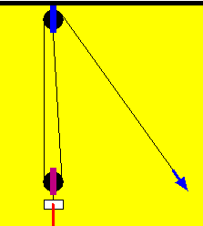
Pulleys work on the principle of “support strings.” Support strings are parts of the pulley string that hold weight up.

- Look at the arrow on the picture to the right. Is this part of the string a support string? Why or why not?

- Label the number of support strings under each figure below.
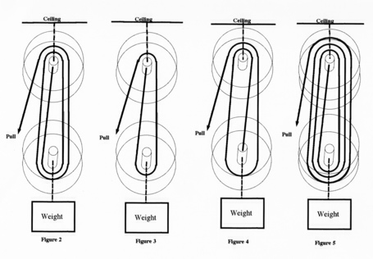

_______ _______ _______ _______

For each station, record the amount of force you needed to lift the 5 N load.

Station | # of Support Strings | Force (N) | Length (cm) (needed to pull on string to lift weight about 5 cm off the table)
Station A: No Pulley

Station B: Single Fixed

Station C: Single Moveable
Station D: Single Fixed, Single Moveable
Station E: Single Fixed, Double Moveable
Station F: Double Fixed, Double Moveable
Station G: Double Fixed, Triple Moveable

Analysis Questions
- Compare your required lifting force for Station A (no pulley) and Station B (single fixed). How are they different? Explain your answer.

- Compare your required lifting force for station B (single fixed) and Station C (single moveable). How are they different? Explain your answer.

- What happens to the force needed when you have only 1 support string compared to 5 support strings?

- Mechanical advantage (MA) is the word used to describe how many times easier it is to do work because of simple machines. What is the mechanical advantage of 3 support strings?

- In general, what happens to the required lifting force if you use more support strings?

- Compare the length you had to pull on the string to lift the weight off the table for stations B and G.

Summary Questions

- Complete the following sentence:

As the number of support strings increases,

.

- Bales of hay are often lifted by hand to the second floor of barns where they are stored. A common bale may have a mass of 200 N. How many support strings would a farmer need to decrease the lifting force to just 40 N? Show your math work or explain your answer.

