How We Know the Earth Rotates Name:
Foucault’s Pendulum

Materials for each group of students: 6 soda straws (straight, non-flexible)
8 inches of string
12 paper clips (to fit ends of straws)
1 large nut, several washers, or a big fishing weight

Definitions: rotate – to spin on one’s axis; revolve – to orbit another other object.

1) If you watch the sky for a few hours, you will clearly see that sun, moon, and stars rise in the eastern sky and set in the western sky. This is NOT proof that the Earth spins; these motions would be the same for two reasons. Please state the second reason:

a) Earth spins on its axis.

b)

2) Which of the two reasons is better for explaining what is observed sky motions?

3) What evidence do you have for supporting this choice?

A French scientist, Jean Foucault, in 1851 came up with evidence to support the rotation of the Earth rather then the revolution of the Sun, Moon, and stars around the Earth.
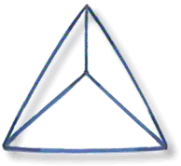
Follow these directions to reproduce his classical experiment called the Foucault pendulum: Obtain 12 paper clips and hook them together in groups of three. Using six straws, construct the pyramid as shown to the left employing the four sets of hooked paper clips to hold the pyramid together at its “vertices”. Using a sting, suspend a substantial weight from the top of the pyramid.
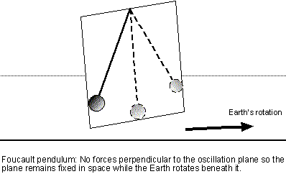
Rest your pendulum on your desk, the floor, or some other level surface. Pull the suspended weight back and let it go. Notice that the pendulum (the weight and string) swings back and forth in the same plane if you release it without imparting a “spin” that produces an oval motion. Practice carefully, releasing the pendulum so that it moves in a plane as shown in the figure to the right.
Notice how the plane of motion remains fixed in space even as the pendulum slowly loses energy. Note this direction carefully with respect to the level surface upon which the pyramid rests.

4) Start the pendulum again, and again note the direction of its motion. Slowly turn the base of the pyramid and note the direction of the pendulum’s motion. Does the pendulum continue moving pretty much the same plane or does it change direction along with the pyramid?

A basic property of pendulums is that once set in motion, they continue to swing in the same direction even if the support structure turns.

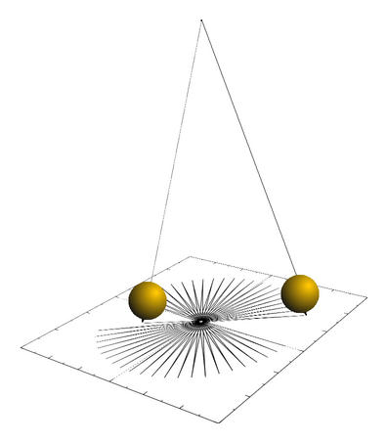
Imagine that you are located at the North Pole of planet Earth and set a long and very heavy pendulum swinging. As the pendulum swings, it drops a trail of sand. With the passage of time, the pendulum continues its swinging motion and lays down a sand pattern similar to that show in the figure to the left.

5) Based on your knowledge and observations of the Foucault pendulum, write a paragraph to explain what must have happened.

6) How could a Foucault pendulum at the North Pole be used to tell time?

