Ocean Tides! Be the Astronomer I Name:

Have you ever seen ocean tides? If you have never travelled to the ocean, you probably have only seen tidal phenomena in photographs. Below are two photographs showing a Canadian village at both low tide (top) and high tide (bottom). The ocean is in the distance.

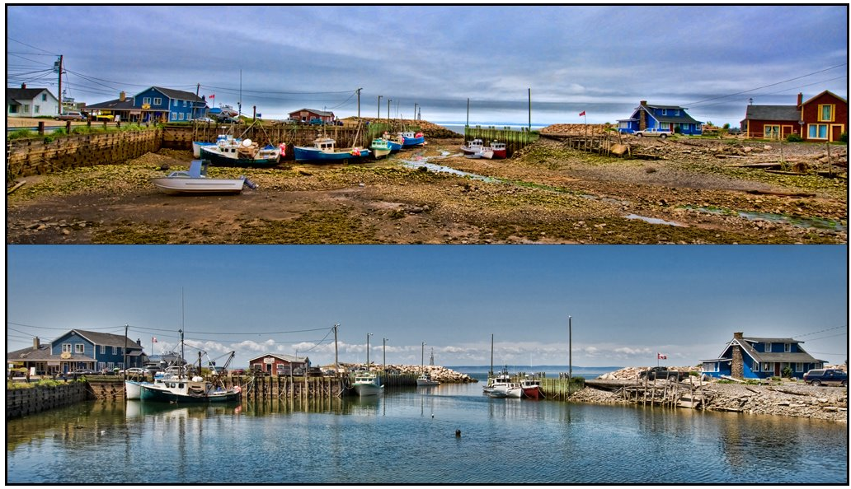

For centuries, people who have lived and worked near seacoasts have understood the importance of being able to predict tides and tidal currents. Low tides can prevent ships from entering harbors, while high tides can make it impossible for ships to pass beneath low bridges. Tidal currents can significantly increase the speed of a vessel, or can carry it into dangerous waters. Boaters who anchor near shore can find themselves stranded by a falling tide. Fishermen throughout the world have learned that catches are likely to be much larger during certain portions of the tidal cycle than others.

Both seamen and astronomers have long wondered about the cause of tides. Isaac Newton (1642-1727), the scientist best know for his laws of force and gravitation, wrote a whole book about tides. The purpose of this book was to explain the causes of tides thereby allowing navigators to accurately predict the occurrence of high and low tides at any one place. In this activity, you will “make observations” and use actual data from the Eastern Seaboard to generate a hypothesis (an initial explanation) about the cause of ocean tides.

- Examine the two pictures of the Canadian coastal village. What differences do you see between the top (low tide) and bottom (high tide) pictures?

- What do you think happens to the ocean current at the entrance of this harbor when going from high tide to low tide and from low tide to high tide?

- High to low:

- Low to high:

- What do you think might be responsible for these changes? List as many reasonable explanations as you can think of.

It’s really hard to tell which of the above suggestions – or those of your classmates – might be responsible for the tidal variation seen in these pictures. In order to explain certain natural phenomena, it is often best to collect data to see if there is any sort of regularity or pattern in the changes. These changes might then be connected with other regularities or patterns observed elsewhere in nature and a link between the two (or more) firmly established.

Below are some typical data relating to tidal variations at St. Andrews in Passamaquoddy Bay on Canada’s east coast. You will use these data to begin your study of tides. Note that St. Andrews experiences some of the greatest tidal variations in the world. In many places, the tidal variations are so small as to be difficult to measure accurately.

Date | Time - AST (Atlantic Standard Time)
Hour | 00 | 01 | 02 | 03 | 04 | 05 | 06 | 07 | 08 | 09 | 10 | 11
Dec. 19 | 4.9 | 3.8 | 2.8 | 1.9 | 1.5 | 1.9 | 2.8 | 4.0 | 5.2 | 6.3 | 6.7 | 6.4
Hour | 12 | 13 | 14 | 15 | 16 | 17 | 18 | 19 | 20 | 21 | 22 | 23
2010 | 5.5 | 4.4 | 3.1 | 1.9 | 1.1 | 1.1 | 1.8 | 2.9 | 4.2 | 5.4 | 6.2 | 6.3

Using a sheet of graph paper and the data from the Saint Andrews tide table, plot the hourly variation of tide height (given in meters where 0 meters represents the average low tide for the location). Once you have plotted your points, draw a smooth curve through all of them and answer the following questions:

- How many low tides are there on a typical day?

- What is the average height of the low tides (in meters) on this day?

- How many high tides are there on a typical day?

- What is the average height of the high tides (in meters) on this day?

- What is the range of tidal variation today (average high minus average low)?

In meters: In feet:

- What are the approximate times of low and high tides on this date?

1st low tide: 1st high tide:

2nd low tide: 2nd high tide:

- What is the average length of time between low tide and high tide on a typical day expressed in decimal hours?

Time difference between 1st low and high tide:

Time difference between 2nd low and high tide:

Average time difference:

- What is the average length of time between the times of two successive low tides?

- What is the average length of time between the times of two successive high tides?

Ocean Tides! Be the Astronomer II Name:

In the first part of this activity, you used tide data for only one day to determine several time intervals. If you compared your results with your classmates, you probably found that there is a bit of disagreement about your values. This is the problem with collecting just a small amount of data. If you were able to collect more data over a period of the next several days, you would have gotten a much better graph and averages. Here is what your graph and data might look like had you done this:
Source: http://www.mobilegeographics.com:81/locations/6063.html

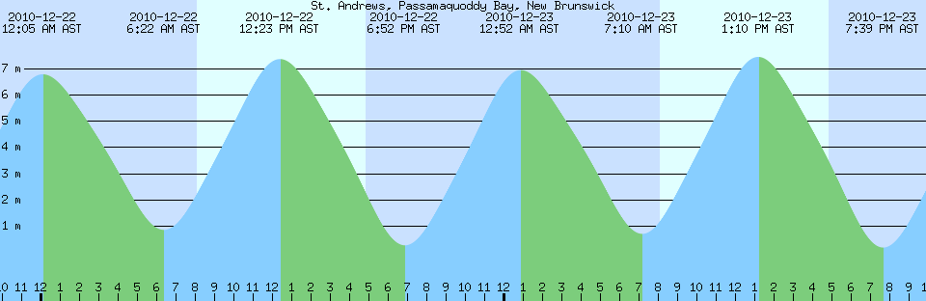
 | 1st High Tide* | 1st Low Tide* | 2nd High Tide* | 2nd Low Tide*
Wed 22 | 0:05 AST / 6.78 m | 6:22 AST / 0.84 m | 12:23 AST / 7.36 m | 18:52 AST / 0.25 m
Thu 23 | 0:52 AST / 6.94 m | 7:10 AST / 0.69 m | 13:10 AST / 7.44 m | 19:39 AST / 0.16 m
Fri 24 | 1:39 AST / 7.03 m | 7:58 AST / 0.62 m | 13:59 AST / 7.41 m | 20:27 AST / 0.19 m
Sat 25 | 2:28 AST / 7.05 m | 8:49 AST / 0.63 m | 14:49 AST / 7.28 m | 21:17 AST / 0.31 m
Sun 26 | 3:18 AST / 7.02 m | 9:41 AST / 0.70 m | 15:41 AST / 7.07 m | 22:09 AST / 0.49 m
Mon 27 | 4:11 AST / 6.96 m | 10:36 AST / 0.80 m | 16:36 AST / 6.82 m | 23:03 AST / 0.70 m
Tue 28 | 5:07 AST / 6.89 m | 11:34 AST / 0.88 m | 17:34 AST / 6.60 m
* This table uses a 24-hour clock where 0:00 corresponds to midnight. Any hours less than 12:00 (noon) correspond to the AM hours; any hours greater than or equal to 12:00 (noon) correspond to the PM hours (e.g., 15:00 = 3:00 PM).

You will now work cooperatively in small groups to answer the following questions:

- Group 1: What is the average time delay between successive 1st high tides?

- Group 2: What is the average time delay between successive 1st low tides?

- Group 3: What is the average time delay between successive 2nd high tides?

- Group 4: What is the average time delay between successive 2nd low tides?

- Group 5: What is average length of time between successive 1st and 2nd low tides?

- Group 6: What is average length of time between successive 1st and 2nd high tides?

It has long been suspected that the moon and sun are the causes of the tides to greater and lesser degrees. The question is, do the moon and sun have any regularities or patterns of motion that occur with the same periodicity as the tides? Consider the following information.

- Period of time between two successive passes of the sun across the sky: 24 h
- Period of time between two successive passes of the moon across the sky: 24h, 50m
- Period of moon’s orbit around the earth with respect to the stars: 27.3 days
- Period of full set of moon phases – full moon to full moon: 29.5 days

- Which of the above periods appears to be most closely associated with the tides? Explain your reasoning.

If you said the time period between two successive passes of the moon across the sky you are correct. The moon’s gravity pulls on the oceans of Earth producing a bulge in the general direction of the moon. But a problem remains with this explanation. How is it possible for the moon to produce two high tides and two low tides each day?

- On the drawing below you are looking down on the earth-moon system. The moon orbits the Earth in the plane of the paper in a counterclockwise direction. You are looking down on the Earth’s north pole. The Earth rotates in the same direction as the moon revolves. Draw the two bulges of water on the Earth’s surface that would be necessary for the Earth to experience two high tides each day – each about a half day apart.

Moon Earth

The bulge of water directed to the moon is fairly easy to understand. The one directed away from the moon is harder to understand. This second bulge can be easily explained with a simple experiment using a cup of water. First, however, one needs to understand that while the moon orbits the earth, the earth also orbits the moon. Both objects go around a point between the two called the barycenter (center of mass) as shown in the picture below.
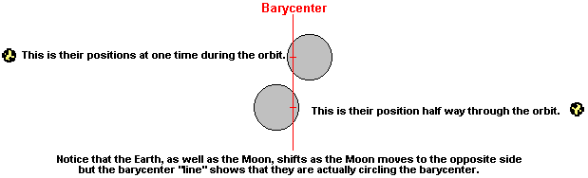

If you hold a cup partially filled with water as you spin, you will see the water will flow to the outside side of the cup due to your spinning motion. So it is with the Earth and the ocean water. The ocean bulge on the side of the Earth facing the moon is caused by the moon’s greater gravitational pull; the ocean bulge on the opposite side of the Earth is caused by the Earth orbiting the center of mass of the Earth-moon system raising ocean waters as shown below. The + mark denotes the position of Earth’s north pole.
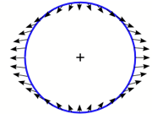

Moon ➔

- On the drawing above, indicate two places on the surface of the Earth that are currently experiencing low tides. Label these points A and B. Indicate two places that are currently experiencing high tides. Label these points C and D.

As the Earth turns daily upon its axis, we are swept through two successive bulges of ocean water. This is what causes two high tides per day. We are also swept through two depressions in the ocean water and this is what causes two low tides per day.

- Given what you know about the moon’s orbital motion around the Earth, why do you think it is that the first high tides of two successive days (as well as similar combinations of tides) are delayed by about 50 minutes each day on average?

For the teacher:

For a simple explanation of tides, it is sufficient to consider only the effects of the moon (the size of the moon’s effect is about twice that of the sun, because the moon is closer to the Earth). At any point in a day, one side of the Earth will be closer to the moon than the opposite side. Ocean waters on the closer side of the Earth will experience a greater gravitational pull from the moon than waters on the opposite side of the earth. This causes a “bulge” in the waters closest to the moon, and creates a high tide as the Earth turns beneath it. At the same time, inertial forces on the opposite side of the Earth causes a similar “bulge” creating another high tide. Low tides occur at longitudes that are 90° from the longitudes of locations that are experiencing high tides.

The sun also exerts a gravitational force on ocean waters. Depending upon the positions of the sun and moon relative to the Earth, the sun’s gravity may enhance or diminish the tidal effect caused by the moon. When the sun and moon are aligned (at the time of full moon or new moon), their gravitational forces act in the same direction and produce more pronounced high and low tides that are called spring tides. When the sun and moon are at right angles relative to the earth, the gravitational force of the sun pulls in a different direction than the moon. The result is less pronounced high and low tides that are called neap tides. The actual distances between the sun, moon, and Earth also affect the magnitude of tides. Gravitational attraction increases when the Earth is closest to the sun (perihelion) or moon (perigee).

The 50-minute average delay between successive corresponding tides (e.g., first high tides of two successive days) results from the fact that the moon orbits Earth. The moon’s rising is delayed an average of about 50 minutes each day due to its orbital motion around our planet. The moon moves ahead in its orbit by just over 13 degrees each day with respect to the stars; Earth spins at a rate of just under 15 degrees per hour with respect to the stars. So, it takes 50 minutes of the Earth’s turning to bring the moon back to the same spot in the sky.

For more information on the causes and types of tides, visit the following URL:

http://www.nos.noaa.gov/education/tides/welcome.html

