Name:
Determining the Size of Earth

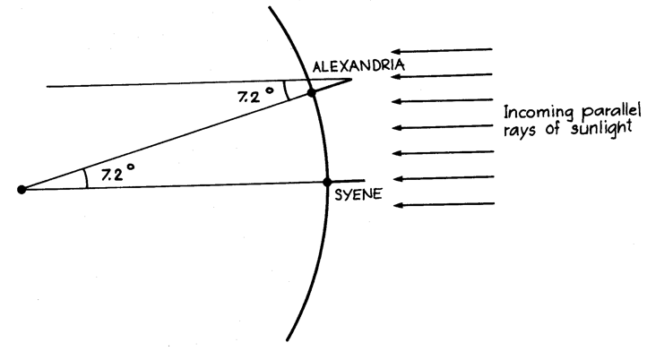
Just how big is the Earth? The answer to this question was determined with considerable precision thousands of years ago by the astronomer Eratosthenes. In one year he was in the Egyptian town of Syene and noticed that on the first day of summer, the Sun passed directly overhead at noon. A year later, he observed the location of the Sun again, but this time from Alexandria, a town “5,000 stadia” to the north. At noon on this day, the Sun appeared 7.2 degrees south of the overhead point in the sky. He reasoned correctly that, using proportions, he could determine the circumference (the distance around) the Earth. This is what he did.

He noted that if 7.2 degrees corresponded to 5,000 stadia, then 360 degrees corresponds to a proportional distance – the distance around the Earth. In effect, he set up the following mathematical relationship:

$$\frac{7\text{.}2^{o}}{5,\text{000}\text{stadia}}=\frac{{\text{360}}^{o}}{\text{circumference}}$$

- Solve this relationship for circumference of the Earth. Show your work.

- Now, in order to find the circumference of the Earth in more common units, convert your answer in stadia to miles using the following conversion factor: 1,000 stadia = 95.9 miles. Show your work, being certain to include units in each step.

- The accepted value of the Earth’s circumference at the equator is about 24,900 miles. How accurate was Eratosthenes’s work? Determine the percent error. Recall the definition of % error:

$\text{\%}\text{error}=\frac{\left|\text{predicted}−\text{actual}\right|}{\text{actual}}\text{*100}$ =

- We know from the study of mathematics that the radius of a circle is related to its circumference in the following fashion:$\text{circumference}=2p∗\text{radius}$ where $p$ = 3.14 approximately. Using this relationship, determine the radius of the Earth. Show your work.

- Recall the diameter is twice the value of the radius. What is the diameter of the Earth given this radius?

- Today, we can determine the circumference of the Earth very easily and accurately using a hand-held GPS receiver. The author of this activity, using a GPS, traveled a north-south distance of 1,000 feet and found a change in latitude of 9.9 arc seconds. Using Eratosthenes’ method and these data (or your own), can you determine the circumference of the Earth even more accurately than Eratosthenes? Note that 1 arc second is equal to 1/3,600 of 1 degree.

