Lunar Craters Lab*

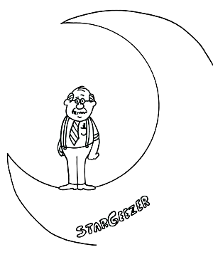
Learning Target: To experimentally determine which factors affect the appearance of lunar craters and their “rays”.

Hi, Boys and Girls! I’m StarGeezer and I’m going help you understand where the moon’s craters and “rays” came from. Just follow each of the following steps, and you’ll be solving this mystery the same way scientists did years ago.

Hypothesis development: A hypothesis is an explanation of something based upon evidence – it’s not merely a wild guess. Look at the pictures of the moon’s craters provided by your teacher, and then use your experiences in life to come up with one or more explanations as to their cause.

- After looking at photographs of the Moon, how do you think the lunar craters were formed?

- What factors do you think affect the appearance of craters and their “rays” or ejecta?

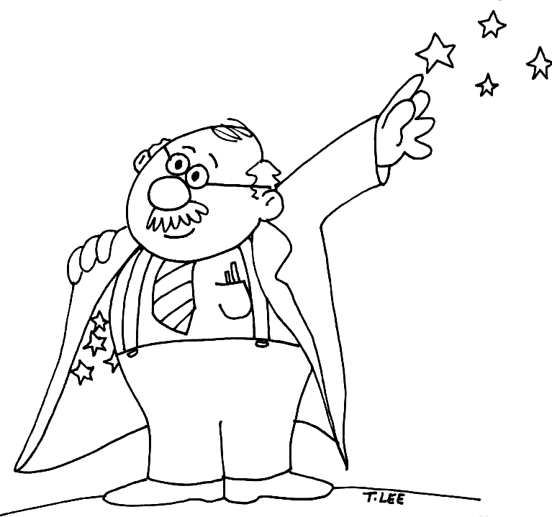

Preparing a “lunar” test surface: Well, it’s time to get down and dirty. Ah, in science we call this experimentation! Let me slip on my lab coat and work along with you. Just follow these steps.

- Fill a pan with the provided surface material (corn starch or flour works well) to a depth of about 2 - 3 cm. Smooth the surface, then tap the pan to make the materials settle evenly.
- Sprinkle a fine layer of dry tempera paint evenly and completely over the surface. Use a sieve or sifter for more uniform application.

- Describe what this “lunar” surface look like before testing.

Cratering Process: Now, this next activity will cause quite an impact don’t you think?

- Use a balance or scale to determine the mass of each impactor. Record the mass on the “Data Sheet” for this impactor.

- Drop impactor #1 from a height of 30 cm onto the prepared surface, then carefully remove it.

- Using a ruler, measure the diameter and depth of the resulting crater.

- Note the presence of ejecta (rays). Count the rays, measure, and determine the average length of all the rays.

- Record your measurements and any other observations you have about the appearance of the crater on the Data Sheet. Make three trials and compute the average values.

- Repeat steps 2 through 5 for impactor #1, increasing the drop heights to 60 cm, 90 cm, and 2 meters. Complete the Data Sheet for this impactor. Note that the greater the drop height, the faster the impactor hits the surface.

- Now repeat steps 2 through 6 for two more impactors each of a different mass. Use a separate Data Sheet for each impactor.

- Graph your results. Graph #1 is average crater diameter vs. impactor speed. Graph #2 is average ejecta (ray) length vs. impactor speed. Note: on the graphs, use different symbols (e.g., dot, triangle, plus, etc.) for different impactors.

Results: Well, we are just about done and it’s nearly time for me to leave but, before that, tell me what you found out. Is there any sort of relationship between the mass of the impactor, the speed of impact, and the size of the crater and length of rays produced? Whoa, that’s a long question. Let’s break it down into more manageable steps. Be certain to look at your graphs to decide on the best answer. Don’t just guess.

- Is your hypothesis about what affects the appearance and size of craters supported by test data? Explain why or why not.

- What do the data reveal about the relationship between crater size and speed of impactor?

- What do the data reveal about the relationship between ejecta (ray) length and speed of impactor?

- If the impactor were dropped from 6 meters (a speed of 1,084 cm/sec), would the crater be larger or smaller? How much larger or smaller? Explain your answer.

Impactor Energy and Crater Size: The size of a crater made during an impact depends on a combination of mass and energy of the impactor known as kinetic energy. Kinetic energy, the energy of motion, is described mathematically as ½mv² where, m = mass and v = velocity. During impact, the kinetic energy of an asteroid is transferred to the target surface, breaking up rock and moving the particles around.
- How does the kinetic energy of an impacting object relate to crater diameter?

- Looking at the results in your Data Tables, which is the most important factor controlling the kinetic energy of a projectile, its diameter, its mass, or its speed?

- Does this make sense? How do your results compare to the kinetic energy equation?

- Try plotting crater diameter vs. kinetic energy as Graph #3. Remember that kinetic energy is a product of ½ times the mass (in grams) times the speed (in centimeters per second) squared.

* Based on Impact Craters activity from Hawaii Space Grant College, Hawaii Institute of Geophysics and Planetology, University of Hawaii, 1996.

Lunar Craters Lab Data Sheet

Impactor 1 Observations: Mass = _____________

Trial No. | Crater diameter (mm) | Crater Depth (mm) | Number of Crater Rays | Average Ray Length
1
2
3
Ave

Impactor 1 Observations: Mass = _____________

Trial No. | Crater diameter (mm) | Crater Depth (mm) | Number of Crater Rays | Average Ray Length
1
2
3
Ave

Impactor 1 Observations: Mass = _____________

Trial No. | Crater diameter (mm) | Crater Depth (mm) | Number of Crater Rays | Average Ray Length
1
2
3
Ave

Other observations:

