Name:
Measuring Lunar Crater Wall Heights

Have you ever wondered why you study math? Well, here is a good example of how you can use math to measure the heights of crater walls on the moon without actually having to travel there!
First, we need to consider the figure below. It represents the moon from as seen from above its north pole with us looking down. The sun is to the right and Earth is below. Note the two triangles – CET the larger triangle and SEW the smaller triangle. (Technically, the smaller triangle is not a standard triangle because one side consists of an arc rather than a straight line, but if the shadow is much smaller than the circumference of the moon, then this side of the triangle will be very close to being a straight line).

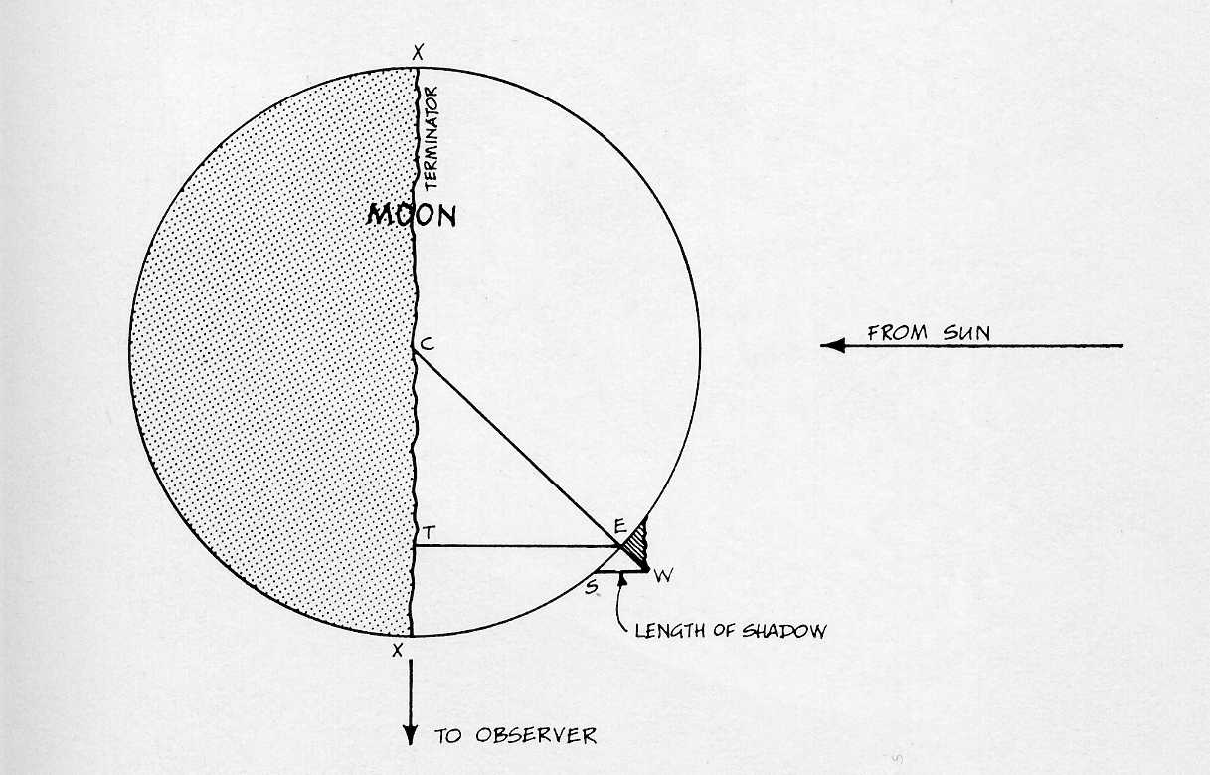

These two triangles are geometrically similar. That is, the two triangles are identical in shape, but just not size. Because these are similar triangles, we can use information from the larger triangle to determine properties of the smaller triangle.

In these triangles,

L = WS = the length of the shadow as seen from Earth (measured left-to-right at the widest part of the shadow)
d = ET = the distance of the crater wall from the terminator
R = ½XX = radius of the moon
h = EW = the height of the crater wall

with all measurements taken from a photograph expressed in millimeters.
Now, given the similar triangles we can determine the height of a crater wall in the following fashion:
$$\begin{aligned}\frac{\text{WS}}{\text{CE}}=\frac{\text{EW}}{\text{ET}} \\ \text{or}\text{by substitution} \\ \frac{L}{R}=\frac{h}{d} \\ \text{and}\text{therefore} \\ h=\frac{\text{Ld}}{R}\end{aligned}$$

The last equation will give the height of the crater wall in millimeters. R mm on the photograph corresponds to 1738km, the actual radius of the moon. Using this conversion factor, we can find the height of the crater wall in kilometers. If we multiply by the conversion factor of 1km = 1,000m, we get the following formula:

$$\text{height}=\frac{\text{Ld}}{R}x\frac{\text{1738}}{R}\text{x1000m}$$

Using a 30cm ruler (with mm divisions) and the photograph provided by your teacher, make the following measurements and insert that information in the locations indicated.

Crater being investigated (circle): Aliacencis Albategnius

Measurements:

L = WS = the length of the shadow as seen from Earth (mm):

d = ET = the distance of the crater wall from the terminator (mm):

XX = diameter of moon image (mm):

R = ½XX = radius of the moon image (mm):

h = EW = the height of the crater wall (mm):

Insert correct values into the equation:

$\text{height}=\frac{\text{Ld}}{R}x\frac{\text{1738}}{R}\text{x1000m}$ =

Perform the calculation, and put the height of your crater wall here: m

Compare: Aliacensis = 5030m (3.1 miles) Albategnius = 3850m (2.4 miles)

