Name:
Moon Phase Journaling

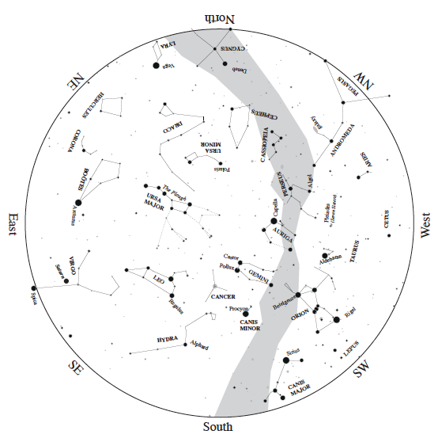
Part A – Moon Journal Observations
The moon is new on March 4, 2011, for those living in central Illinois. Within the next few days, the moon will reappear low in the western sky shortly after sunset. Your goal is to observe the location and appearance of the moon over the course of the following two weeks – making observations at about the same time each night when the sky is clear. Indicate the location of the moon with an “X” on the March sky chart below and indicate the date beside it. In the table below the sky chart, record date, time, elevation, azimuth, and sketch the appearance of the moon as you see it with your unaided eye. Name the phase being certain to include the words waxing or waning as appropriate.

Date | Time | Elevation | Azimuth | Appearance | Phase Name
 |  |  |  | 
Date | Time | Elevation | Azimuth | Appearance | Phase Name

Part B – Moon Journal Reflections
Refer to your moon journal observations when answering the following questions.

- Did the appearance of the moon change throughout your observations? Describe any changes and refer to your sketches. Why do you think any changes occurred?

- Did the position of the moon change throughout your observations? Describe any changes and refer to your sky chart data. Why do you think any changes occurred?

- Where do you think the moon was with respect to the Sun (elongations) on the days of your observations? Why do you think this?

- From the azimuth data that you collected, find the angle between the sun and the moon for the days you observed. Is this angle changing?

- Do you think the moon set at an earlier time, a later time, or the same time on consecutive days of your observations? Explain your reasoning.

- Was there any day when you could not see the moon other than a cloudy day/night? Why do you think this happened?

- Consider your observations from the first day you observed the moon. Comparing this observation to subsequent observations,

- how long do you think it will take the moon to once again appear as it did during your first observation? Explain your reasoning.

- where would the moon be in the sky the next time it appears the same? Explain your reasoning.

