Celestial Sphere Exercise Name:

The celestial sphere is a great tool for describing the apparent motions of the heavens. Because we cannot see that half of the sphere below our horizon, we will represent the motions of the sky with the use of a celestial hemisphere – or half sphere.

In the figures below, note the locations of the horizon, cardinal points, north celestial pole, zenith, meridian (a line that separates the sky into eastern and western halves), and celestial equator (a circle directly above the Earth’s equator). Note that the position of the north celestial pole (NCP) depends upon one’s location on Earth. The angular distance of the NCP above the northern horizon is the same as one’s latitude. At 50 degrees latitude, the NCP will be 50 degrees (just over half way) up in the northern sky.

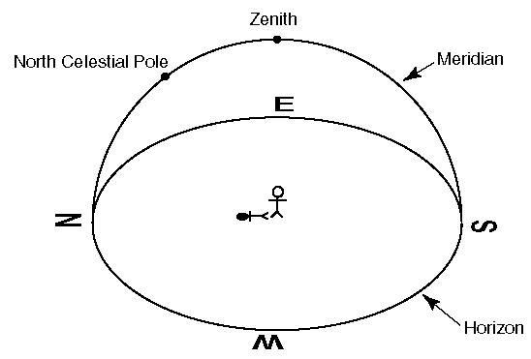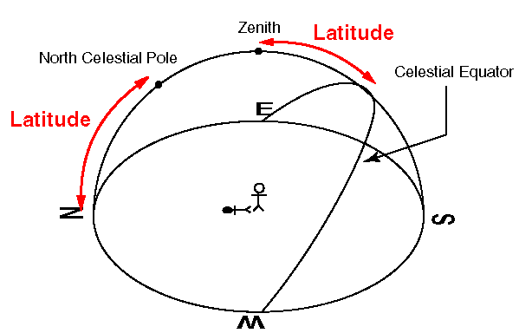

Where would you expect to see the North Star (which roughly marks the NCP) if you were viewing the night sky from Earth’s equator?

Where would you expect to see the North Star if you were at Earth’s north pole?

Would you expect to see the North Star if you were south of Earth’s equator? If so, where?

How high above the southern horizon would you expect the celestial equator (where it intersects the meridian) if you are at a latitude of 40 degrees north?

If you were at Earth’s north pole, where would you expect the celestial equator to appear in your sky?

Stars appear to move parallel to the celestial equator and circle round the NCP. Imagine yourself standing in the center of the celestial hemisphere and watching the stars move. How would they appear to move looking in each of the following directions? Draw lines, curves, or circles to show the paths of the stars in the boxes below and include arrows to indicate the direction of motion.

At 40 degrees north latitude:

Looking north Looking south Looking east Looking west

At Earth’s equator:

Looking north Looking south Looking east Looking west

At Earth’s north pole:

Looking up Looking south

Why aren’t there boxes for “looking” west, north, and east at the North Pole?

