The Celestial Sphere Name:

It is easy to gain the impression that the night sky consists of a large spherical shell (of indeterminate size) that holds the Sun, Moon, planets, and stars, that turns around the Earth daily. This concept of the “celestial sphere” – though wrong – is quite useful to us. It is not difficult to imagine the sphere continuing below the horizon and totally enclosing the Earth.

If you watch the skies for a few hours, you will note the apparent motion of this fictitious celestial sphere and all things on it. This apparent motion is caused by the spinning motion (rotation) of the Earth on its axis.

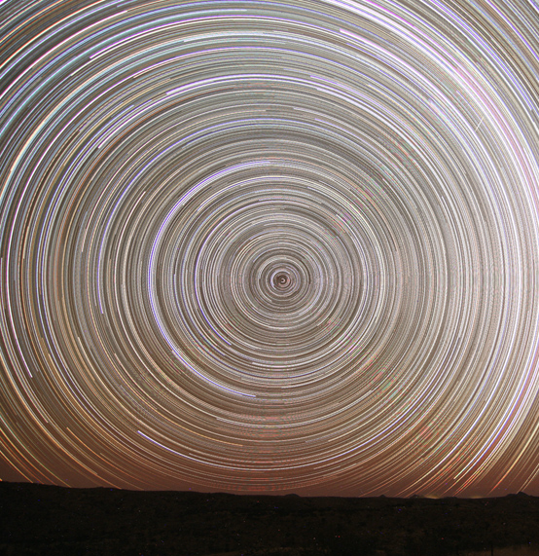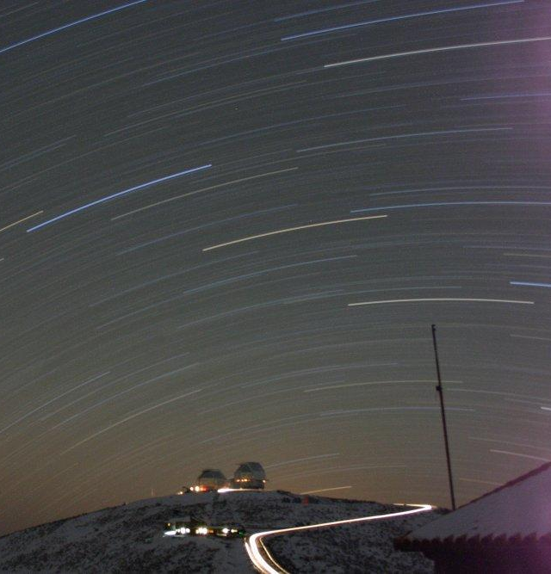
Looking North Looking South

The model of the celestial sphere is quite useful to us. It can readily be used to explain some of the motions of objects in the sky. For instance, the first time exposure above and to the left shows the sky over the course of several hours. The stars appear to move with a circular motion around a point in the northern sky (the North Celestial Pole). The second time exposure above and to the right shows the southern sky over the course of several hours. The stars appear to move sideways around a point located below the southern horizon (the South Celestial Pole). Can you imagine a huge sphere surrounding the Earth with one axis above the northern horizon and the other axis below the southern horizon?

Now everyone should know their directions, north, south, east and west.

Facing north, what direction is to your right?

Facing west, which direction is to your left?

If stars rise along the eastern half of the sky and set along the western half of the sky, which way will stars appear to move when viewing the southern sky? (Circle the best response)

Left to right Right to left

If stars rise along the eastern half of the sky and set along the western half of the sky, which way will stars appear to move when viewing the northern sky? (Circle the best response)

Clockwise Counterclockwise

Note that there is one star in the northern sky that barely moves at all. It stands as an indicator of the direction north. The star’s name is Polaris, the Pole Star. What is this star’s more commonly used title?

.

This is the star about which all others in the northern sky appear to revolve. Can you find it on the left picture on the previous page?

Other celestial phenomena, such as the various phases of the moon and the changing of the seasons require a more sophisticated model and will be addressed later.

Here is how the celestial sphere accounts for the motions of the stars…
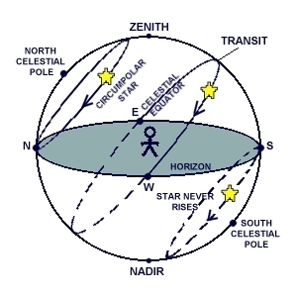
http://www.astro.columbia.edu/~archung/labs/fall2001/images/sky_day.jpg

Other terms you should know: horizon – where the Earth appears to touch the sky
zenith – the point directly over the observer’s head
nadir - the point directly below the observers feet
transit – cross from eastern sky to western sky
circumpolar star – a star than never sets
celestial equator – a ring in the sky above Earth’s equator

