Name:

Testing Your Sky
Limiting Magnitude, Transparency, and Seeing

Darkness Scale:

The darkness of the sky as seen from your favorite observing site can be either a help or a hindrance when it comes to observing the night. Under brightly lit conditions you'll not be able to view the fainter objects of the night.

What follows is an exercise for determining darkness of the sky, a condition that might affect your viewing. Be sure to make the observation only after your eyes have become fully dark adapted, and near the end of evening twilight at the earliest. That is, the observation are best made after you've been at the observing site for at least 20 to 30 minutes and at least 90 minutes after sunset or before sunrise.

To determine just how dark and clear the skies are, attempt to find the faintest stars visible in the area of the Little Dipper. Use the chart below to find stars of the first to fifth magnitude if possible. The stars of the constellation are labeled with a number indicating their brightness according to a magnitude scale. Stars of the first magnitude are generally the brightest stars in the sky; stars of the sixth magnitude are generally the faintest visible by any observer under excellent conditions. If more stars are visible than are present on the star map, your limiting magnitude will be on the order of six.

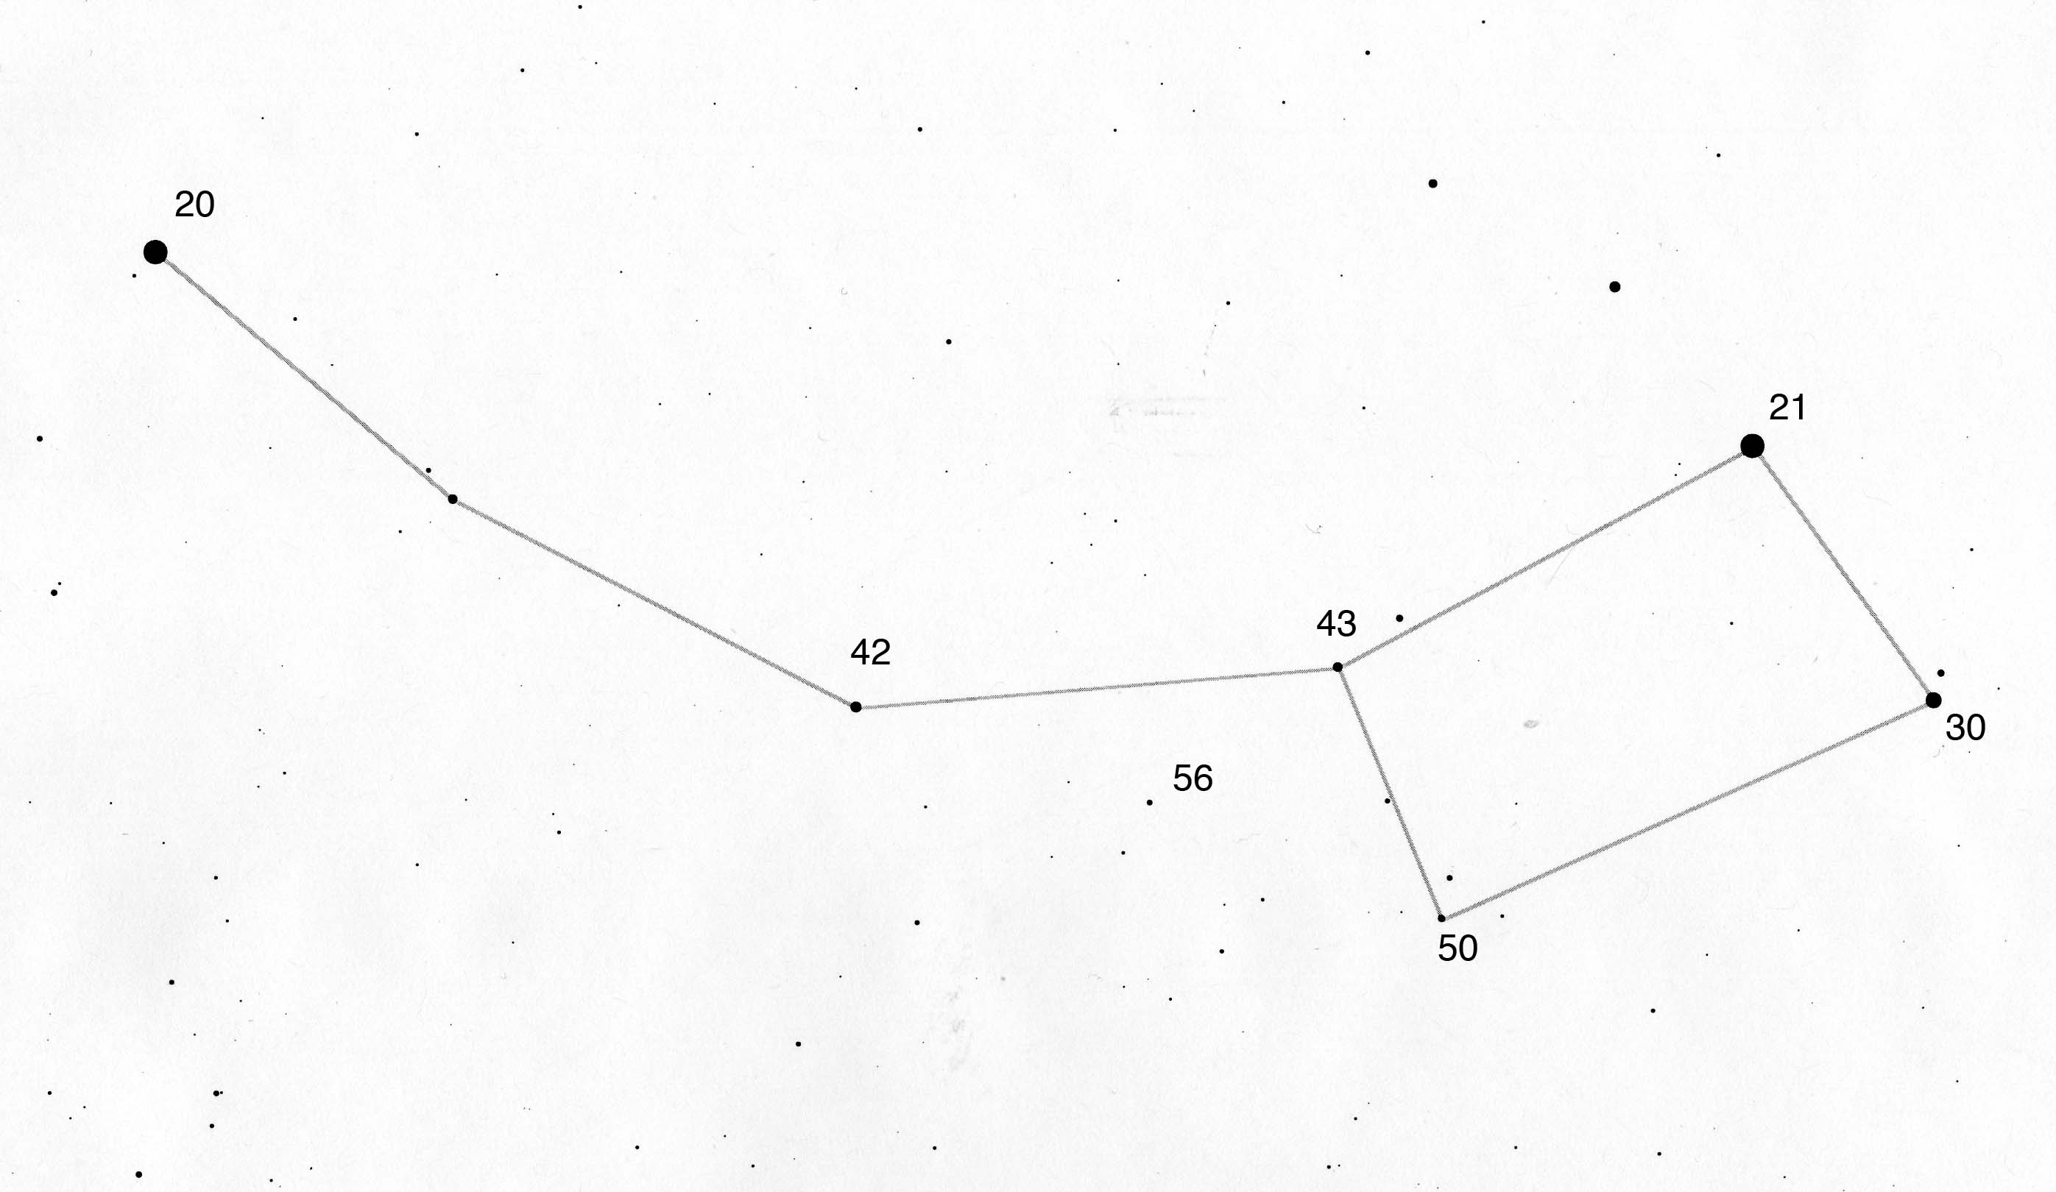
THE LITTLE DIPPER (Ursa Minor)

The magnitudes of the brighter stars in the Little Dipper are expressed without decimal points so that the points are not confused with stars. Read 42 as 4.2 and 30 as 3.0
On the line below, record the magnitude of the faintest star visible in the Little Dipper. This will be your limiting magnitude. Be sure to include the decimal point.

Limiting Magnitude:

There is another factor that must be kept in mind when it comes to viewing the heavens - the transparency of the atmosphere. Even if the sky is totally dark, unless the sky permits the starlight to travel through it you won't be able to see the heavens very well. This is akin to viewing the sky through a dark fog bank or on a dark, cloudy night. Now you won't be viewing the sky when its foggy or cloudy, but you might attempt to view the heavens during the warmer months when its loaded with water vapor.

During the winter months the air is cold and it cannot hold much water vapor. This is the reason that on especially cold winter days the sky is a dark, deep blue. During the summer months when the air is loaded with moisture the sky scatters light all about and the sky takes on a white, milky appearance. Under such conditions sky watching at night is not very fruitful, especially is one is attempting to view dim space objects. Though there is no way of directly measuring transparency, it can at least be estimated by viewing the sky by day. Transparency will adversely affect the limiting magnitude and, hence, limiting magnitude is somewhat a measure of transparency as well.

Observing the stars from under the ocean of earth's air has been said to be analogous to observing birds from the bottom of a swimming pool. In no better way can this be seen to be true than when examining the phenomenon of twinkling. Observer a bright star, especially when it's low in the sky. Can you see it change colors and appear to dance about? This change of color and dancing motion has nothing to do with the star itself. Rather, these phenomena are caused by the earth's atmosphere. Such combined phenomenon are called twinkling.

The twinkling phenomenon can be responsible for disturbing images of celestial objects when viewed through the telescope. When the atmosphere is calm, superior images can be obtained of planets and other space objects. The more violent the twinkling the more disturbed the view. The stability of the atmosphere is called "seeing." If twinkling is quite noticeable, seeing is bad; if very little twinkling, seeing is good.

As the condition of the atmosphere is generally responsible for the quality of the view, the more atmosphere one observes through, the poorer the viewing. When looking at an object near the horizon one is viewing through as much as five time more atmosphere than when that object is viewed overhead.

Go outside on a clear night and see if twinkling and limiting magnitude increase near the horizon. Before you begin a night of viewing you should become aware of the condition of the sky by day. Thin wispy clouds, though they don't keep out much of the sunlight, can really reduce transparency. See if the sky is blue or milky white. Watch for twinkling as a measure of atmospheric seeing. Include such information in your observing records.

Seeing Scale:

LEVEL 1 – Severely disturbed skies: Even low power* views are uselessly shaky. Go read a good book.
LEVEL 2 – Poor seeing: Low power images are pretty steady, but medium powers are not.
LEVEL 3 – Good seeing: You can use about half the useful magnification of your scope.
LEVEL 4 – Excellent seeing: Medium-powers are crisp and stable. High-powers are good, but a little soft.
LEVEL 5 – Superb seeing: Any power eyepiece produces a good crisp image.

Transparency Scale

0. Cannot Observe – Completely overcast.
1. Very Poor – Mostly Cloudy.
2. Poor – Partly cloudy or heavy haze. 1 or 2 Little Dipper stars visible.
3. Somewhat Clear – Cirrus or moderate haze. 3 or 4 Little Dipper stars visible.
4. Partly Clear – Slight haze. 4 or 5 Little Dipper stars visible.
5. Clear – No clouds. Milky Way visible with averted vision. 6 Little Dipper stars visible.
6. Very Clear – Milky Way and M31 visible. 7 Little Dipper stars visible.
7. Extremely Clear – M33 and/or M81 visible.

