Name:

Daily Motions of the Stars

Without watching the motions of the stars, indicate what motions of the stars you would expect to see by looking in each of the four directions. Draw arrows in the boxes below indicating the motions of the stars. If the North Star is in your field of view, mark its location and label it “NS” for North Star.

Looking East | Looking West
Eastern Horizon | Western Horizon
Looking South | Looking North
Southern Horizon | Northern Horizon
Now, looking in each of the four directions, record the motions of the stars as they actually occur over a period of time. Draw arrows indicating motions of the stars.

Looking East | Looking West
Eastern Horizon | Western Horizon
Looking South | Looking North
Southern Horizon | Northern Horizon

Were your predictions the same as your observations? If different, how were they different from what you expected?

Name:

Path of the Sun and Midday Elevation

Path and elevation of the midday sun as observed from 40 degrees north latitude

Observe the elevation (angular distance above the horizon) of the midday sun on the following dates. The sun will be on the meridian. Record your data in the table below.

Date | Elevation (d) | Date | Elevation (d) | Date | Elevation (d)
January 21 |  | May 21 |  | September 21
February 21 |  | June 21 |  | October 21
March 21 |  | July 21 |  | November 21
April 21 |  | August 21 |  | December 21

Once all of the observations have been completed, make a graph. Using the grid below (showing elevation on the y axis and date on the x axis), plot the elevation of the midday sun for each of the above dates. Draw a smooth line between all the plotted points. Answer the following questions using the completed graph.

90º ^
80º ^
70º ^
60º ^
50º ^
40º ^
30º ^
20º ^
10º ^
0º ^ | 1/21 | 2/21 | 3/21 | 4/21 | 5/21 | 6/21 | 7/21 | 8/21 | 9/21 | 10/21 | 11/21 | 12/21

- During which month of the year do we see the midday sun at its greatest elevation?

- How many degrees is the midday sun above the horizon when we see it at its highest?

- Which season is just starting when we see the midday sun at is highest in the sky?
- What is the elevation of the midday sun when we see it lowest in the sky?

- During which month do we see the midday sun at its lowest in the sky?

- How many degrees is the midday sun above the horizon when we see it at its lowest?

- Which season is just starting when the seem the midday sun at its lowest in the sky?

- How many months does it take the midday sun to move from highest to lowest?

- Does the midday sun ever appear directly overhead for observers at 40 degrees north latitude? If so, on what approximate date?

- Does the midday sun appear to get a little higher or a little lower with each passing day moving from the start of summer to the start of winter?

- Is there ever a day when the sun does not appear in our sky at midday (excluding the presence of clouds)? If so, when?

- Why do you think it is that the sun appears to change its midday elevation over the course of the year?

- How many degrees of elevation does it change from its highest to its lowest midday elevation?

- Divide the change of elevation noted in answer to the question above and divide it by two. What result do you get?

- How might this angle be related to anything you know about the orientation of the earth’s axis from perpendicular to its orbital plane?

Name:

Time and Length of Day Data Sheet
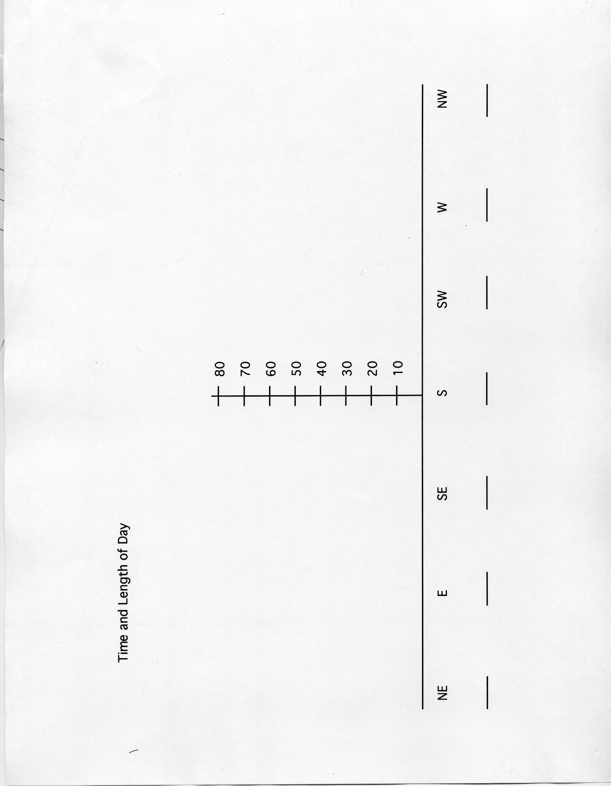

Name:

Time and Length of Day

Following your planetarium/sky simulation about time and length of day as observed from 40 degrees north latitude, answer the following questions using your data sheet. Where appropriate, circle the correct answer to questions that present ( options ).

- When the sun is east of the meridian (the north-south line in the sky that passes directly overhead), the time is said to be ( a.m. / p.m. )

- The sun moves across the sky from ( east to west / west to east) daily due to Earth’s spinning motion or rotation.
- When the sun crosses over the meridian, the time is said to be: ____________

THE FOLLOWING SIX QUESTIONS RELATE ONLY TO OBSERVATIONS MADE ON THE FIRST DAY OF SUMMER LOCALLY, ON OR AROUND JUNE 21ST EACH YEAR.

- Using your data sheet, tell what time the sun rises on the first day of summer. __________ ( a.m. / p.m. )

- How many hours does it take the sun to reach the meridian on this date? ____ hours

- What time does sunset occur on this date? __________ ( a.m. / p.m. )

- How many total hours of sunlight occur on this date? __________ hours

- On the first day of summer the sun makes its ( highest / lowest ) path across the sky.

THE FOLLOWING QUESTIONS RELATE TO ANY TIME OF YEAR.

- At the beginning of which season would a northern hemisphere observer have the longest night?

- The beginning of which two seasons would have only 12 hours of possible sunlight?

- From the available data, it would appear that the length of the day is closely tied to the elevation of the midday sun. ( true / false )

- State the nature of that relationship: The higher the sun’s midday elevation, the ( longer / shorter ) the day.

- The sun rises due east and sets due west on only which two approximate dates during the year?

- At the start of winter, the sun rises in the ( northeast / southeast ) and sets in the ( northwest / southwest).

- At the start of summer, the sun rises in the ( northeast / southeast ) and sets in the ( northwest / southwest).

- When the sun rises and sets farthest north or south the dates are known as the ____________.

- When the sun rises and sets due east and west respectively, the dates are known as the ____________.

- The solstices are associated with the beginnings of ( winter and summer / spring and autumn )

- The longest and shortest days of the year are associated with the ( solstices / equinoxes )

- Daylight lasting 12 hours is most closely associated with the ( equinoxes / solstices )

Name:

Seasons Data Sheet
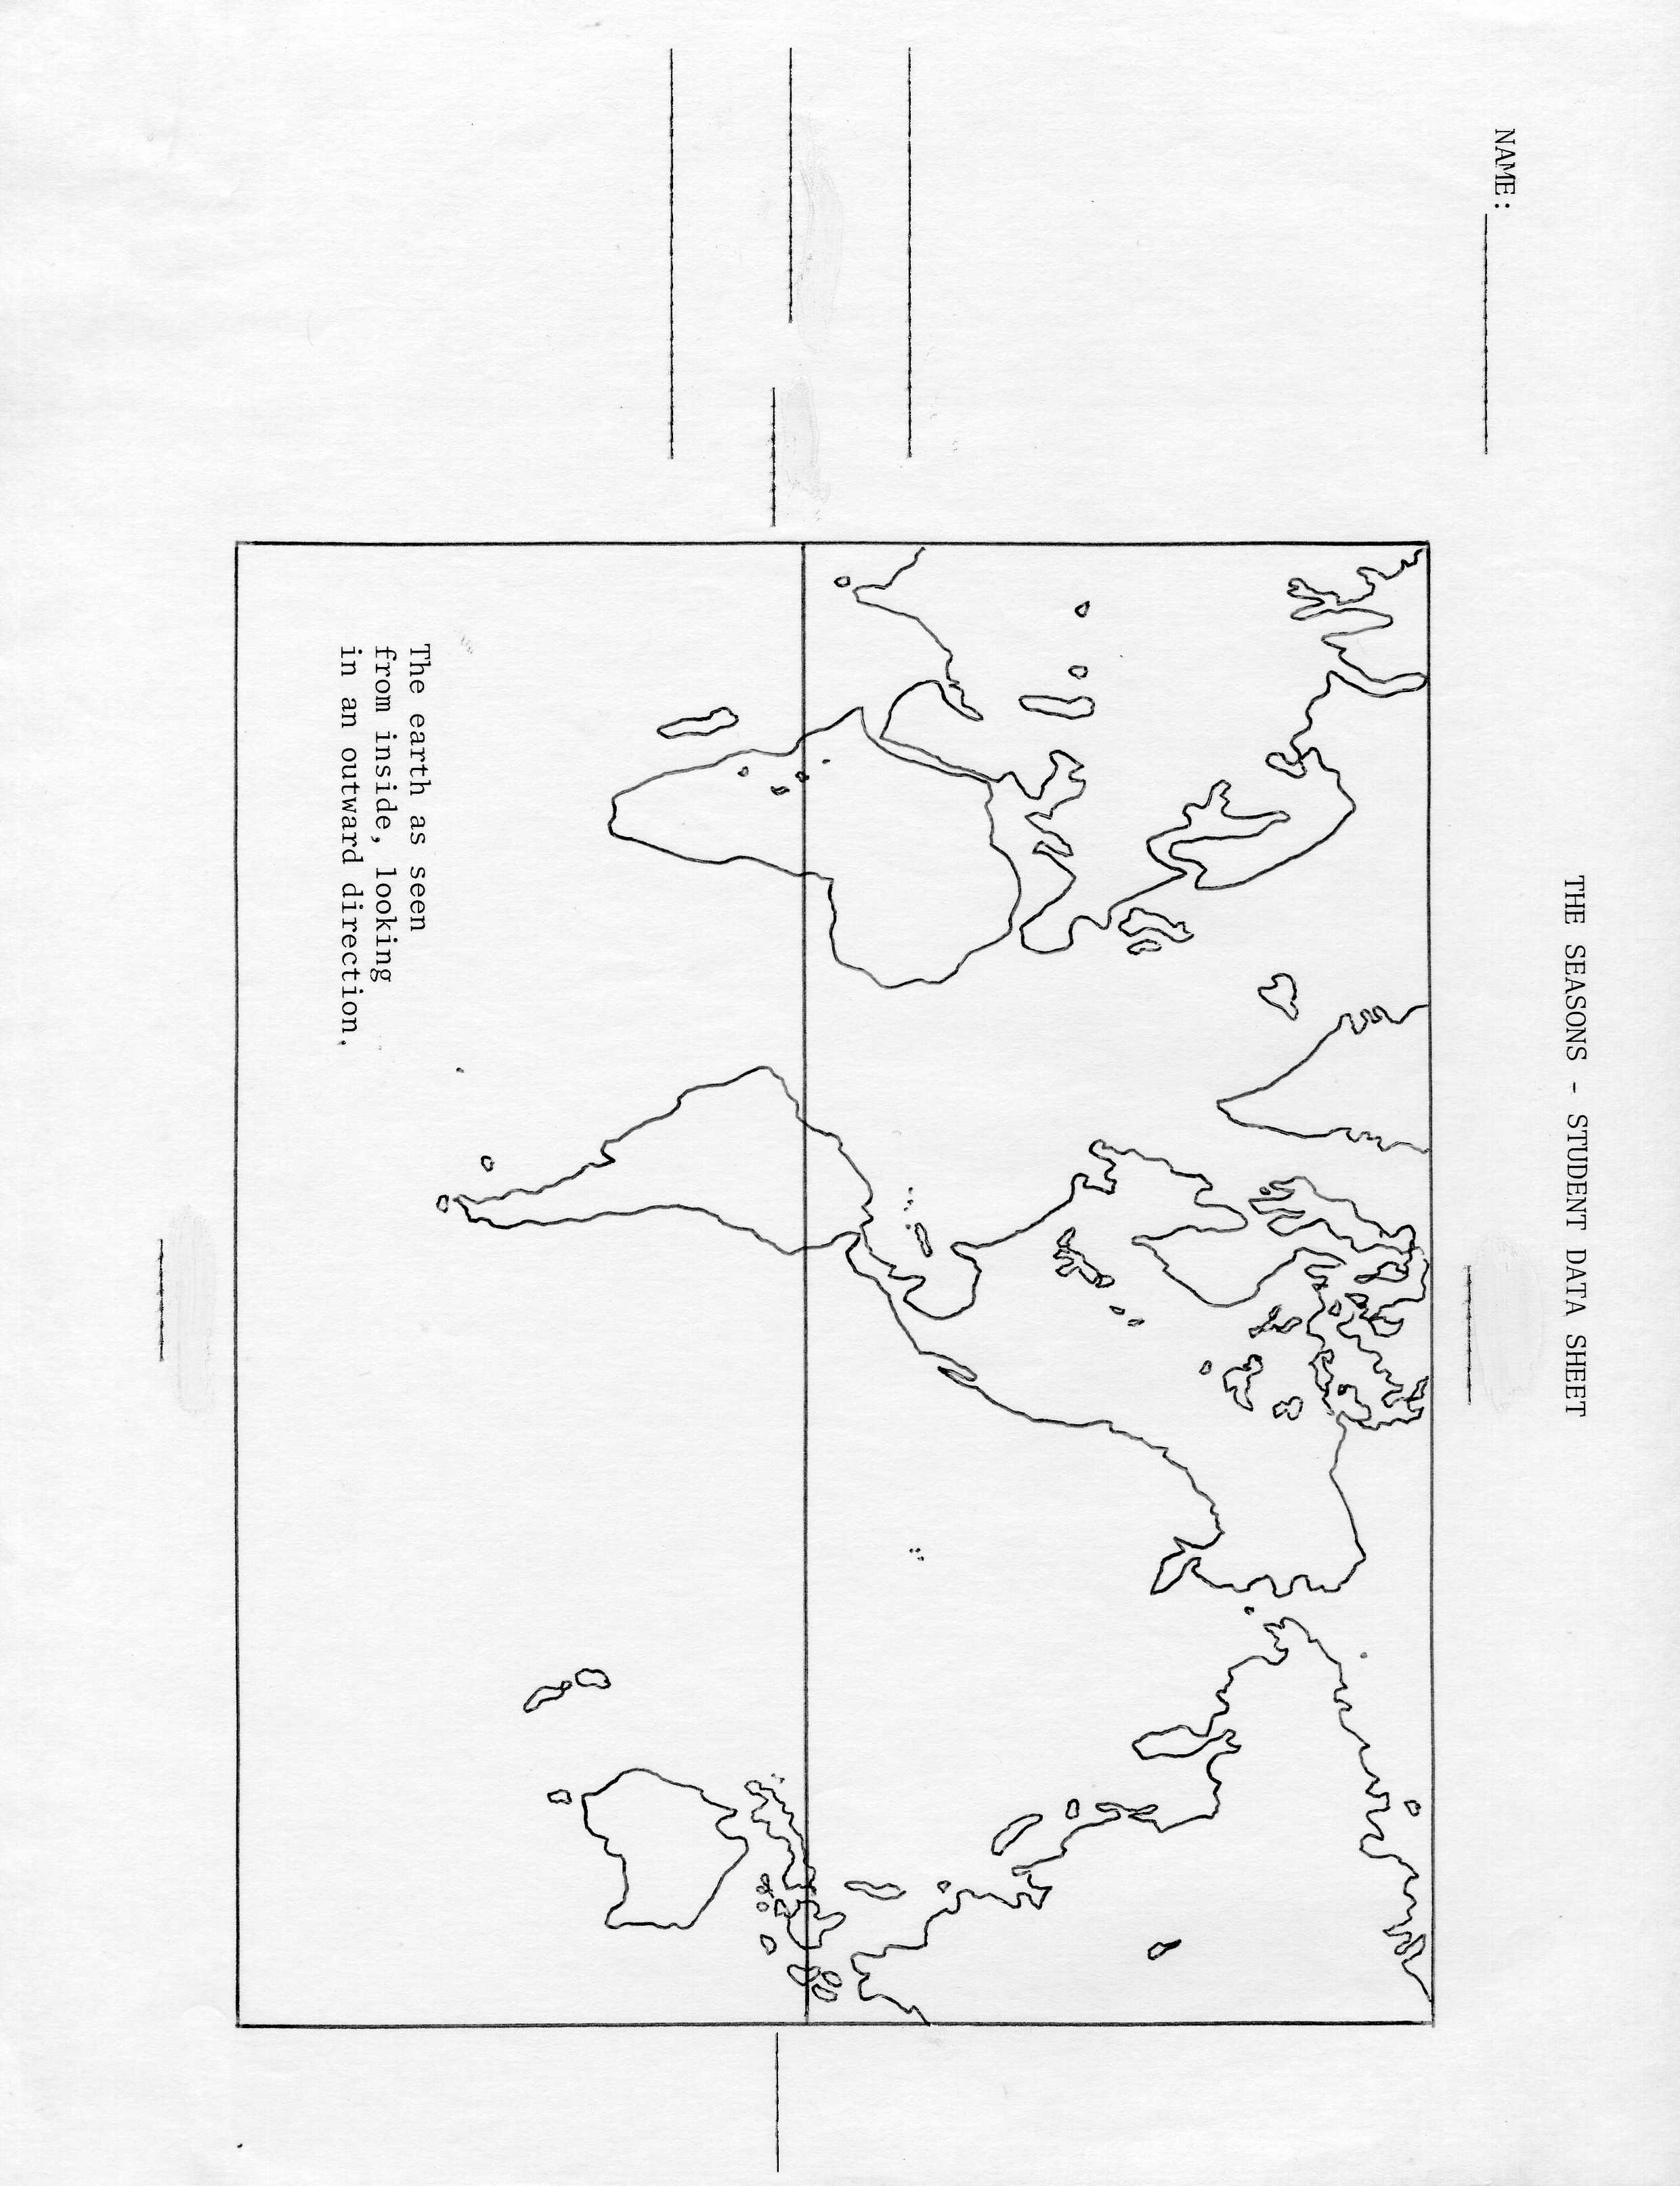
Name:

The Seasons

- Will the sun ever pass directly overhead for a person living in the 48 continental states? If yes, when? _____, __________________________________________
- This sun can pass directly overhead at midday only for people living between what two lines on Earth? _____________________________________________________
- Summer in the United States begins around June 21st. Is the sun located over the northern hemisphere or southern hemisphere at this time? ____________________
- Would the above date mark the beginning of summer if you lived in South America?
_________________________________________________________________
- When the sun reaches the Tropic of Cancer, which season is just beginning in the southern hemisphere? _____________
- Equinoxes occur when the sun appears to cross over Earth’s _____________.
- Solstices occur whenever the sun appears over either of Earth’s ______________.
- Twice during the year the sun is directly overhead at noon for observers located on the equator. This happens during which two months? ____________ and ____________
- On what date does the sun appear overhead at midday for observers located on the Tropic of Capricorn? __________________________
- Are the seasons north and south of the equator the same at any one point in time? If not, how do they differ? _____, ________________________________________
_________________________________________________________________
Name:

Putting it All Together

Using the data sheets from “Time and Length of Day”, “Path of the Sun and Midday Elevation” and “Seasons”, answer the following questions. Answer all questions from the local perspective as in the first question.

- Is the sun’s midday elevation at it highest or lowest on the first day of summer as seen from central Illinois? __________
- Approximately how long is each of the seasons? __________ months
- The ecliptic and Earth’s equator intersect each other at an angle of __________ degrees.
- The ecliptic is the path of the sun among the background of stars. The sun traces out the ecliptic once per _______________.
- The sun moves along the ecliptic due to Earth’s _________________.
- The sun moves across the sky due to Earth’s _________________.
- Would Earth have any seasons if its axis were not tilted relative to its orbital plane? __________
- How high do we see the sun at midday locally when it is located over Earth’s equator? __________ degrees
- Where on Earth is the sun located directly overhead at midday on the first day of winter? _______________
- Does the sun’s path across the sky appear to get higher or lower with each passing day during our winter season? _______________
- Earth’s longest day and shortest night occurs when the sun’ midday elevation is at its ( highest / lowest ).
- If you lived on Earth’s equator, at the beginning of which season would the sun appear to pass directly overhead at midday? _______________
- If you lived on Earth’s equator, would the sun always appear above the southern horizon at midday? _______________
- If you answered “no” to the above question, please explain your reasoning. _________ __________________________________________________________________________________________________________________________________
- For an observer located in which zone of Earth would the sun appear directly overhead at midday on at least one day during the year? ( tropical / temperate / polar )
- When central Illinois has summer, the sun’s daily path across our sky is at its highest. When we have winter, the sun’s daily path across the sky is at its lowest. Based on this information alone, would you say that the both the northern and southern hemispheres would have summer at the same time? Winter at the same time? __________
- When does the sun’s warming light seem to beat down upon you most intensely? When it is located ( high / low ) in the sky.
- Earth is closest to the sun each year during early January; it is farthest away from the sun during early July. Does Earth’s changing distance from the sun cause the seasons? Please explain your answer. _______, _____________________________________ __________________________________________________________________________________________________________________________________
- In your own words, explain how the sun’s changing path across the sky and the associated changing length of day account for the seasons. _________________________________________________________________ __________________________________________________________________________________________________________________________________
- What does the tilt of the Earth’s axis have to do with the seasons, if anything? _________________________________________________________________ __________________________________________________________________________________________________________________________________
Name:

Effects of Latitude Motion Data Sheet
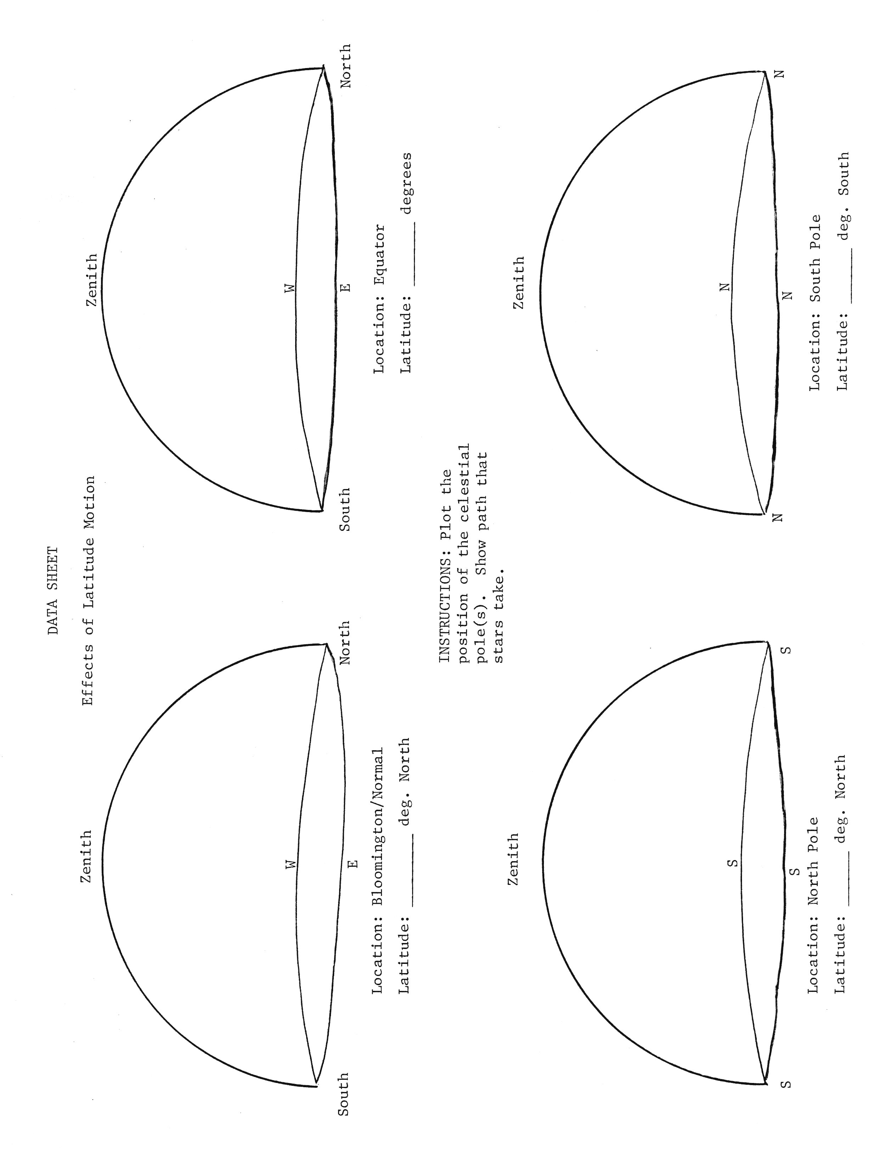
Name:

Effects of Latitude Motion

Using the data you have collected about the effects of changing latitude on the motions of the stars, complete the following statements by filling in the blanks or circling the best answer.

- What is the relationship between the elevation of the celestial pole and the observer’s latitude? The elevation of the celestial pole ____________ the observer’s latitude.
- In Peoria, the north celestial pole is _________ degrees above the northern horizon.
- When looking at the north celestial pole from Peoria, which way do the stars appear to turn? ( clockwise / counterclockwise )
- As seem from your town, stars rise in the ( eastern / western ) sky, cross over the meridian, and set in the ( eastern / western ) sky.
- Circumpolar stars can be found in our ( northern / southern ) sky while equatorial stars ca be found in our ( northern / southern ) sky.
- At the equator the celestial poles can be found on the north and south ____________.
- Are the stars seen at the equator all circumpolar or equatorial or a combination of both? _________________________.
- What fraction (1/2, 1/3, all, none) of that stars that surround Earth is visible from the equator? __________
- At the equator, do stars rise straight up and go straight down, rise and set at an angle to the horizon, or move in a circle parallel to the horizon? ______________________
- At Earth’s north pole, the North Star can be found at the ( horizon / zenith ).
- Are the stars visible from Earth’s poles all equatorial or circumpolar? _____________
- Of all the stars that surround Earth, what fraction (1/2, 1/3 all, none) is visible from one of the poles? __________
- When looking up at Earth’s south pole, the stars appear to move with a ( clockwise / counterclockwise ) motion.
- At Earth’s north pole, all directions are ( north / south ) whereas at the south pole, all directions are ( north / south ).
Does any star rise or set at Earth’s north or south poles? ______ If yes, which one?

