Kepler’s Laws of Planetary Motion Name:

Materials for each group: Cardboard base to fit a sheet of paper
Masking tape to affix paper to cardboard
Loop made from a 40cm length of string
Two (2) pushpins
One pencil
A ruler

Johannes Kepler (1571-1630), using observations by the astronomer Tycho Brahe (1546-1601), figured out how the planets move in their orbits around the sun. Kepler started by carefully charting the motion of the planet Mars around the sun on a sheet of paper. Kepler, being quite the mathematician, attempted to determine the nature of Mars’ orbit and wanted to see if it had a regular mathematical form – it certainly wasn’t a perfect circle. Rather, it was a slightly flattened circle. Perform the following steps to see if you can draw the same conclusions that Kepler did.

- Under the guidance of your teacher, tape a sheet of paper to a piece of cardboard large enough to hold it. Place one pushpin to represent the position of the sun and a second pushpin within the range of the loop provided and as shown in the drawing below. Each of these points is known as a focus. Using the loop and pencil provided, replicate the orbit of Mars on this sheet similar to that shown in the picture below.
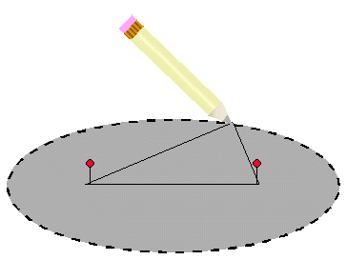

The shape you have just created is called an ellipse. It matched the path of Mars precisely. As you can see, Mars appears to orbit the sun in an ____________ orbit with the _______ at one focus; the other focus is empty. This is known as Kepler’s first law of planetary motion. All planets, as well as comets and asteroids, are known to move precisely in this fashion.

- Kepler carefully plotted the positions for Mars as shown in the drawing below. (In our case we have made the orbit of Mars a more elongated oval than it really is so that you can discover what Kepler did much more easily. Mars’ real orbit really appears like a slightly flattened circle.) This exaggerated drawing shows the planet’s position every two weeks. The dot at the center represents the middle of the oval; the dot to the right of center the position of the sun.
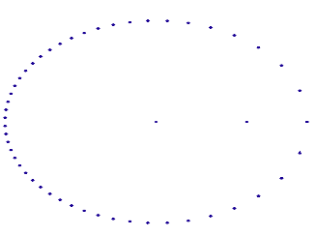
Using a ruler and a pencil, draw lines between the sun and any two consecutive points along the planet’s path – first where Mars is farthest from the sun, and next when nearest the sun. Using your pencil, shade in the area contained within each zone. Note that for equal time intervals, the areas contained within each of these triangles are the same. What this meant for Kepler was that the closer Mars came to the sun, (circle your response) the ( faster / slower ) the planet moved in its orbit. He also noted that the farther Mars moved from the sun, the ( faster / slower ) it moved in its orbit. This is known as Kepler’s second law.

- Kepler struggled for ten years to make sense of the relationship between the orbital periods of the planets (expressed in years) and their average distances from the sun (expressed in Astronomical Units). You will find this relationship in just a few minutes by doing simple calculations and comparing the results.
Take the period of each planet below and square it using a calculator; write the result in the box provided in the table below. Cube the distances of each planet with a calculator and write the results in the boxes provided.

Planet | Period (yrs) | Period² | Distance (AU) | Distance³
Mercury | 0.24 |  | 0.39
Venus | 0.62 |  | 0.72
Earth | 1.00 |  | 1.00
Mars | 1.88 |  | 1.52
Jupiter | 11.86 |  | 5.20
Saturn | 29.46 |  | 9.54

Compare the two sets of calculated values. How close are they? Keep in mind that Kepler’s values for the distances to the planets were not precise, and neither are yours. What made Kepler famous was his ability to predict the actual nature of the relationship between period-squared and average distance-cubed using approximate periods and distances. (Of course, it also helped that he turned out to be correct!) What do you think the relationship is between a planet’s orbital period and its average distance from the sun? Express this relationship in your own words below. This is known as Kepler’s third law of planetary motion.

