Using Balances and Graduated Containers

During your study of density you will use balances and graduated containers – beakers or cylinders with volume markings on their sides. This sheet will explain the use of these devices – including pan balances and triple-beam balances.

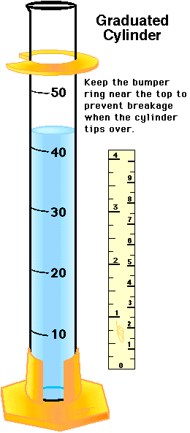 | 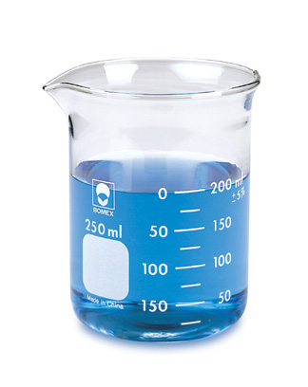  Beaker with graduations | 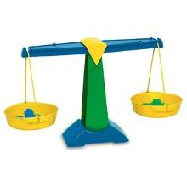  Pan Balance | 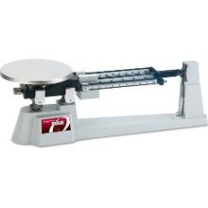  Triple-beam Balance

Graduated cylinders and beakers can be used to determine volumes of objects, no matter what the shapes of the objects – so long as they can fit into the container. Volumes will be determined using the process of displacement. That is, you will immerse an object whose volume you wish in liquid (usually water) held by the container. When fully submerged, the increase in the apparent volume of the liquid will give the volume of the object immersed.

For example, a 100 ml graduated cylinder or beaker is filled to the halfway point with water – that is, to the 50 ml mark. When an object is placed in the container and fully immersed, the new water level reads 87 ml. Thus, the volume of the object immersed in the water is (87 ml – 50 ml) = 37 ml. For all intents and purposes, 1 ml = 1 cm³.

The use of balances is only slightly more complicated. To use a pan balance, an object to be weighed (or massed) is put in one pan and a variety of smaller objects of known weight (or mass) are placed in the other pan until such time as the support beam is horizontal. When horizontal, the weight (or mass) of one side is equal to the weight (or mass) of the other. This process assumes, however, that the pan balance is calibrated at the start. That is, before any objects are placed in the pan balance, it must be horizontal. Small weights on the balance’s lever arm can be used to calibrate it.

A triple-beam balance is more convenient to use as it has sliding masses (usually 3) resting each on its own graduated beam. Before using a triple-beam balance, it should be calibrated with the lever arm level. Place the object to be weighed (or massed) on the pan. Then, adjust the weights (masses) on the beams until such time as the lever arm is horizontal once again. Merely add up the indicated values of the indicators on the beams and add them together. This will be the weight (or mass) of the object resting on the pan.

