Atmospheric Refraction Demonstration

Did you know that Earth’s atmosphere lengthens the period of daylight by about four minutes each day? At the times of sunrise and sunset the atmosphere bends the rays of the sun such that the sun is visible about two minutes before it actually rises and for about two minutes after it actually sets. The effect of the atmosphere is the bend the path of the sun’s light such that it makes a gentle curve as it moves to reach the observer’s eyes. The following demonstration exhibits this phenomenon.
For this demonstration you will need a book or books a total thickness of about 5cm, a clear, flat water bottle filled with clean water, and an artificial sun. The books will constitute the horizon, and the water-filled bottle Earth’s atmosphere. Using a thin index card or card stock about 6cm x 8cm. Bend the card parallel to the longer edges so that the card can be free standing as shown in the figure below. In the center of the vertical area, cut a circular hole 1cm in diameter to represent the disk of the sun. For a more interesting effect, cover the hole with a yellow, orange, or red transparent filter cut from report cover.
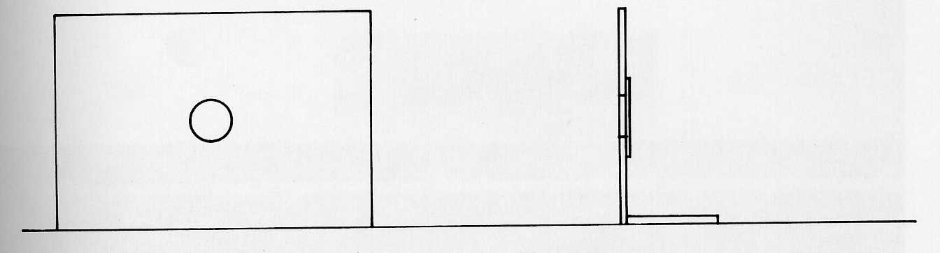

Arrange these items as shown in the figure below. Look along the surface of the book by placing the eye in the position show in the figure. The surface of the book represents the land and distant horizon. The sun, even though it is below the horizon, will be clearly seen. Remove the bottle and the image of the sun cannot be seen.
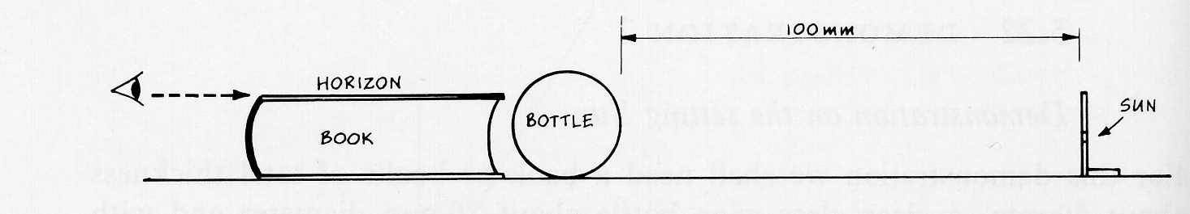
What’s happening: As the light leaves the “sun”, it strikes the bottle. The path of the rays are bent by the water within the bottle making them curve just enough so that they reach the observer’s eyes. With the bottle removed, the rays of light leaving the “sun” continue straight along and pass above the observer’s eyes.

