Name:

Sun Scale Activities

To the teacher: Students should only perform one of these two activities. After doing both activities yourself, it should be clear that it is impossible to use this approach to determine the diameter of the sun without knowing its distance and visa versa. Other indirect techniques (e.g., parallax, radar) must be first used to determine the earth-sun distance first. Either approach is good for showing the utility of geometry (the study of similar triangles) to solve such problems.

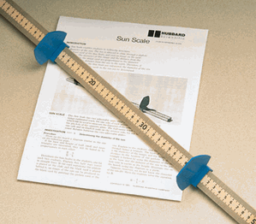
Activity 1: This activity will allow you to indirectly determine the diameter of the sun. Light from the sun is allowed to pass through a pinhole and fall on a scale. The diameter of the image so produced, included with knowledge of the distance of the image from the pinhole and the distance of the sun, can be used to determine the diameter of the sun using the following relationship:

$$\frac{\text{diameter}\text{of}\text{the}\text{sun}}{\text{distance}\text{from}\text{sun}\text{to}\text{earth}}=\frac{\text{diameter of}\text{image}\text{of}\text{the}\text{sun}}{\text{distance}\text{from}\text{pinhole}\text{to}\text{image}}$$

From measurements using the sun scale, you can determine only two of the above four numbers. To determine the diameter of the sun, you will need to know the distance from sun to earth. That value is about 93 million miles. Given this information, use the above equation to determine the diameter of the sun. Show all work.

Activity 2: This activity will allow you to indirectly determine the distance from sun to earth. Light from the sun is allowed to pass through a pinhole and fall on a scale. The diameter of the image so produced, included with knowledge of the distance of the image from the pinhole and the diameter of the sun, can be used to determine the distance of the sun using the following relationship:

$$\frac{\text{diameter}\text{of}\text{the}\text{sun}}{\text{distance}\text{from}\text{sun}\text{to}\text{earth}}=\frac{\text{diameter of}\text{image}\text{of}\text{the}\text{sun}}{\text{distance}\text{from}\text{pinhole}\text{to}\text{image}}$$

From measurements using the sun scale, you can determine only two of the above four numbers. To determine the distance of the sun from earth, you will need to know the diameter of the sun. That value is about 865 thousand miles. Given this information, use the above equation to determine the distance of the sun from earth. Show all work.

