Building a Refracting Telescope – II *

Subject: Physics/Physical Science – Light Rays, Optics

Grade Level: 6-12

Behavioral Objective:
1. Design and create a telescope with two convex lenses.
2. Calculate the magnification of a telescope.

ILS Science:
11.B Know and apply the concepts, principles and processes of technological design.
12.C Know and apply concepts that describe properties of matter and energy [light rays] and the interactions between them.

Time: 1-2 45-minute lessons

Materials:
Building a Refracting Telescope II Worksheet (per student)
Refracting telescope kit (per student group)

Teacher Notes:
Refracting telescope kits can be purchased from most major science education suppliers. Kits often sell in bundles of 10 telescopes for around $70.
Building a Refracting Telescope – II *
The word “telescope” comes from two Greek words: tele “far” + skopos “seeing”. Therefore, the telescope is a “far-seeing” optical instrument used to see things a great distance away. Using the materials provided, assemble a telescope similar to the one Galileo first constructed and used to study the heavens. Assemble your telescope as shown in the figure below:

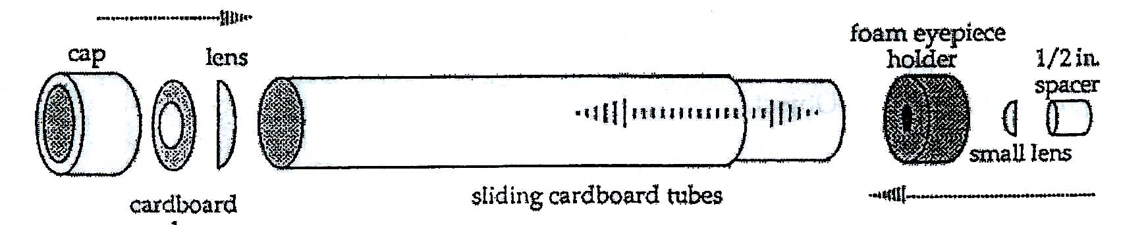

Warning: NEVER direct your telescope at the sun; viewing the sun can cause eye damage or blindness. Turn your telescope on a distant and then a near land object. Focus the objects as clearly as possible. Note that the focus of the telescope changes for objects near and far. You will see that a telescope magnifies objects – makes them look larger than they would appear to the unaided eye. Magnification helps us to see more detail than before. Note also that the images are inverted or turned top to bottom and side to side. This inversion is caused by the objective lens. Remember, the eyepiece used as a magnifying glass merely enlarges the image created by the objective; it will not invert it. By changing eyepiece lenses we can also change the magnification of a telescope.

You will note that your telescope magnifies the apparent size of the viewed object several times. You can use the same method Galileo first used to determine the magnification of your telescope. First, cut out circles of paper, one each of 1, 2, 3, and 4 inches in diameter. Tape the 1-inch disk to a nearby wall and tape the other circles in a vertical line to the left of the 1-inch disk in the arrangement shown in the figure below:

1. Using your right eye, look through the telescope to observe the 1-inch disk. Using your left eye, compare what you see with the unaided eye with what you see with the telescope-assisted eye. Which disk, the 2-inch, 3-inch, or 4-inch appears the about the same size as the image revealed by the telescope? Write your answer on the line below:

2. If the 1-inch telescopic disk appears only as large as the 2-inch disk, then the magnification of your telescope is 2X or two times. That is, the telescope makes things look 2 times higher and wider than seen with the unaided eye. The same thing is true with the 3-inch and 4-inch disks. What is the magnification of your telescope?

X

Scientists have developed a formula to calculate the magnifying power of a telescope:

Magnification = focal length of the objective / focal length of the eyepiece

3. What is the focal length of your objective lens?

4. What is the focal length of your eyepiece lens?

5. Using the above magnification formula, calculate the magnifying power of your telescope; show your calculations.

M = __________ = __________ X

6. How do your predicted and observed magnifications compare?

Magnification calculated = __________ Magnification measured = __________

If the two magnifications differ by more than a little, you might want to check your calculation and your measurement to see if one of them is in error.

Magnifying power is just one of the many different types of power your telescope possesses. It also has light-gathering power and resolving power. Because a large lens (like a telescope lens) can gather more light than the human eye, it will often show faint objects not visible with the unaided eye. The larger lens of a telescope will also reveal more detail in an enlarged image.

