Physical Science Name ________________
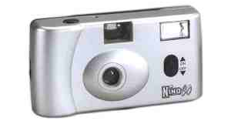
Test; Light Part 2
Lab Practical
Look through the camera like you are taking a picture. This area is called the viewfinder.
- What kind of lens do you think makes up the viewfinder?

- Explain how you know the kind of lens that makes up the viewfinder.

Open up the back of the camera and look through the camera lens, holding the camera at arm’s length.
- What kind of lens do you think is the camera eye lens?

- Explain how you know the kind of lens that makes up the camera eye.

Now open up the camera entirely by removing the middle and front piece of the camera. Remove the lenses.
- Feel the viewfinder lens – describe or draw its shape.

- Does your answer to #5 agree with your first prediction before you opened the camera? Explain why or why not.
- Feel the camera eye lens – describe or draw its shape.

- Does your answer to #7 agree with your first prediction before you opened the camera? Explain why or why not.

- Some cameras allow you to manually focus the camera lens. Using your knowledge of lens, explain how a lens can be adjusted to focus on an object.

You can come up to the front of the room and look through the sample periscope, if you like.
- Using your knowledge of mirrors and light, explain AND draw how a periscope works. (hint: think laser challenge)

