Refraction Activity

Subject: Physics/Physical Science – Light Rays, Optics

Grade Level: 4-12

Behavioral Objective:
Describe how light breaks and changes direction (refracts) as it passes from one material to another and causes image distortion.

ILS Science:
12.C Know and apply concepts that describe properties of matter and energy [light rays] and the interactions between them.
Time: 1 45-minute lesson

Materials:
Beakers (2 beakers per pair of students)
Pencil (1 pencil per pair of students)
Refraction Activity Worksheet

Teacher Notes:
From this activity, students should understand that a beaker filled with water acts like a lens, in how it is able to magnify objects. Objects become magnified because refraction of light can cause rays to be spread further apart.

Refraction Activity

Long ago scientists discovered that there is a way around the problems inherent in the pinhole projection system. These workers knew that light rays could be bent if the light was forced to pass through different substances such as water or glass. It's time for another experiment to see what they discovered.

Take an EMPTY tall, clear water beaker (or glass) and rest a pencil in it. Look at the pencil from the side looking through the glass. Draw a picture of what you observe by completing the first figure below. Record a description of what you see.

Now, fill the beaker with water about 2/3 way up. What do you see? Does the pencil appear any different than before? Draw a picture of what you observe by completing the other figure below. Record below any changes you observe in your description.

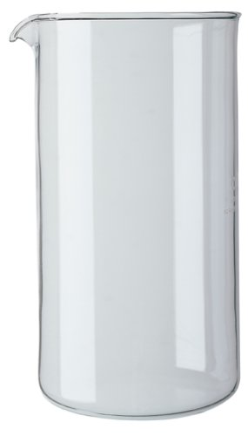
Waterless Beaker Water-filled Beaker
1. Description: 2. Description:

3. Pull the pencil towards you, while keeping it in the beaker. What happens to the apparent size of the pencil in the water when it is brought toward the front of the beaker (toward you)? What happens to the apparent size when it is sent toward the back of the beaker (away from you)?

If you have been careful in your observations, you will have seen that not only does the pencil appear to be “broken”, but the size of the pencil immersed in the water appears to be “larger” when brought forward. You know that the pencil “really” hasn't been bent or enlarged by the water – it only looks that way. When you pull the pencil out of the water is doesn't appear any different than before. Something has happened to the light coming from that part of the pencil immersed in water.

Think about what has happened to the light to make the pencil look “broken” or “much larger than expected” when it was drawn nearer to you. Look at the picture below. You see identical dogs, but one is larger than the other; both are at the same distance from the boy.

4. Draw a line from the tip of the top dog’s top ear to the boy’s eye and another line from the bottom of the top dog’s chest to the boy’s eye. Do this with the bottom dog as well.

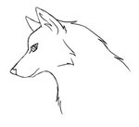

Free Clip Art Provided by Artclips.com

5. Using a protractor, measure the angle between each dog’s ear tip and chest, and record below:

Top Dog’s Angle: Bottom Dog’s Angle:

6. Which dog’s ear and chest appears to span the larger angle? Why?

7. Using only his eyes, how does the boy know that the top dog is bigger than the bottom dog?

8. Using what you know from the example of the dogs, what do you think the water in the beaker does to the path of the light rays coming from the pencil to make the pencil look larger? Include a sketch in your explanation.

The ability to change the direction of light is known as “refraction”.

