A Basic Test of Astronomical Facts & Concepts Name:
(Adapted from a Project STAR Activity)
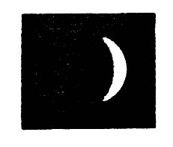
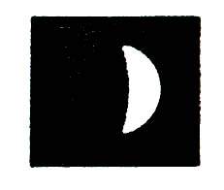
1. One night we looked A few days later we looked
at the moon and saw this: again and saw this:

What do you think best describes the reason for this change?
A. Fewer clouds block the Moon. B. The Moon moved out of the Earth’s shadow.
C. The Moon moves out of the Sun’s shadow. D. The Moon is black and white and rotates.
E. The Moon moves around the Earth. F. The Earth moves around the Moon.
G. The Moon passes the planets and goes in and out of their shadows.

2. What causes night and day?
A. The Earth turns on its axis. B. The Earth moves around the Sun.
C. The Moon blocks out the Sun’s light. D. The Earth moves into the Sun’s shadow.
E. The Sun goes around the Earth.

3. On October 17, 1604, Johannes Kepler went outside, looked up and saw a bright star where none had been before – what astronomers today call a supernova, an exploding star. When do you think the star exploded?

A. Before October 17, 1604 B. On October 17, 1604 C. After October 17, 1604
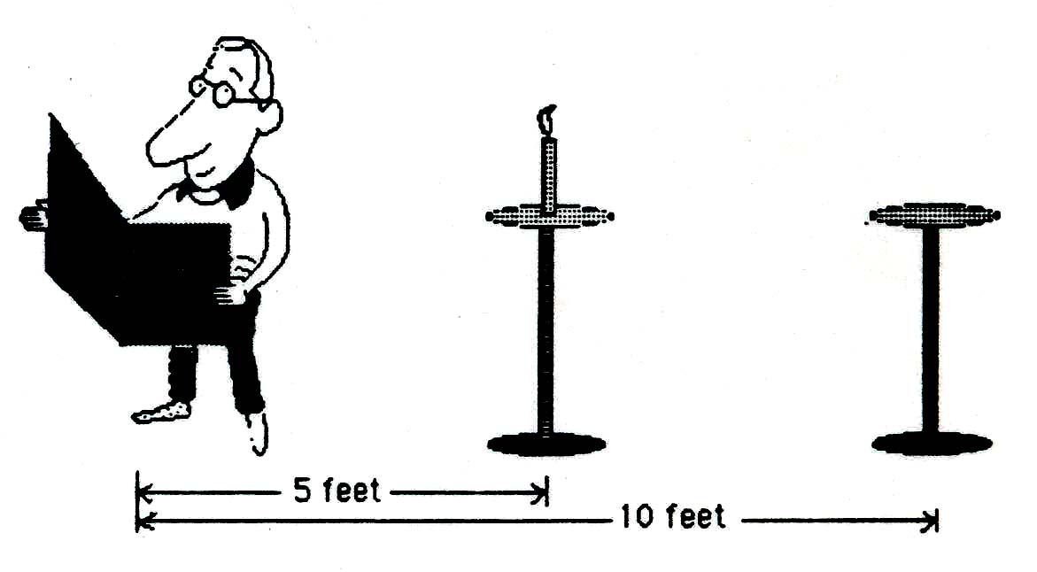
4. The man is reading a newspaper by the light
of a single candle 5 feet away. State the
number of candles necessary to light up the
paper to the same brightness if the candle
holder were moved 10 feet from the newspaper.

A. 1 candle B. 2 candles
C. 3 candles D. 4 candles
E. 5 candles F. more than 5 candles

5. What causes the seasons?
A. The Earth’s changing distance from the Sun.
B. The Earth’s axis flipping back and for as it travels around the Sun.
C. The Sun’s motion around the Earth.
D. The Earth’s axis always pointing in the same direction.
E. The shifting seasons on the Earth.

6. Which answer goes from the smallest size to the largest size?
A. Sun -> Earth -> Moon B. Sun -> Moon -> Earth
C. Earth -> Moon -> Sun D. Earth -> Sun -> Moon
E. Moon -> Sun -> Earth F. Moon -> Earth -> Sun

7. What time could it be if you saw a thin crescent Moon (as in question 1) on the western horizon?
A. Shortly before sunrise B. Shortly after sunset
C. Noon D. Midnight
E. Anytime of day or night F. Not possible
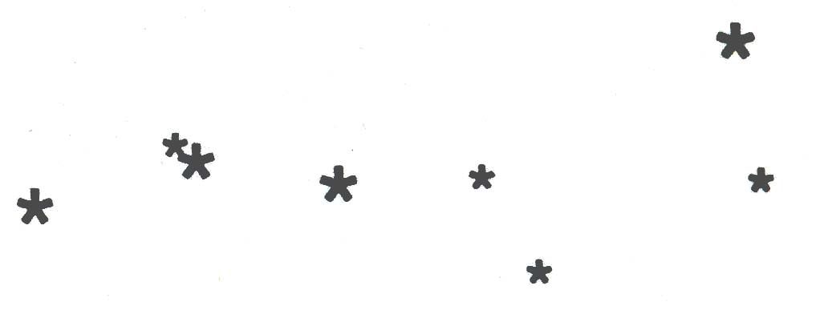
8. What is the name of this pattern of stars?

A. Orion
B. Ursa Major
C. North Star
D. Big Dipper
E. Pleiades

9. If you could see stars during the day, this is what the sky would look like at noon on a given day. The Sun is in the constellation of Gemini.
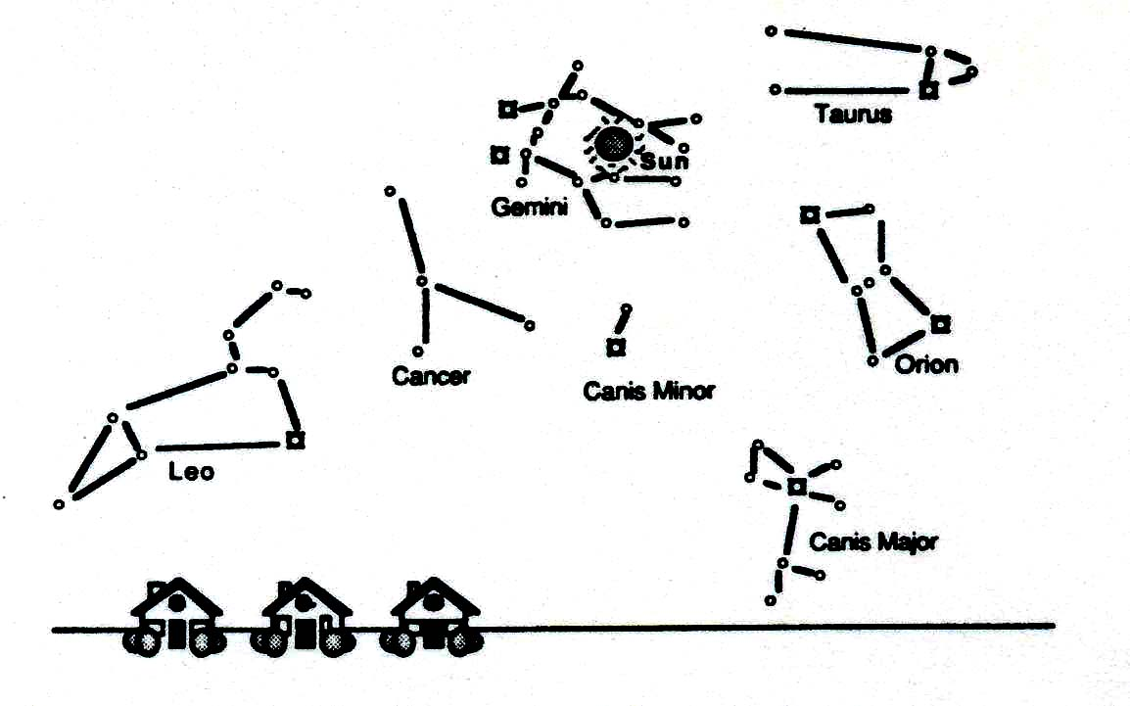
In what constellation is the sun at sunset on the same day?

A. Leo B. Canis Major C. Gemini D. Cancer E. Taurus

10. Assume these circles represent to objects in the solar system with their diameters drawn to scale.

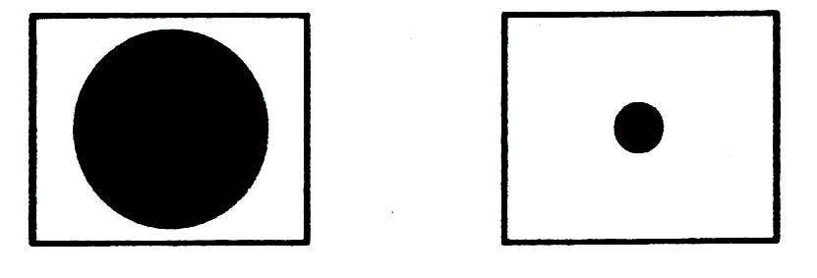

Which objects could they accurately represent?
A. Earth and Moon B. Jupiter and Earth
C. Sun and Earth D. Sun and Jupiter

