Civil Time Keeping (intended primarily for teachers)

The time we keep on our watches and clocks is know as civil time. It is not solar time. Solar time depends upon the motion and location of the sun. Solar time reads 12 p.m. each day when the sun is due south in the sky. That is rarely the case with our current system of time keeping. One of the reasons that time keeping is not based upon the sun per se, is because the sun’s motion is irregular. Because of its seasonal north-south peregrinations resulting from the tilt of the earth’s axis, and because of the changing earth-sun distance, the sun’s eastward motion among the stars is not at all uniform. Clocks move at uniform rates; the sun does not. Hence, the sun is not a reliable clock generally speaking.
Observations of the sun can be used to determine the local time based upon a hypothetical uniformly moving sun known as the mean sun. Sundials using the true sun are used to determine apparent local solar time and then corrected for the sun’s irregular motion to determine the local mean time. Here is where it gets complicated.
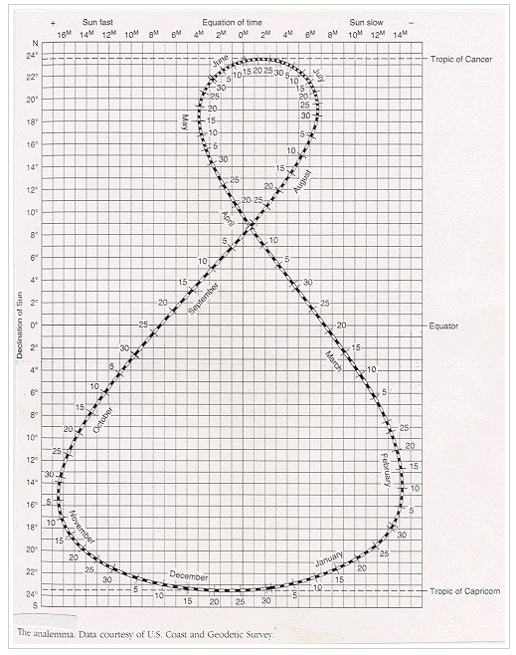
The sun’s irregular eastward motion among the background stars (caused by the earth’s irregular orbital motion around the sun – faster when closer and slower when farther), is recorded graphically in a figure known as the analemma. You might have seen this figure on a globe or map. The sun’s north-south motion is fairly well understand by most people. When coupled with the sun’s irregular eastward motion (which amounts to as much as about +/- 16 minutes over the course of the year), the analemma results. Sundial users correct sundial readings by taking into account this “equation of time”. Depending upon the date (or sun’s declination), the equation of time is read as showing the sun as either fast or slow. If the sun is slow like it would be on February 10, 14 minutes would be added to the apparent local solar time to obtain the local mean time. Now, bear with me!
Because it is impractical for every town to have its own local mean time, the American railroad system instituted four times zones within the United States in the late 1800s. Everyone within one of these four time zones had to set their clocks to the same local mean time kept at the center of each time zone (75º, 90 º, 105 º, and 120 º West longitude in this case). For every degree EAST of the central meridian, the local mean time is ahead of zone time by 4 minutes per degree of longitude so 4 minutes have to be subtracted for each degree of longitude EAST to get standard or zone time. The opposite is true with locations WEST of their central meridian. Not quite finished!
During the summer we institute daylight saving time, when we add one hour to the clock to give us more sunlight during the summer evening hours when people are around and about. We return to standard time when sunrise gets too late and students find themselves going to school in the dark during the mornings. Capice?!

