Earth’s Orbit Diagram
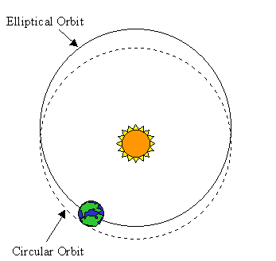

Earth travels around the sun in a slightly elliptical (nearly circular) orbit. Note that the earth's orbit is an ellipse, not a circle. Compare the elliptical and circular paths. (Ellipticity of Earth’s orbit in this drawing is highly exaggerated.)

Earth is closest to the sun around January 3rd each year, and farthest from the sun around July 4th each year.

http://www.timezone.com/img/articles/tmachine0004/TBfig1-4.gif

