Name:
Exploring the Moon Activity

It’s rather amazing what you can learn about the moon by studying photographic maps of its surface. In this exercise you will use Sky & Telescope’s Moon Map to learn a bit about lunar features and history. Use this moon map to answer the following questions to the best of your ability. Your answers to some of the questions will be “hypotheses”, attempts to explain what you see. As a result, some of these answers might be either right or wrong. Only a visit to the moon can answer some of the questions with reasonable certainty.

Look carefully at your image of the moon. Notice the following features:

- Craters | - Mountain ranges
- Maria or “seas” | - Apollo landing sites

- Some of the largest features on the moon are maria (pronounced $m\bar{a}r^{'}−e−\text{uh}$). Give the name of the largest maria on the visible surface of the moon.

- What general shape do some of the largest maria have, especially those in the northern hemisphere?

- What do you think accounts for the marias’ smooth appearance?

- Can you find any evidence of once flowing material within various lunar maria? If yes, explain.

- Look for craters within the lunar maria. Which do you think came first, the maria or the craters? How can you tell?

- Look at the lunar highlands, especially the rugged mountainous region in the far southern hemisphere. What do you think caused the terrain to appear as it does?

- Look for the largest crater on the visible surface of the moon. Can you find it? It’s nearly 700 miles across. Find it and give its name.

- Look for the crater Tycho (crater number 234) on the Sky & Telescope Moon Map. Because this is actually a painted relief map and not a photograph, the fine details surrounding the crater are not evident on the map. See an actual photograph below, and attempt to explain the reason for the “rays” coming out of Tycho.

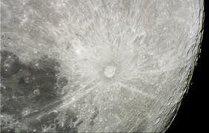

- Compare the maria with the highlands. Which region do you think is older, and how can you tell?

- What happened at the various locations known as the Apollo landing sites?

