Elevation and Azimuth Worksheet

Everyone uses directions to describe the locations of objects in the sky. Non-scientists use the directions around the horizon (e.g., north, southeast) and fractional distances above the horizon (e.g., half way up). Scientists use much more precise angular distances around horizon (azimuth with 0º north and 90º east) and above the horizon (elevation with 0º at the horizon and 90º at the zenith). To exhibit your understanding of both systems of location, answer the following questions.
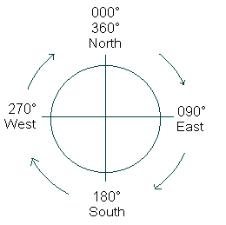
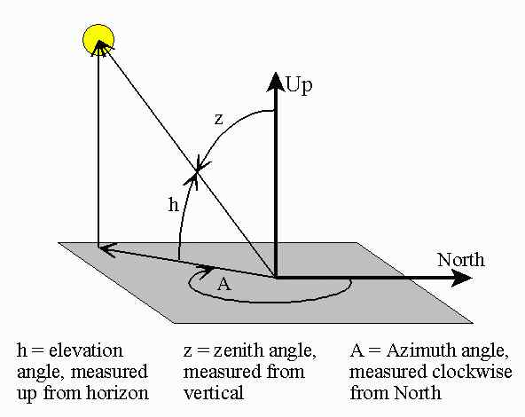

CARDINAL POINTS:

- You are facing south. Which direction is behind you? _____
- You are facing west. Which direction is to your left? ______
- You are facing east. Which direction is to your right? ______

ELEVATION AND AZIMUTH:

- The sun is located half way up in the southwest. What is its elevation? ___
- The sun is located half way up in the southwest. What is its azimuth? ___

LOCATION OF POLARIS: Earth’s rotation axis points nearly at the star Polaris, the North Star. As a result, the star stands nearly still in the sky and its azimuth is nearly 0º for all observers in the northern hemisphere. The elevation, however, depends upon where one is located on the earth. The elevation of the North Star is nearly equal to one’s latitude.

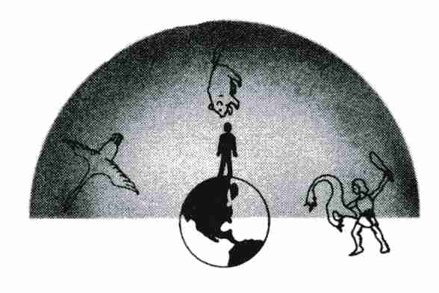
- You are located at Earth’s north pole, 90º north latitude. Give the azimuth and elevation of the North Star as seen from this location.

- Describe in words where you would look to find
Polaris, the North Star.

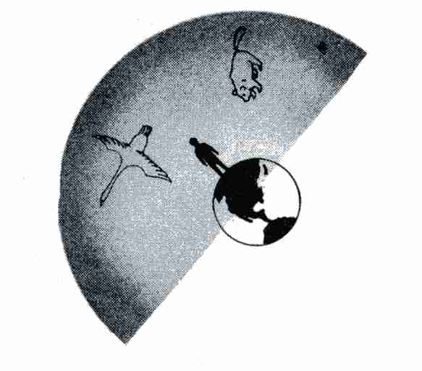
- You are located at home, about 40º north latitude. Give the azimuth and elevation of the North Star as seen from this location.

- Describe in words where you would look to find Polaris, the North Star.

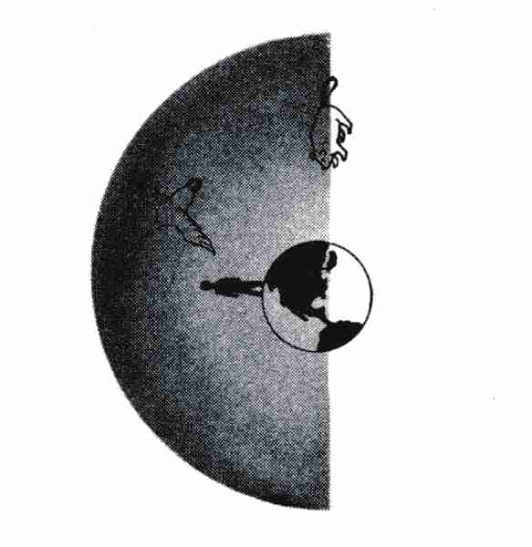
- You are located at Earth’s equator, 0º latitude. Give the azimuth and elevation of the North Star as seen from this location.

- Describe in words where you would look to find Polaris, the North Star.

- Imagine that you are located at Earth’s south pole. Where would you point if you were asked to indicate the location of the North Star?

Credit: The above images were taken from Tracking the Stars, Preliminary Edition, by Robert H. Duke. © 1968 (copyright expired)

