Star Finder Activity

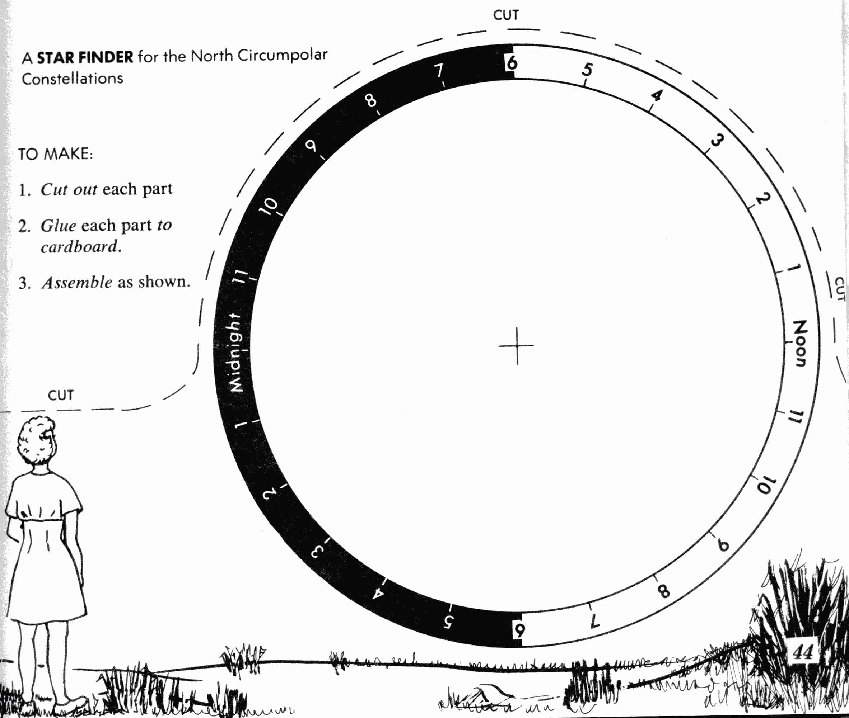

Credit: The graphics and text of this activity were taken from Tracking the Stars, Preliminary Edition, by Robert H. Duke. © 1968 (copyright expired)

