Stars Around Polaris Worksheet

Note the five north circumpolar constellations in the image below that appear to move in a counter-clockwise fashion around Polaris, the North Star.

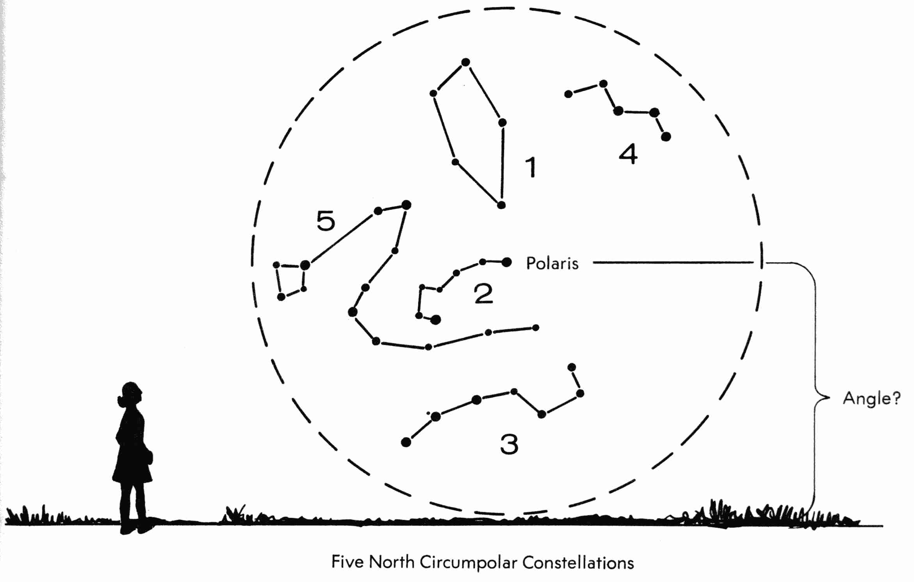

- What is the angle between Polaris and the northern horizon?

- Name the five popular North Circumpolar Constellations pictured above. Use the images and information on the next page to help in your identification. But first, doing the following with the images on the next page:

- form a stick figure of each north circumpolar constellation by connecting the stars you find with straight lines.
- beside each of the names, state what figure each constellation represents.

Constellation #1:
Constellation #2:
Constellation #3:
Constellation #4:
Constellation #5:
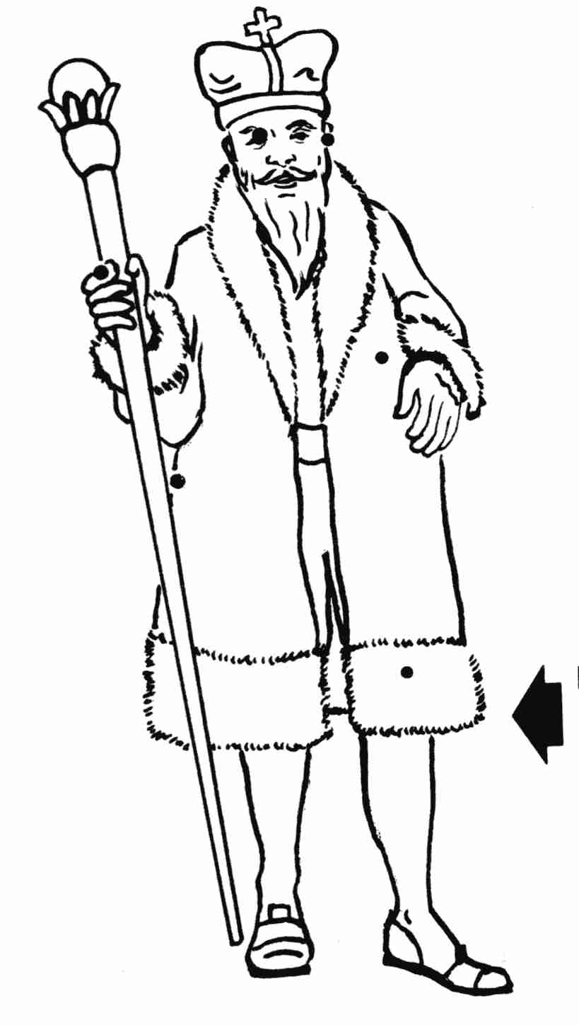
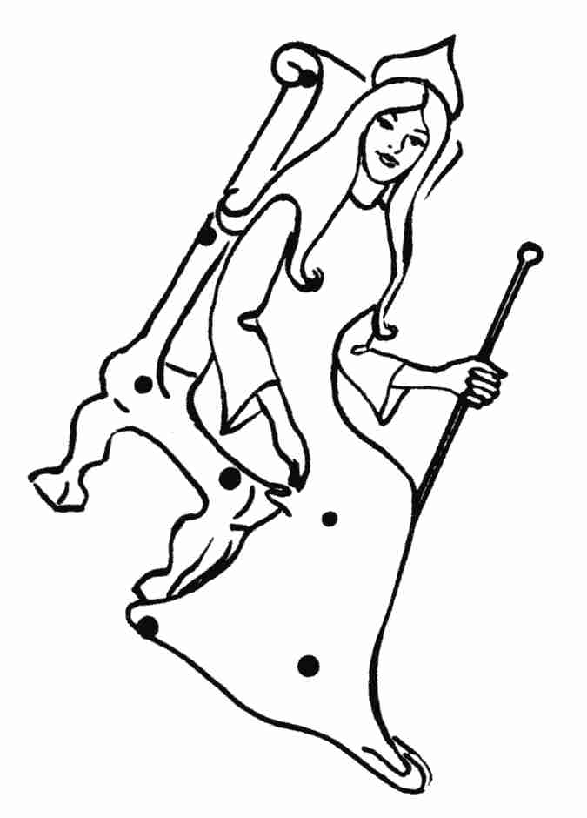
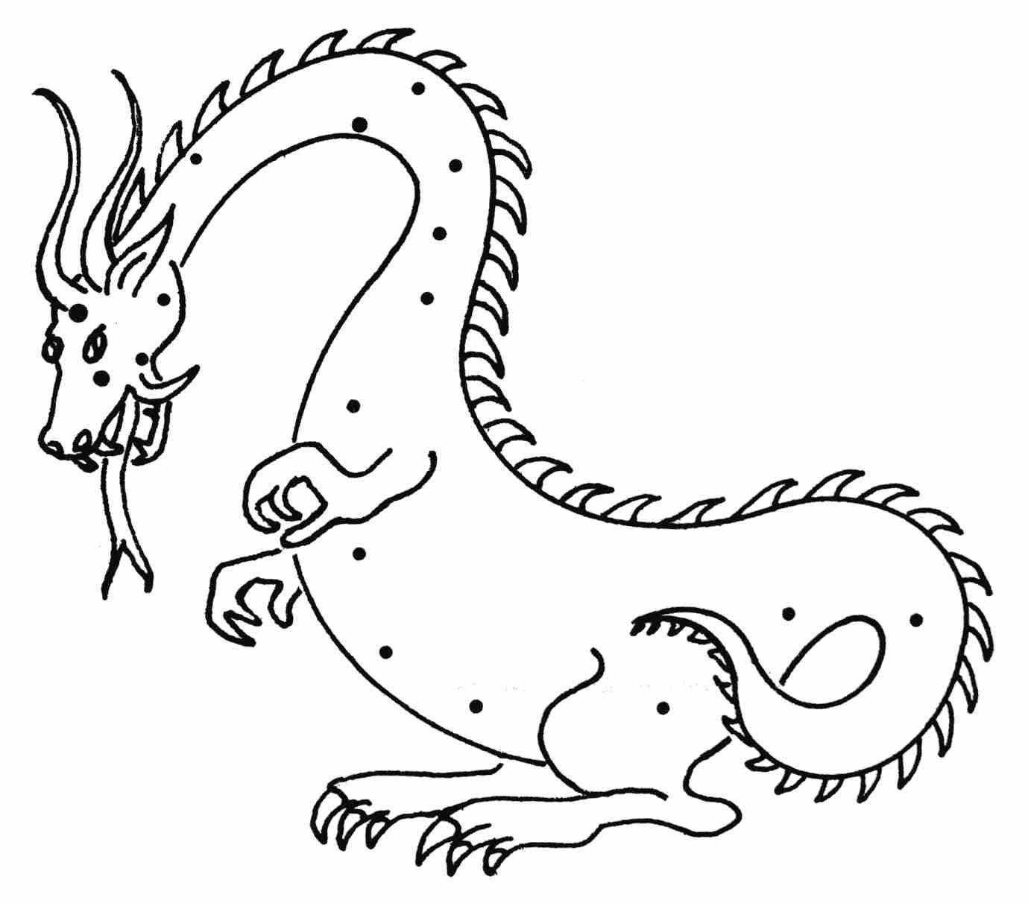

Name: Cassiopeia
Name: Cepheus
Figure: _______
Figure: ________

Name: Draco

Figure: _________
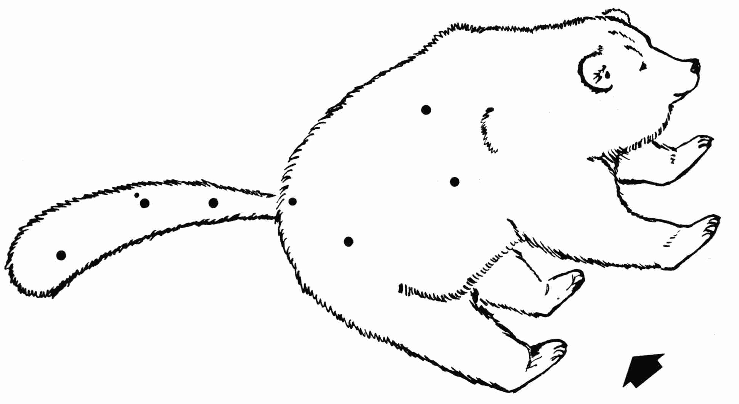

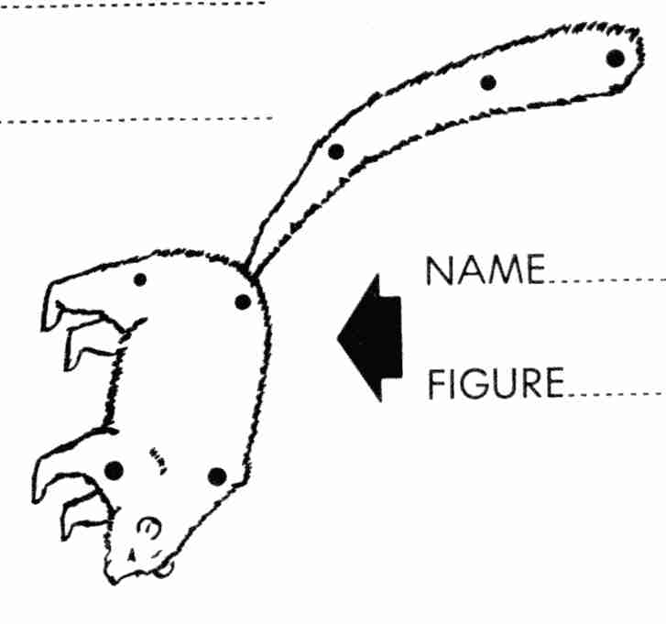
Name: Ursa Minor Name: Ursa Major
Figure: ______ __________
Figure: _______ __________

Credit: The graphics and text of this activity were taken from Tracking the Stars, Preliminary Edition, by Robert H. Duke. © 1968 (copyright expired)

