The View from Earth Worksheet

- Add stars to the drawing below. Draw them as astronomers might – by drawing small disks. The brighter the star, the larger the disk.

TO BE CORRECT:
- You should draw more dim stars than bright stars. True / False
- You might draw as many as 3,000 stars. True / False
- You should draw the sky “bowl shaped”. True / False



- The sky at night appears bowl shaped no matter where you stand on the earth’s surface. True / False
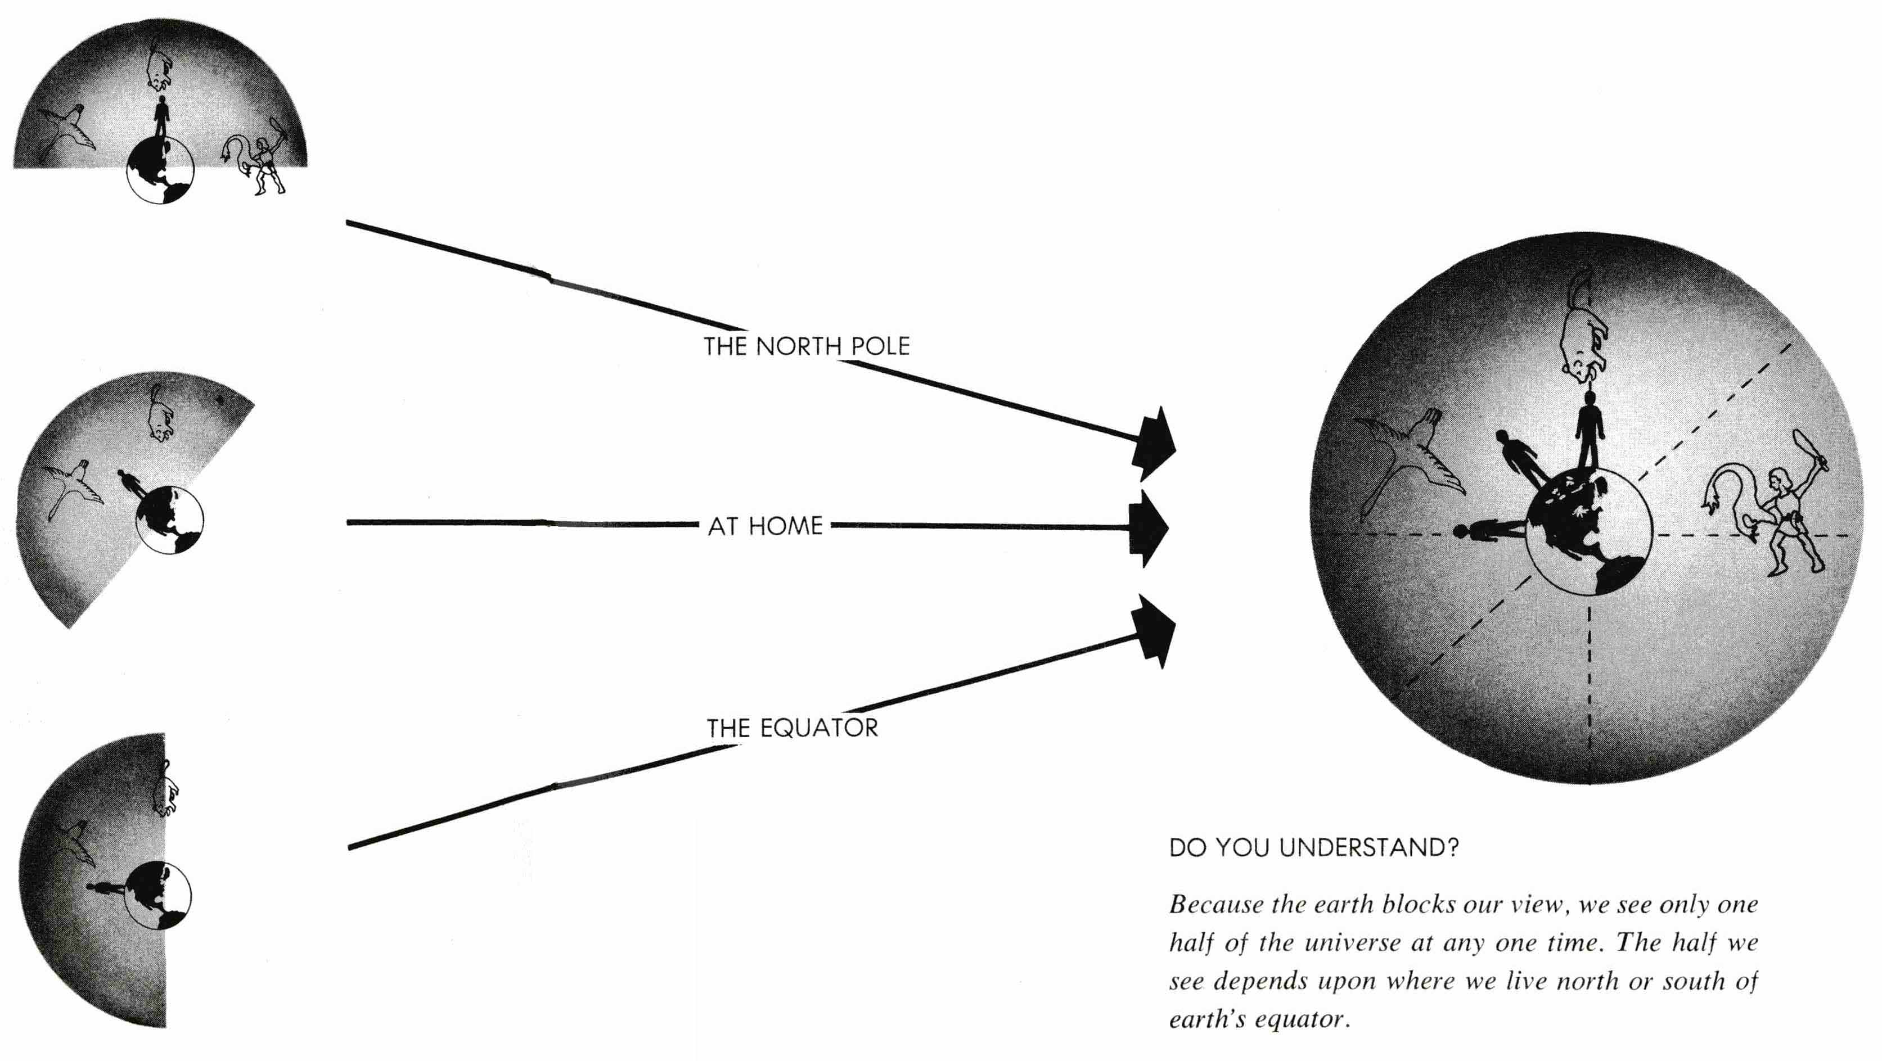

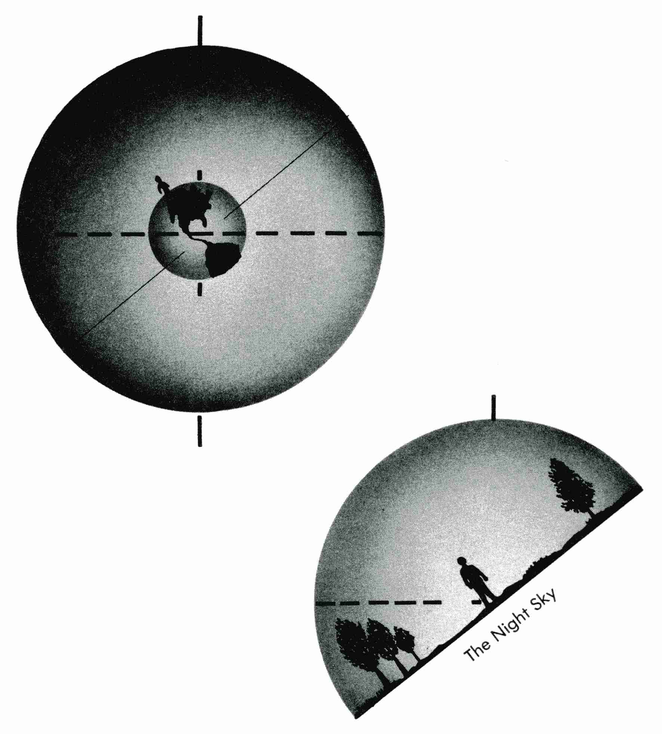
- Label the following on the celestial sphere:
- North Celestial Pole
- Celestial Equator
- observer’s horizon

- Label the following on the celestial hemisphere:
- North Celestial Pole
- Celestial Equator
- North and South

- Also on the celestial hemisphere:
- Indicate the elevation of the North Celestial Pole in degrees as seen from central Illinois.
- Indicate the elevation of the Celestial Equator in degrees as seen from central Illinois.

Because the Earth is spinning west to east, the stars appear to rise in the east and set in the west. In the hemisphere above (and on the next page), east is on the near side of the hemisphere and west is on the far side. Now, examine the images on the next page and answer the following questions.

- In the celestial sphere on the next page, do the stars appear to move parallel to or perpendicular to the Earth’s axis of rotation? Parallel / Perpendicular

- Also in the celestial sphere on the next page, do the stars appear to move parallel or perpendicular to the celestial equator? Parallel / Perpendicular

- In the celestial hemisphere on the next page, draw the apparent motion of the stars on the hemisphere as we see them move from our location on earth. First, draw stars. Then, add arrows.

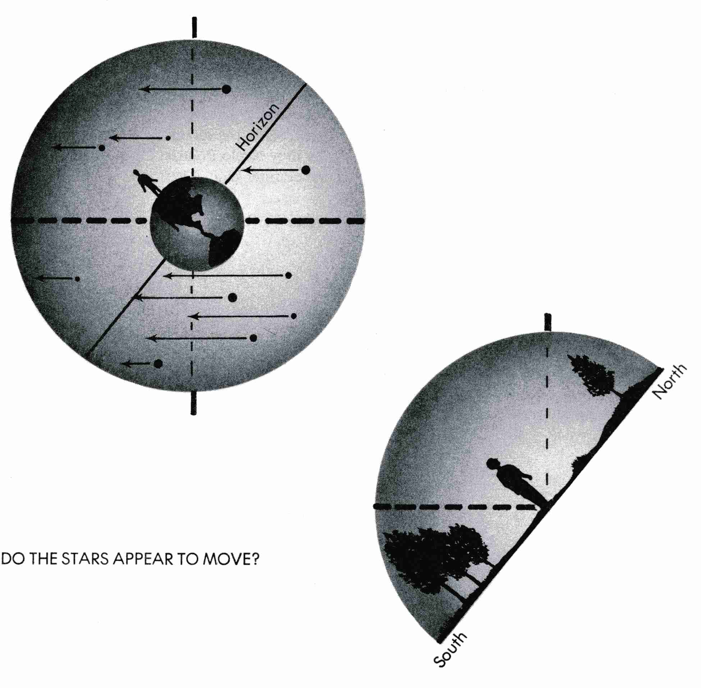
LOOKING NORTH: Notice in the drawings below that most stars cross the horizon as they rise in the east, move across the southern sky, and set in the west. However, some stars remain above the horizon throughout the day and night, and other stars never rise into view at all. One faint star appears to stand nearly still in the sky – Polaris the North Star.

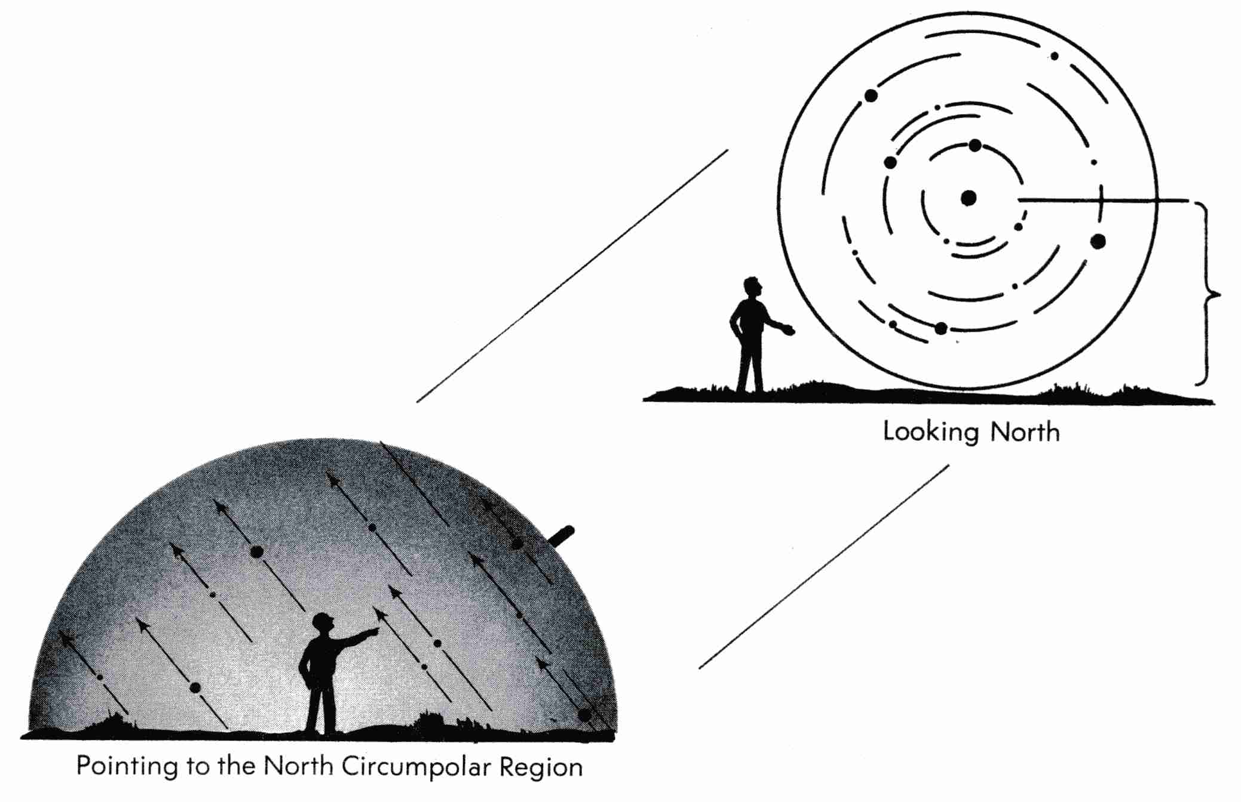

- Using arrow heads, or an arrow, show the direction the stars seem to move as they circle Polaris, Do they move clockwise or counter-clockwise? (circle)
- In the second of the lower drawings, shade the area of the sky where the stars remain above the horizon day and night. Label that area the North Circumpolar Region.
- In the second of the lower drawings, also indicate the location of the star that stands nearly still in the night sky, and label it Polaris the North Star.

LOOKING SOUTH: Notice in the first image below that most stars rise in the eastern sky, set in the western sky, and move across the southern sky.

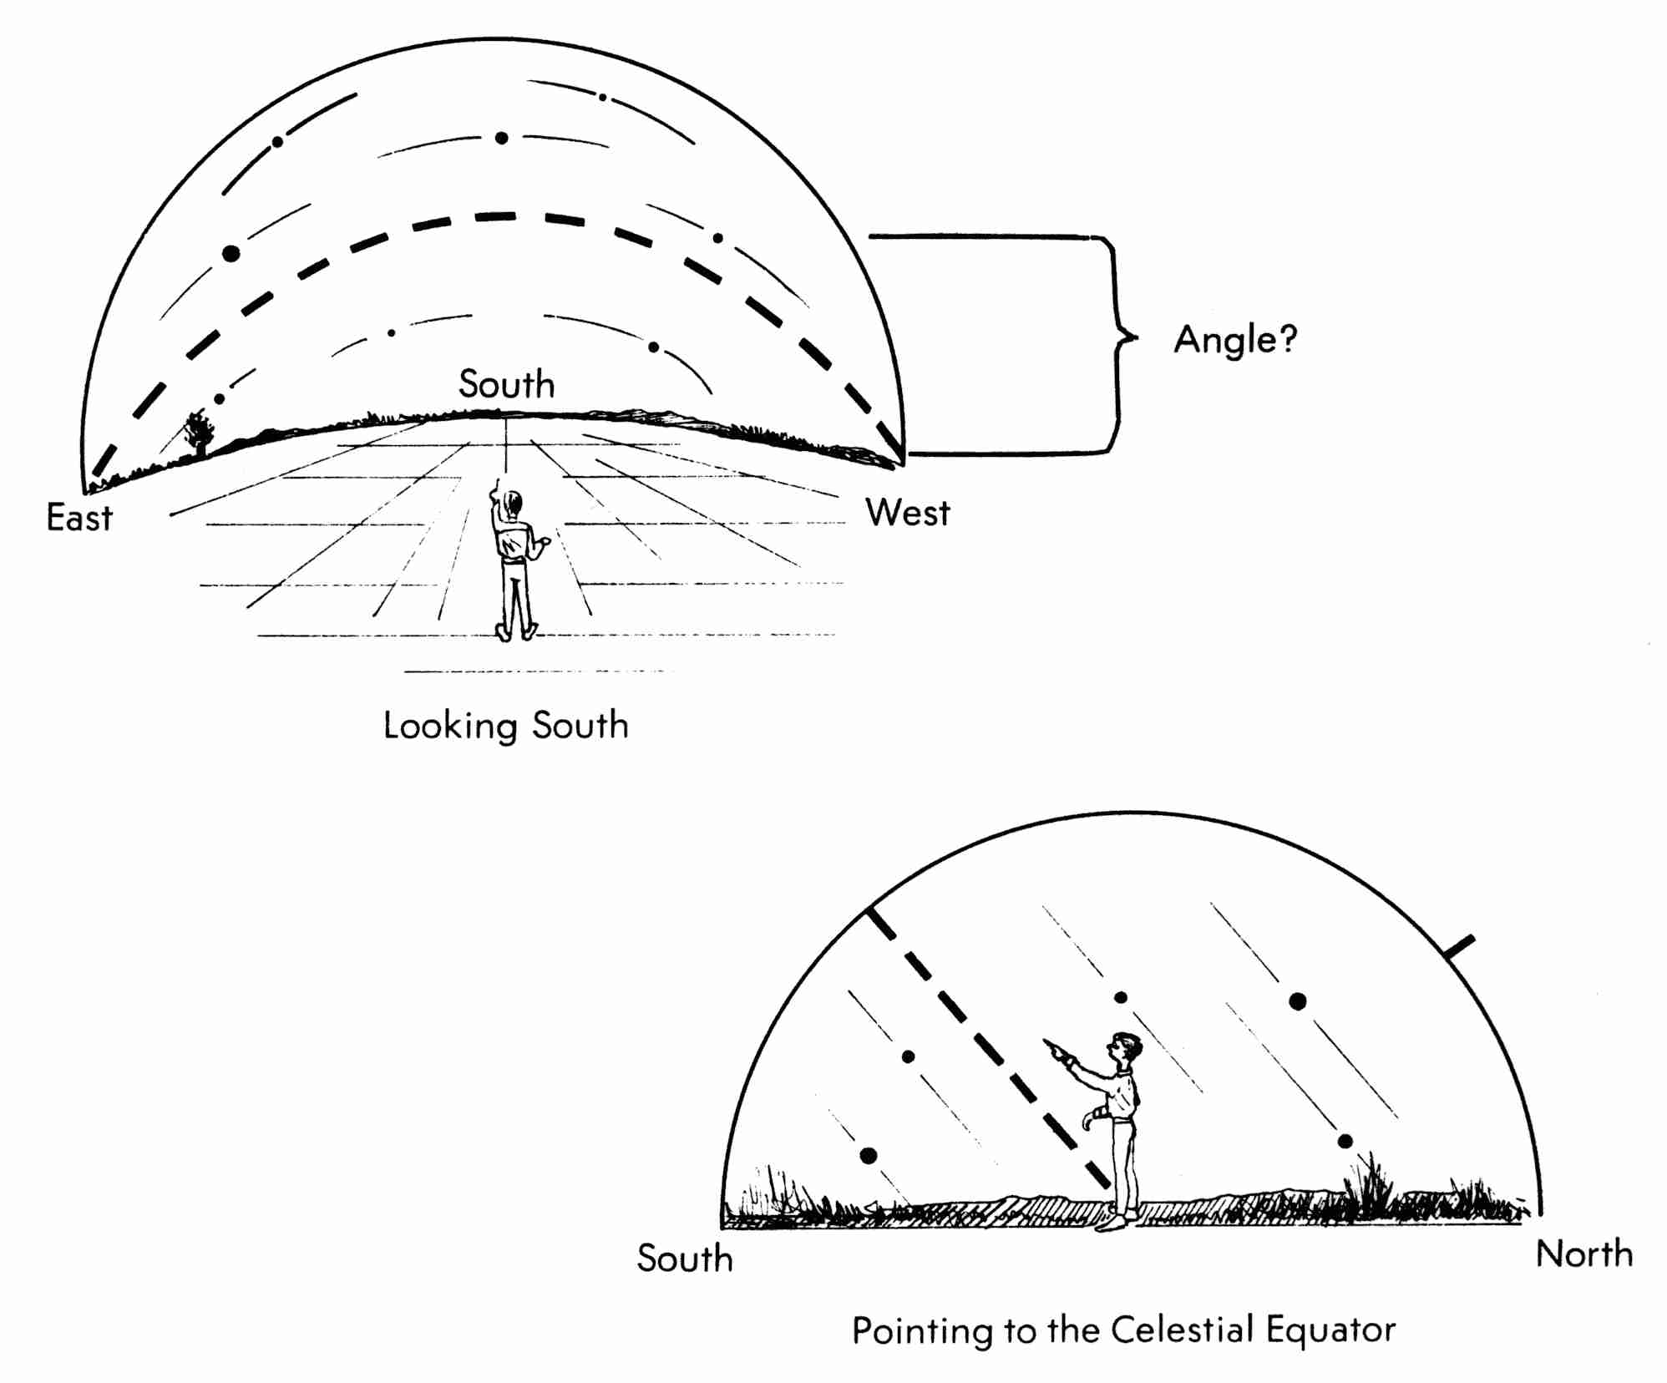
- In the second image above, shade the area of the sky where all stars (except the north circumpolar stars) rise and set. Label that area the Equatorial region.
- In both images the boy is pointing to the celestial equator at its highest point. How high above the horizon is he pointing? Indicate this angle in the first image.
- Label the celestial equator in both images.
- Using arrow heads, or an arrow, show the direction the stars seem to move across the southern sky.

REMEMBER: The spinning of the Earth causes the daily motion of the stars. As the Earth spins from west to east, stars appear to rise in the east and set in the west.

Credit: The graphics and text of this activity were taken from Tracking the Stars, Preliminary Edition, by Robert H. Duke. © 1968 (copyright expired)

