Name:
Plot the position of: Sun in yellow Mercury in gray Mars in red
Moon in white Venus in orange Jupiter in green
Earth in blue Saturn in purple
Name:
Equatorial Sky Chart Activity

Using the provided Equatorial Sky Chart, complete the following activities and provide the required answers.

- Using the Naval Oceanography Portal from the US Naval Observatory (available at http://www.usno.navy.mil/USNO/astronomical-applications/data-services/geo-pos), obtain the apparent geocentric positions of the Sun, Moon, and planets for a date determined by your teacher. Record the date and required solar system information below. Alternatively, obtain this information from your teacher. The constellation information will be obtained from the sky chart once you plot the location of objects.

Date:

Planet | Right Ascension  (h m s) | Declination  (d m s) | Distance  (au) | Constellation
Sun
Moon
Mercury
Venus
Mars
Jupiter
Saturn
Uranus
Neptune

- Using colored pencils, draw circles showing the positions of the sun, moon, and planets on the Equatorial Sky Chart and fill them using the specified colors. Mark the location of Uranus with an “x” and of Neptune with a “+”. If necessary, label each object with one or two letters to assist in their identification (e.g., Su for Sun; Sa for Saturn).

- Using the sky chart, list in the table above the constellation wherein the Sun, Moon, and planets each are located.

- Note that the Sun, Moon, and planets all appear very close to a “wavy” line that cuts across the sky chart. What is the name of this path?

You should note that the names of the constellations associated with this wavy line are rather familiar. These are the constellations of the zodiac. The word comes from the Greek “zoon” meaning “living thing” (like in the English word “zoology”). Note that the constellations of the zodiac are mostly living things: Aries the Ram, Taurus the Bull, Gemini the Twins, Cancer the Crab, Leo the Lion, Virgo the Maiden, Scorpius the Scorpion, Capricornus the Sea Goat, Aquarius the Water Bearer, and Pisces the Fishes. Only Libra the Scales is a non-living thing. These stars once marked the claws of the Scorpion, but were “cut off” to make the 12 constellations of the zodiac. Note that Ophiuchus the Serpent Handler also is in the region of the zodiac.

- Perhaps you haven’t noticed it, but the angle between this “planetary” path and the celestial equator (the line in the sky directly above the Earth’s equator) is 23.5 degrees. Doesn’t this number seem familiar in an astronomical sense? What, do you think, is the reason for this angle?

- As the month goes along, the Moon moves quickly from west to east (right to left) among the background of stars and completing its circuit in 27.3 days. (The Sun moves eastward along this path completing its circuit once per year.) The Moon’s 12x faster motion allows it to overtake the Sun once every 29.5 days or “moonth” (month). Interestingly, the word for the wavy path comes from a Greek word meaning “disappearance” or “abandonment”. Given the Moon’s motion, explain why.

- Measure the elongation (angular distance in degrees) of the Moon from the Sun. Include angle and “east” or “west” below. Hint: Measure the shortest distance between the Sun and Moon and compare with the declination scale. If the Moon is “left” of the Sun, it is east of the Sun. Caution: Sometimes the shortest distance can be measured “around the edge” of the sky chart.

Elongation: Direction:

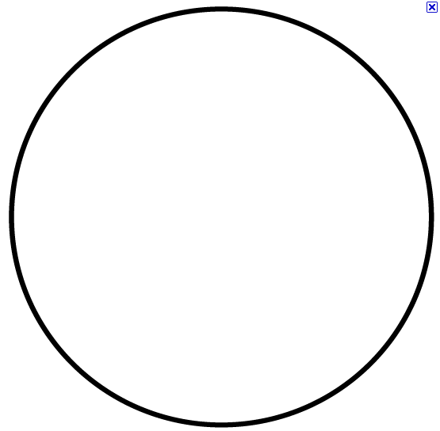
- Given the Moon’s elongation (Elong.) and direction from the Sun, determine its phase using the table below. Draw the Moon’s appearance in the circle.

Moon’s Phase:

Elong. | Direction | Phase | Approx. rise time | Approx. set time
0º | Conjunction | New | 6 a.m. | 6:00 p.m.
45º | East | Waxing crescent | 9 a.m. | 9 p.m.
90º | East | First quarter | 12 p.m. (noon) | 12 a.m. (midnight)
135º | East | Waxing gibbous | 3 p.m. | 3 a.m.
180º | Opposition | Full | 6 p.m. | 6:00 a.m.
135º | West | Waning gibbous | 9 p.m. | 9 a.m.
90º | West | Third quarter | 12 a.m. (midnight) | 12 p.m. (noon)
45º | West | Waning crescent | 3 a.m. | 3 p.m.
0º | Conjunction | New | 6 a.m. | 6:00 p.m.

- When the Moon is east of the Sun, it sets after the Sun. When the Moon is west of the Sun, it rises before the Sun. At what approximate time do you expect the Moon to rise and set on this date?

Rise: Set:

- As the night progresses, celestial objects move toward the west across our sky. Using a ruler or other straight edge held at roughly a 45-degree angle to the right to represent the western horizon, move the horizon west to east starting with the Sun. Describe the order in which the planets appear to set after the Sun.

First:
Second:
Third:
Fourth:
Fifth:

