Name:

Planetary Orbits Worksheet

What are the shapes of orbits of solar system objects? How do orbits of planets differ from those of comets? What are the laws of planetary motion?

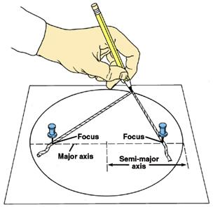
Ellipses: All solar system objects orbit the sun in elliptical orbits. The astronomer Johannes Kepler (1571-1630) discovered this through a study of Mars that the planet orbits the sun with elliptical – not circular – motion. This was his first law of planetary motion.

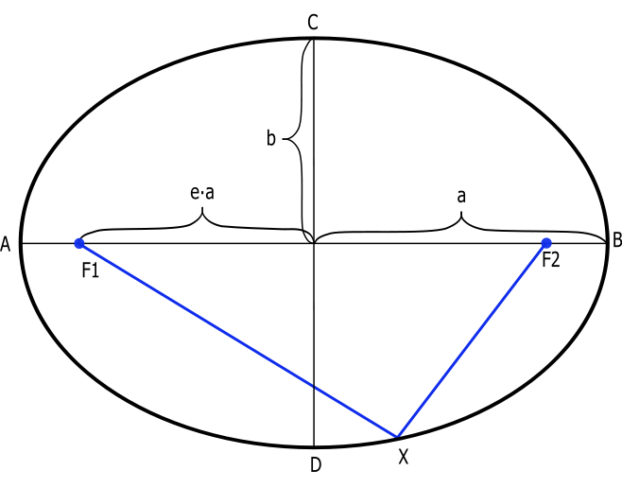
An ellipse is a flattened circle defined by two foci. You can create an ellipse by taking a loop of string, two push pins, and a pencil, and tracing a loop as shown in the image to the left.

Examine the ellipse to the right. Line AB is called the major axis; line CD is called the minor axis. Segment “a” is known as the semi-major axis, and segment “b” is known as the semi-minor axis. The value of “e” in this diagram is known as the eccentricity. Eccentricities between 0 and <1 represents objects in closed orbits around the sun. The sun occupies one of the two foci (F1) in the ellipse. Note that if one measures the length of segment going from F1 to the center of an ellipse (e * a) and divides it by the length of the semi-major axis, a, this gives the value of the eccentricity, e.

- Using a pencil, a 30-cm length of string tied in a loop, two pushpins, and paper taped to a piece of cardboard, create three ellipses with the push pins located 10 cm, 7 cm, and 2 cm apart. Determine the eccentricity of each ellipse by making the appropriate measurements and completing the following table.

Ellipse | F1-F2 | (e * a) | a | e =(e * a)/a
1 | 10 cm
2 | 7 cm
3 | 2 cm

- Look at your drawings and data table, then examine the pattern between eccentricity and “flatness” of the ellipse. What would the eccentricity be for a perfect circle?

Here are the approximate orbital eccentricities of some solar system objects:

Mercury | 0.206 | Ceres (dwarf planet) | 0.080
Venus | 0.007 | Jupiter | 0.048
Earth | 0.017 | Saturn | 0.056
Moon | 0.055 | Pluto (dwarf planet) | 0.248
Mars | 0.093 | Halley’s Comet | 0.967

- Which object has the greatest orbital eccentricity? State its name and draw a picture of what you think its orbit looks like. Be certain to include the sun in your drawing.

- Which planets have a nearly circular orbit?

- Which planet (not including Pluto which is no longer considered a planet!) has the most elliptical orbit?

Orbital Speeds: Planets with nearly circular orbits don’t show much variation in orbital speed, but the same is not true with comets or asteroids on highly elliptical orbits. Consider the orbit of Halley’s Comet shown at the top of the next page (eccentricity = 0.967). In this drawing the planets move in a clockwise direction, while Halley’s Comet moves in a counter-clockwise direction. Halley’s Comet has a period of just over 75 years, and last passed the sun in 1986. It will return in 2061. Note that the comet’s positions are shown for the beginning of each year.

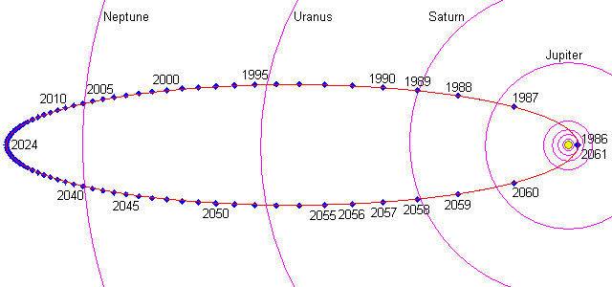

- In which part of the orbit (perihelion - nearest the sun, or aphelion - farthest from the sun) does Halley’s Comet move the fastest and slowest? Explain how you know.

Fastest:

Slowest:

- What role does the force due to gravity play in changing the comet’s speed?

- Where does Halley’s Comet spend most of its time over the course of its orbit, in the inner solar system or the outer solar system? Explain how you know.

Because Johannes Kepler knew nothing about Newton’s universal law of gravitation he was unable to determine the absolute speeds of planets and comets. Nonetheless, he was able to state that the radius arm of a solar system object (the line between the object and the sun) sweeps out equal areas in equal time intervals (Kepler’s second law of planetary motion). This implies that objects closer to the sun must faster than those farther away. Is this what you found out?

Orbital Periods: The greater the average distance of a solar system object from the sun, the greater the orbital period of the object.

The periods of selected solar system objects can be found in the following table. They are expressed in earth years. Anyone can generate the distances of the planets from the sun with an equation known as the Titius-Bode law. The law relates the semi-major axis, a, of each solar system object outward from the Sun in units such that the Earth's semi-major axis equals 1. This law states that

a_{T-B} = (n + 4)/10

where n = 0, 3, 6, 12, 24, 48... The resulting values are in astronomical units (AU) – the average Earth-Sun distance. Complete the table’s distance column a_{T-B} using this law; the results for Mercury and Venus have been provided as a check on your calculations. Note that asteroids (e.g., the dwarf planet Ceres) were not included in the law but they curiously fit the law nonetheless.

SS Object | P (years) | a_{T-B} (AU) | a (AU) | P² | a³
Mercury | 0.24 | 0.4 | .387 | 0.056 | 0.059
Venus | 0.62 | 0.7 | .723 | 0.38 | 0.37
Earth | 1.00 |  | 1.000
Mars | 1.88 |  | 1.524
Ceres | 4.60 |  | 2.766
Jupiter | 11.86 |  | 5.203
Saturn | 29.46 |  | 9.539
Uranus | 84.01 |  | 19.182
Neptune | 164.79 |  | 30.06

- How closely does the Titius-Bode law approximate the actual distances of solar system objects from the sun?

So, what is the relationship between period and semi-major axis for solar system objects? One could create a graph to find out, but the solution would be hard to come by unless one has a lot more math skills than a typical middle school student possesses. Nonetheless, try to find the relationship between P² and a³. Square the value of P and write its value in the P² column. Cube the value of a (not a_{T-B}) and put it in the a³ column. Note how these pairs of numbers relate to one another.

- What is the relationship between P² and a³ that you found in the step above?

The above relationship is known as Kepler’s third law of planetary motion.

