Building a Refracting Telescope – I *

Subject: Physics/Physical Science – Light Rays, Optics

Grade Level: 6-12

Behavioral Objective: Design and create a telescope with two convex lenses.

ILS Science:
11.B Know and apply the concepts, principles and processes of technological design.
12.C Know and apply concepts that describe properties of matter and energy [light rays] and the interactions between them.

Time: 1-2 45-minute lessons

Materials:
Building a Refracting Telescope I Worksheet (per student)
Convex lenses (2 per pair)
Styrofoam cups
Scissors
Tape
White paper / vellum

Building a Refracting Telescope – I *

The basic principle behind a telescope is that an image is produced by a convex lens (now called the objective lens or, more commonly, the objective) and then examined with a magnifying lens (now called the eyepiece). With your knowledge of convex lenses you will use the provided lenses to “invent” a telescope.

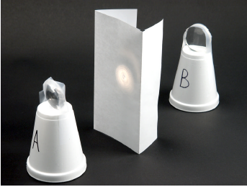
Mount the lenses on the top of Styrofoam cups as shown in the image to the left. Cut a 1-2cm slit in the base of each cup (now top of the inverted cup) and insert the lenses. Use a piece of tape to stabilize the lenses atop each cup as shown. Label the cup with the longer focal length lens “A” and the cup with the shorter focal length lens “B”. Fold a thin piece of white paper (vellum is best) as shown to serve as a screen. Using a bright light bulb as an object and lens B (the objective), focus an image of the object on the screen. The bulb and lens should all be at the same height above the table or desk.

Use lens A (the eyepiece, also at the same height above the table) to examine the image created by the objective on the screen.

1. Is it necessary to have the screen in place between the objective and eyepiece to observe the image with the eyepiece? Remove the screen and report what you observe.

Arrange the two lenses so that the longer focal length lens is in front of the shorter focal length lens (in other words, so that the longer focal length lens is closer to you). Look at a distant object through the lenses. Move the lenses closer together and farther apart to achieve a clear image.

2. Can you create a focused, magnified image of the distant object using this configuration?

Describe what you see.

Now, reverse the lenses and again look at the distant object through the lenses. As before, move the lenses closer and farther apart as necessary.

3. Can you create a focused, magnified image of the distant object using this configuration?

Describe what you see.

4. Draw below the better arrangement for seeing the distant object. Include the following items in your drawing: (1) object, (2) image, (3) objective, (4) eye, and (5) eyepiece to display the optical structure of your telescope. Label each with its corresponding number.

5. Using the best arrangement for viewing a distant object, examine a distant object by focusing your telescope on it carefully. Have your lab partner measure the distance between the two lenses when you are looking at a clearly focused distant object. Record that distance here:

6. What is the relationship between the focal lengths of the lenses and the distance between them when clearly focused on a distant object?

7. Is the image erect or inverted?

Explain why this is so.

