Convex Lenses as Image Projectors

Subject: Physics/Physical Science – Light Rays, Optics

Grade Level: 6-12

Behavioral Objective:
1. Identify the properties of convex lenses.
2. Measure the focal length of a convex lens.

State Standard:
12.C Know and apply concepts that describe properties of matter and energy [light rays] and the interactions between them.

Time: 1 45-minute lesson

Materials:
Convex Lenses (“Thick” and “thin” lens per student pair/group)
Convex Lenses as Image Projectors Worksheet (per student)

Teacher Notes:
At the beginning of the lesson, hand out the lenses and ask students to feel them and describe their differences – they should note that one is thicker than the other.

Ensure that the focal length is measurable for students. Aim to purchase lenses with focal lengths between 5 cm and 25 cm. Focal lengths that are too long will be hard for students to measure, and the images produced will be dim and possibly too large to see clearly on a note card.

Convex Lenses as Image Projectors

Lenses can be used to create images in the same way that you used pinholes, with an added advantage. Go to the window and use a convex lens (thick in the center; thin at the edge) in place of the index card with the hole in it to create an image of the outside world on your second index card. You will have to adjust the distance between the lens and the paper to bring the image into clear focus. This is quiet unlike the small holes you used to project the images before. You will understand this difference in a few moments – for now, make observations about the image you see projected on the card.

Note how the image is now bright and quite clear compared to the image produced with a pinhole. The lens forms an image by bending the light from landscape objects so that every point of light is bent to the correct place to make a clear (focused) image. Clear images of far away objects are created at a distance called the focal distance of the lens. Pinholes do not have focal distances.

For instance, in the figure below you see that a lens has replaced the pinhole. Light from the arrow passing through the upper portion of the lens (the principal ray) is bent downwards by the refracting power of the lens. Light from the arrow passing through the central part of the lens (central ray) is basically unaffected. Light from the arrow passing through the lower portion of the lens (the focal ray) is bent slightly upwards. The final result is the creation of the tip of the arrow by many light rays. The rays from the bottom of the arrow – and every point in between – are similarly “mapped” to the right side of the lens producing a clear image.
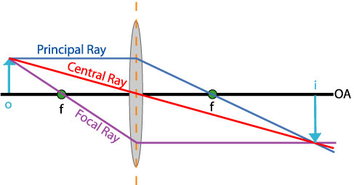
Again, use the “thick” convex lens to project an image from outdoors onto an index card. You will notice that there is only one lens-to-image distance where the image is brought to a proper focus for remote objects. This distance is called the focal length.

1. Using a ruler, measure the distance from the lens to the focused image on the index card and give that information here, including units:

Thick lens focal length:

2. Show your teacher your measurement from #1. If you are not correct, try again. If you are correct, get your teacher’s initials:

3. Make the same measurement using the “thin” convex lens. Write that focal length here:

Thin lens focal length:

4. Show your teacher your measurement from #1. If you are not correct, try again. If you are correct, get your teacher’s initials:

5. Based on your observations, how is focal length related to thickness? Circle the correct response in the sentence below.

The thicker then lens, the ( longer / shorter ) the focal length.

6. Switch back and forth between the two lenses noting the following:

Which lens, the thick or thin lens, produces the brighter image?

Explain your observation:

7. Again, switch back and forth between the two lenses, noting the following:

Which lens, the thick or thin lens, produces the larger image?

Explain your observation:

8. For both lenses, are the projected images right side up or upside down?

If you hypothesized that the image brightness and size is related to the focal length, you are right. A lens of a particular diameter can only pass so much light; hence both of the lenses passed the same amount of light. Because the longer focal length lens produced a larger image, the light from that image is spread out over a larger region. Conversely, since the short focal length lens produced a smaller image, that light is concentrated into a smaller region with each part appearing brighter than in the larger image.

