Physical Science
MIRRORS ACTIVITY

Mirrors are all around us. The first mirrors were made of shiny flat pieces of metal in Mesopotamia (modern-day Iraq). Many cultures also made reflecting pools to adorn their cities.

- Draw a concave mirror and a convex mirror. Show where the object would be located.

For direction of image, write “right-side-up” or “up-side-down.”
For size of image, write “bigger,” “same,” or “smaller.”

- Put the object CLOSE to the mirror.
 | Plane | Concave | Convex
Direction of Image

Size of Image

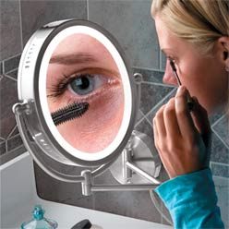
- When removing debris from the eye, people often have a hard time seeing the details. As a mirror manufacturer, what kind of mirror do you suggest to use?

- Which mirror is the most simple? Why do you think this is the case?
- Put the object FAR from the mirror.
 | Plane | Concave | Convex
Direction of Image

Size of Image

- Take the concave mirror and place the object very near to it. Look at the image, and slowly move the mirror away from the object. What happens to the image between the “near” and “far” positions?

- Try the same thing with the plane mirror. What happens to the image?

- Try the same thing with the convex mirror. What happens to the image?

- Now, watch the laser and smoke demonstration done by your teacher. Using what you saw, explain why concave lenses can give different images.
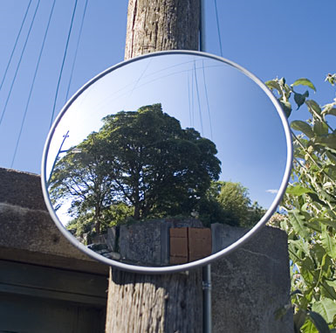

- On some street corners and in stores, mirrors are used to view a very large area – this helps people see around corners at blocked intersections, and helps fight shoplifting. What kind of a mirror is this? Explain how you know.

